THEME RESOURCES
2022

1

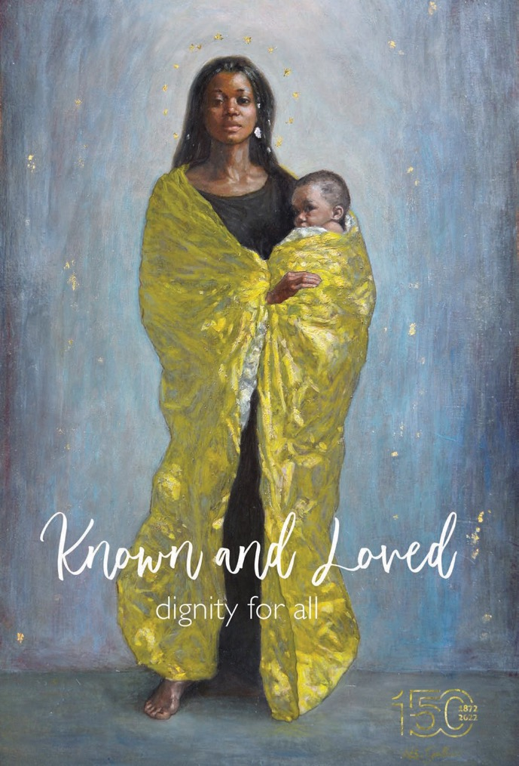

After taking the pulse of Australia for over six decades, the social researcher and renowned psychologist, Hugh Mackay, claims that: “Everyone’s deepest desire is to be heard.”1 He says by nature we are social beings who are born to connect – we share a common humanity and we need each other. What we long for most is to be listened to, have a sense of belonging, and to be accepted. Interestingly, this was echoed by a number of our Marist students who were recently asked, “What is the one thing you fear the most?” They expressed that their greatest fears were loneliness, being forgotten, and a lack of love for who they are.
What then could this be saying about the deepest desire of the human heart? Perhaps it is the desire for a place where people are known, loved, and feel the immense value of their personal worth; where everyone is welcomed and has a place at our table, where their voice is heard, valued, and respected. A place where every person is treated with ‘dignity’. The word dignity is derived from the Latin word dignitas meaning, ‘of being worthy of honour or respect’. Doesn’t this speak to what is at the heart of the Gospel message? That every human being, no matter who they are or where they come from, possesses dignity because they are created in the image of God. St Paul captured this beautifully by describing each one of us created as “God’s work of art” (Eph 2:10).
What does this ask of us? Jesus’ mission was to restore human dignity and what he cared about was lifting people up from whatever dehumanised them or caused them suffering. Jesus put his words into action by restoring sight, removing social stigmas, setting people free, and reclaiming the inherent dignity of each person he encountered. The pandemic has given us moment to pause and breathe, now it feels like it is a time to act.
We believe as Marists we are being called not simply to recognise the dignity of all, but let the world know about it by the way we live our lives for and with others. It’s a call to roll up our sleeves and to live our spirituality on the streets; it includes the staff member sitting next to you, the student in the second row that often feels invisible, the cleaner on a temporary visa, the family risking their life in a desperate search for a home where they can raise their kids safely, those suffering from the effects of inequality because of race, sexuality, economic class or gender. Anyone who is at risk of feeling and being left-out or forgotten.
In this year of our Sesquicentenary it is a time for celebrating our Marist mission of making Jesus Christ known and loved among the young, especially the most neglected. Let us be encouraged to live this mission courageously through our actions and the witness of our lives. Human dignity is the heartbeat of the Gospel, Catholic Social Teaching and our Marist story: “Love one another as Jesus Christ has loved you…May it be said of the Little Brothers of Mary as of the first Christians: ‘See how they love one another” (Marcellin Champagnat). Let our prayer be that everyone, especially the least, lost, and invisible are ‘known and loved’ as we strive to uphold, restore and defend the dignity for all.
Mary, defender of the displaced, the accompanier of the lost, the least and the lonely. Pray for us.

Tony Clarke
Director of Mission and Life Formation

1 The Kindness Revolution, Hugh Mackay, 2021.

Contents

Theme Image Reflection. 5
Assembly and Liturgy 6
Student Prayers and Reflections. 13
Staff Reflections. 24
Scripture Suggestions. 33
Themed Prayers. 36
Pope Francis’ Words on Human Dignity 40
Electronic Resources. 42

Theme Image Reflection

A reflection on the painting, Our Lady of Loreto with the Refugee’s Cloak
Let us gaze upon the image and take the words of the artist, Margherita Gallucci, into our hearts...
“I felt in my heart the need to give an image of tribute to all the people who suffer marginalisation, war, hunger, despair, escape from their land, loneliness, illness... one day I looked at the images of African migrants who landed in Italy, who miraculously survived their escape into the sea, and shocking photos of all those people and children drowned in water. My heart got tight. The images
of those people wrapped in emergency blankets reminded me of the Madonna of Loreto.

I did not want to make the image of Mary royal,
I wanted a simple emergency blanket to acquire royalty around her, since what is royal is the warmth of love that allows us to rescue and help each other. Not even the child has a royal symbolism, I would like that in that child there can be every child in the world, because every person we help, love, is Jesus.
I used small pieces of gold leaf to mark the twelve stars around Mary’s head, and points of light that float in the background. Gold leaf, in the tradition of Christian art, is the symbol of God’s light. The points of light that float in the blue, in my imagination, recall people drowned in the sea, lost in the waters. The light that illuminates the stars around Mary is the same that shines in the soul of each person. The sacredness of life in each of us.”

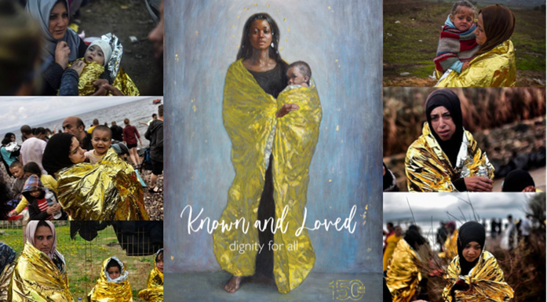

We are inspired as nations, communities, and individuals, to see that those who come to our shores are our brothers and sisters. Let us share with them... share with them the blessings we have received, and recognise that together, as one human family, we are all migrants, journeying in hope to our true home, where every tear will be wiped away, where we will be at peace and safe in God’s embrace.
- Prayer of Pope Francis during his visit to the island of Lesbos with the Ecumenical Patriarch Bartholomew

Assembly and Liturgy

Beginning of Year Assembly

Note: This introduction to the 2022 theme can be incorporated / adapted into a student led assembly. Further prayers and/or scripture (see suggestions) can be inserted and read by representatives of various year/class groups as per local custom.

Reader 1:
In 2022 we celebrate the 150th anniversary of Marist education in Australia. In March 1872, a group of four Marist Brothers led by Frenchman, Br Ludovic, arrived in Sydney to establish a school in the Parish conducted by the Marist Fathers at The Rocks.
It was a very different place than what it is today. The children had enjoyed only a basic schooling, preferring to roam the streets, fish in the harbour and play with their mates. Sitting in a classroom was not one of their priorities.
The Brothers’ first weeks was described as “chaotic”. They struggled to bring order to the undisciplined children and to advance their learning. However, they persevered, and they succeeded.

Reader 2:
Over the last 150 years, Marist schools have provided young people all over Australia, with a solid foundation of a Catholic education.
The Marist Theme for 2022, “Known and Loved – Dignity for All”, speaks to what is at the heart of the Gospel message. That every human being, no matter who they are or where they come from, possesses dignity because they are created in the image and likeness of God.
Saint Paul captures this beautifully by describing each one of us as created as “God’s work of art”.
The image chosen for this theme is by a young Italian artist, Margherita Gallucci, and is called ‘Our lady of Loreto with the Refugees’ Cloak’. She explained that she dedicated the painting to “the sacredness of human life, to the sacredness and dignity of all those who are victims of brutality, war and racism. And that we are all called to recognise the preciousness and sacredness of every person, to welcome the God in them, into our hearts and homes.”

Reader 3:
As a school community, let us now pray:
In the name of the Father, the Son, and the Holy Spirit. Amen
As we begin the new year, we thank God for the blessings we have received through our family and friends and by being here at this school. Help us to recognise the dignity and worth of every person, including those who are strangers or are different to us.

7
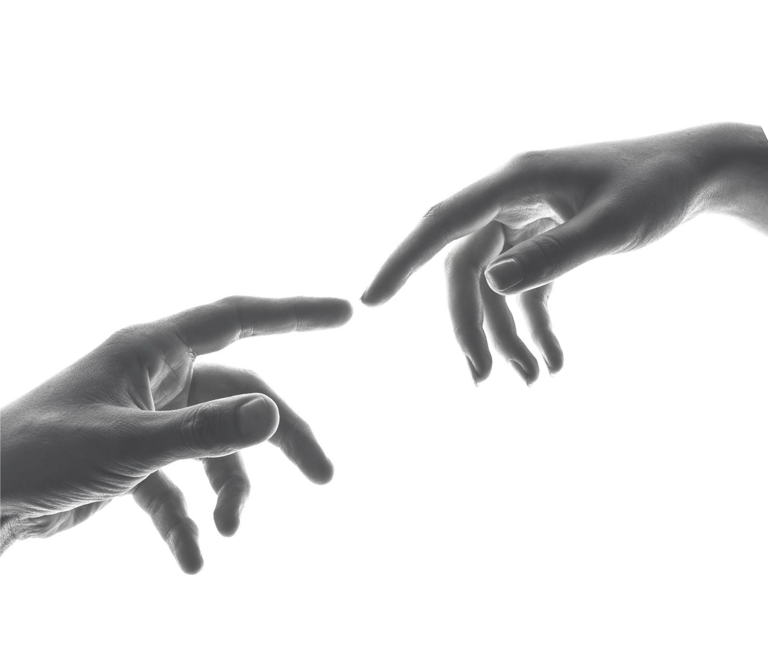
We ask God to bless our teachers and staff who work tirelessly to provide us with a quality education. We pray for Marist schools all over the country, and give thanks to the generations of Marist Brothers and teachers who have devoted their lives to the care and wellbeing of students over the past 150 years.
We pray for the world and for the many people continuing to suffer due to the Covid-19 pandemic. Help our community and government leaders to strive for justice and peace where it is most needed.
And we pray for each other, to be kind and compassionate, tender-hearted and forgiving. To recognise that Christ is in each of us and we are all made in the image and likeness of God.
Amen.
Marist Litany
Mary Our Good Mother... pray for us
St Marcellin Champagnat... pray for us
St Mary of the Cross MacKillop... pray for us
And may we always remember... to pray for one another.
In the name of the Father, the Son, and the Holy Spirit. Amen.

Beginning of Year Mass or Liturgy

Mass for Known and Loved: Dignity for All

2022 Marist Theme
Note: The Scripture readings are a suggestion. Further suggestions are available in this package or readings of the day may also be selected.

Acknowledgement of Country
As a Marist family, we pay our respects to the traditional custodians of this sacred land, the <INSERT-NAME> people, we acknowledge the elders, past and present, and the emerging leaders of Aboriginal and Torres Strait Islander people of Australia.

Introduction
2022 marks the 150th year of the Marists’ contribution to Catholic education in Australia. Having accepted the invitation of Archbishop Polding, the Marists in France had sent four Brothers across the seas. They commenced classes in the first Marist school in Australia at St Patrick’s Parish in The Rocks, Sydney on 8 April 1872. From those early beginnings, the Marists have conducted over 100 schools throughout Australia, educating hundreds of thousands of students and seeking to make Jesus known and loved.
In this special anniversary year we remember, celebrate and thank God for the generous work of Marist Brothers, lay teachers, students, parents and clergy throughout these 150 years. Today as we celebrate this rich heritage we look back in admiration and gratitude. Let us also look forward in hope and expectation. Let us live courageously through our actions and may the positive witness of our lives, build on the Marist mission of making Jesus Christ known and loved among the young, especially the most neglected.
We pray today that everyone here at <INSERT-NAME> has a year in which they truly experience being ‘known and loved’.
May ours be a community that strives to restore and defend the dignity of all.

Collect / Opening Prayer
Gracious and merciful God, You created human beings in your likeness and image so that the dignity of every person is reflected by your Divine love. In this 150th anniversary of Marist Education in Australia, may our hearts be open in gratitude, strengthened by the same spirit calling us forward in this present time, to make Jesus Christ known and loved, who lives and reigns with you in the unity of the Holy Spirit, one God, forever and ever. Amen.

First Reading

A reading from the Book of Jeremiah (Jeremiah 1:4-8 NSRV)
Now the word of the Lord came to me saying, “Before I formed you in the womb I knew you, and before you were born I consecrated you; I appointed you a prophet to the nations.”
Then I said, “Ah, Lord God!
Truly I do not know how to speak, for I am only a child.”

9

But the Lord said to me,
“Do not say, ‘I am only a child’;
for you shall go to all to whom I send you,
and you shall speak whatever I command you. Do not be afraid of them,
for I am with you to deliver you.” The Word of the Lord

All: Thanks be to God

Responsorial Psalm

Psalm 139:13-16
Reader: The response to the Psalm is Search me O God and know my heart.

Response: Search me, O God, and know my heart.
Reader: For it was you who formed my inward parts; you knit me together in my mother’s womb.

Response: Search me, O God, and know my heart.
Reader: I praise you, for I am fearfully and wonderfully made.
Wonderful are your works; that I know very well.

Response: Search me, O God, and know my heart.
Reader: My frame was not hidden from you, when I was being made in secret,
intricately woven in the depths of the earth.

Response: Search me, O God, and know my heart.
Reader: Your eyes beheld my unformed substance.
In your book were written
all the days that were formed for me, when none of them as yet existed.

Response: Search me, O God, and know my heart.

Alleluia Verse

Ephesians 4:32
All: Alleluia, Alleluia

Be kind and compassionate to one another, tender hearted, forgiving one another, as God in Christ forgave you.

Alleluia

Gospel

Mark 12:28-34 NRSV
Priest: The Lord be with you.

All: And with your spirit.
Priest: A reading from the Holy Gospel according to Mark.

All: Glory to you, Lord.
One of the scribes came near and heard them disputing with one another, and seeing that he answered them well, he asked Jesus, “Which commandment is the first of all?” Jesus answered, “The first is, ‘Hear, O
Israel: the Lord our God, the Lord is one; you shall love the Lord your God with all your heart, and with all your soul, and with all your mind, and with all your strength.’ The second is this, ‘You shall love your neighbour as yourself.’ There is no other commandment greater than these.” Then the scribe said to him, “You are right, Teacher; you have truly said that ‘God is one, and besides God there is no other’; and ‘to love God with all your heart, and with all your mind, and with all your strength,’ and ‘to love one’s neighbour as oneself,’—this is much more important than all whole burnt offerings and sacrifices.” When Jesus saw that he answered wisely, he said to him, “You are not far from the kingdom of God.” After that no one dared to question Jesus any more.
The Gospel of the Lord.

All: Praise be to you, Lord Jesus Christ. Prayers of Intercession
Priest: Dear friends, Jesus spent his life among us in the service of all, affording true ‘dignity’ to every person he met. In that spirit let us pray for the needs of the whole human family.
Reader: We pray for faith leaders and heads of state, that they will be free from personal ambition and selfless in service to the good of the whole community, especially to the least, the lost and the lonely.
Lord, hear us.

All: Lord hear our prayer.
Reader: We pray for the leaders of nations, that they will grow to become much more courageous in taking the decisive steps needed to respond to the climate emergency and protect the earth, our common home.
Lord, hear us.

All: Lord hear our prayer.
Reader: We pray for the poor of the world, that the international community will take responsibility for the eradication of poverty and spark renewed efforts to share the world’s resources justly with the poorest.
Lord, hear us.

All: Lord hear our prayer.
Reader: We pray for our public health workers engaging with culturally diverse communities, that they will help them respond effectively to the COVID challenge.
Lord, hear us.

All: Lord hear our prayer.
Reader: We pray for refugees and asylum seekers in Australia who see violence and injustice consuming their homelands, that their pain will be eased by local networks of support.
Lord, hear us

All: Lord hear our prayer.
Priest: God of all goodness, your Son emptied himself of glory to be servant of all. Keep us true to his name. We ask this through Christ our Lord.

All: Amen

Prayer over the Offerings
Grant, O Lord, we pray,
that what we offer in the sight of your majesty
may obtain for us the grace of being devoted to you and gain us the prize of everlasting happiness.
Through Christ our Lord. Amen

Prayer after Communion
Nourished by this sacred gift, O Lord,
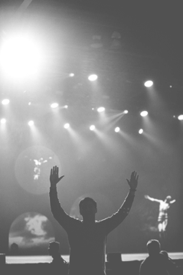
may we always grow in love toward each other, showing kindness and compassion to all whom we meet. Help us to recognise that our inherent dignity is a reflection of your Divine love.

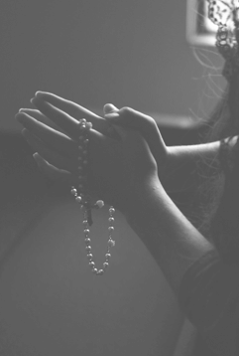

Student Prayers and Reflections

- Care for Creation
Leader: Let us begin by making the sign of the cross.
In the name of the Father, the Son and the Holy Spirit. Amen.
Our Marist theme, Known and Loved – Dignity for All, calls us to remember that God created heaven and earth, the sun, moon and stars. We are told that God created all the animals, the birds and fish, every plant and all the bugs and insects, yes, even mosquitos!
We pray in thanksgiving for this wonderful world and all of creation, that leaders can work together to bring about change in caring for our common home, our planet. Help us to become more aware our planet is fragile and even the small things we do can make big difference for the future of our world.

A Prayer for Our Environment
(by Pope Francis, Laudato Si)
Reader: All powerful God, you are present in the
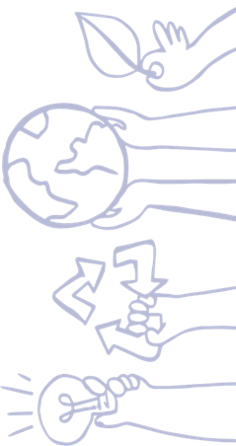
whole universe and in the smallest of your creatures. You embrace with your tenderness all that exists.
Pour out upon us the power of your love, that we may protect life and beauty.

All: Fill us with peace, that we may live

as brothers and sisters, harming no one.
Reader: O God of the poor,
help us to rescue the abandoned and forgotten of this earth, so precious in your eyes.
Bring healing to our lives,
that we may protect the world and not prey on it,
that we may sow beauty, not pollution and destruction.

All: Touch the hearts of those who look only

for gain at the expense of the poor and the earth.
Reader: Teach us to discover the worth of each
thing, to be filled with awe and contemplation, to recognize that we are profoundly united with every creature as we journey towards your infinite light.

All: We thank you for being with us each day.

Encourage us, we pray, in our struggle for justice, love and peace. Amen
Leader: We pause in silence for our own private intentions.
Together we pray this prayer for God’s creation.

All: Lord of life and giver of hope,

we pledge ourselves to care for creation, to reduce our waste, to live sustainably, and to value the rich diversity of life.

May your wisdom guide us,

that life in all its forms may flourish,

and we may be faithful in voicing creation’s praise.

May the commitment we have made this day be matched by our faithful living.

Amen

Marist Litany
Mary Our Good Mother... pray for us St Marcellin Champagnat... pray for us
St Mary of the Cross MacKillop... pray for us
And may we always remember... to pray for one another.
In the name of the Father, the Son, and the Holy Spirit. Amen.

Helping the Least of My Sisters and Brothers

Introduction
Jesus calls his followers to a genuine love, to give to those who cannot repay us and to serve others without seeking anything in return. Sadly, our tendency is to see the poor as ‘different’— or their problems too difficult to tackle — or the poor themselves are to blame for their poverty. For Jesus, helping the ‘other’ or the ‘least’ started with simply talking to them. With asking them a question. “What do you want me to do for you?” Jesus issues the same invitation to us.

Opening Prayer
Dear God, as we live each day, we pray for those less fortunate, especially those who are hurting,
and whose wounds need to be healed.
Dear God, help us become involved in ways that show others how deeply we care.
Give us the personal courage to listen to their stories and concerns and remember that we are all brothers and sisters.
Amen.

Reading

Matthew 25:34-40 (NRSV)
(Jesus said to the crowd)... When I was hungry and you gave me food, I was thirsty and you gave me something to drink, I was a stranger and you welcomed me, I was naked and you gave me clothing, I was sick and you took care of me, I was in prison and you visited me.’ Then the righteous will answer him, ‘Lord, when was it that we saw you hungry and gave you food, or thirsty and gave you something to drink? And when was it that we saw you a stranger and welcomed you, or naked and gave you clothing? And when was it that we saw you sick or in prison and visited you?’ And the king will answer them, ‘Truly I tell you, just as you did it to one of the least of these who are members of my family, you did it to me.’
Personal Reflection:
- Who are Jesus’ ‘least’ within your community and around the world today?
- How does Jesus teach me to encounter others?

A Story
My whole family has been poor for years now. There’s a number of things we do to make it: we don’t own a car and we try to grow our own food. Mum cooks everything from scratch, and we don’t buy anything unless we absolutely need it. Sometimes I ask a mate if I can have a sleep-over just for a good meal and a long shower. My brother and I do yard work and wash cars for a bit of money that we use for school activities. And, we only ever shop at thrift stores or garage sales.
Last year, I found a pair of shoes my size that were getting thrown away. The treads started coming off, so I fixed them with super glue: they were much better shoes than the cheapest ones you can find which only last about a month. The idea of having things like Netflix or mobile phones or iPads is so ridiculous -- we read books from the school library and play games for entertainment. The trick is to be happy with what you have and don’t compare yourself with others.
My name is Hamish and I am 12 years old.

Intercessions
Reader: God, thank you for the abundance in our lives, relationships, health and comforts you have provided us.
Lord hear us.

All: Lord, hear our prayer.
Reader: Guide us towards pursuing justice for the poor and upholding the cause of the marginalised.
Lord hear us.

All: Lord, hear our prayer.
Reader: Let us always pray for those deprived of their human needs, and their human rights, that they may be given the dignity which God gives to all His people.
Lord hear us.

All: Lord, hear our prayer.

Closing Prayer
Dear God,
Help us to be your ears to listen to the concerns of the marginalised. Help us to be your voice speaking out love and acceptance.
Help us to be your feet walking beside those in need.
Help us to be your hands to clothe, feed and shelter them. You came for the least, the lost and last of this world.
Lord, hear our prayer. Amen.

Marist Litany
Mary Our Good Mother... pray for us St Marcellin Champagnat... pray for us
St Mary of the Cross MacKillop... pray for us
And may we always remember... to pray for one another.
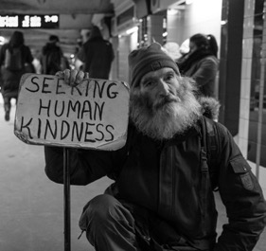
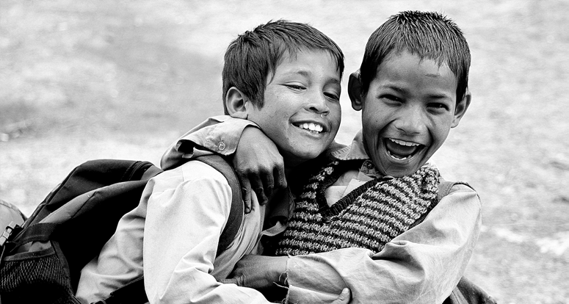In the name of the Father, the Son, and the Holy Spirit. Amen.

17

- Who is My Neighbour?
At this moment we take time to pause and remember we are in the presence of God. In the name of the Father, and of the Son and of the Holy Spirit. Amen.

Introduction
It is a fundamental right for all human beings to be treated with dignity and respect. We know this from our Christian tradition and specifically from the teachings of Jesus himself. In response to the question of which is the most important commandment, Jesus answered:
“‘Love the Lord your God with all your heart and with all your soul and with all your mind.’
This is the first and greatest commandment. And the second is like it: ‘Love your neighbour as yourself.’ All the Law and the Prophets hang on these two commandments.”

Matthew 22:37-40
Our common humanity means we are all neighbours to one another.

Response to Scripture
Reader 1: Who is my neighbour?

Reader 2: Any person of any colour is my neighbour.
Reader 1: Who is my neighbour?

Reader 2: Any person from any country is my neighbour.
Reader 1: Who is my neighbour?

Reader 2: Any person from any culture is my neighbour.
Reader 1: Who is my neighbour?

Reader 2: Every person no matter what language they speak.
Reader 1: Who is my neighbour?

Reader 2: Every person no matter their gender.
Reader 1: Who is my neighbour?

Reader 2: Every person, every person is my neighbour. All: Amen.

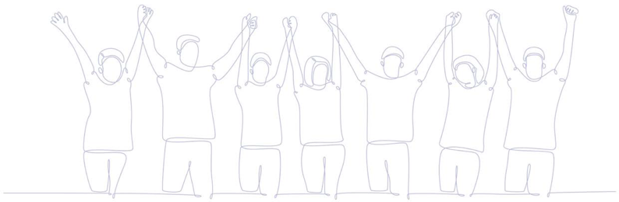
In Australia, we have not always been good neighbours to our First Nations sisters and brothers. Part of being a good neighbour is to listen respectfully to others to understand their story. First Nations people are the longest surviving culture on earth and over 60,000+ years have developed a way of living and a spirituality that has nurtured and sustained them. Let us pray that as one nation, neighbours all, we will listen to the voice of Indigenous people and commit ourselves to peace and justice for all.

Closing Prayer
Leader: Let us pray.
Loving and gracious God, who created all people equal, we thank you for Indigenous people who have given so much to our country and our culture. We pray that we listen to their voice as they speak of their desires, hopes and dreams for their lives and the life of this nation. May we all commit ourselves to seeking justice for all people and show a willingness to find positive solutions that include all.
We ask this prayer in Jesus’ name.

Marist Litany
Mary Our Good Mother... pray for us St Marcellin Champagnat... pray for us
St Mary of the Cross MacKillop... pray for us
And may we always remember... to pray for one another.
In the name of the Father, the Son, and the Holy Spirit. Amen.

19

- First Nations Peoples

Acknowledgement of Country
We acknowledge the traditional custodians of this land... <INSERT-NAME> and pay our respects to the elders past, present and future, for they hold the memories, the traditions, the culture and hopes of all Australia. We honour the presence of these ancestors who reside in the imagination of this land and whose irrepressible spirituality flows through all creation.
At this moment we take time to pause and remember we are in the presence of God. In the name of the Father, and of the Son and of the Holy Spirit. Amen.
Today we gather to pray for our First Nations Peoples of Australia.

Scripture Reflection

Romans 15: 2,7
A Reading from the Letter of St Paul to the Romans.
Each of us must consider our neighbour’s good, so that we support one another. Accept one another then, for the sake of God’s glory, as Christ accepted you.

Prayer of the Faithful
Leader: We now turn to you, O God, and ask for the guidance of your Spirit.
Reader: We pray for all Australians... may we all grow in respect, understanding and appreciation of the culture of the Indigenous peoples of this land and their contribution to our history.
Lord, hear us.

All: Lord, hear our prayer.
Reader: We pray for the leaders of churches and governments in this country... that they may value and engage in meaningful conversations that promote justice and reconciliation for our Indigenous brothers and sisters.
Lord, hear us.

All: Lord, hear our prayer.
Reader: We pray for all Indigenous people... that they maintain a strong spirit of commitment to their culture and be willing to celebrate and promote its uniqueness and distinctiveness.
Lord, hear us.

All: Lord, hear our prayer.
Reader: We pray for our school community... that we may genuinely and lovingly respond to the call to build a strong partnership with our Indigenous brothers and sisters.
Lord, hear us.

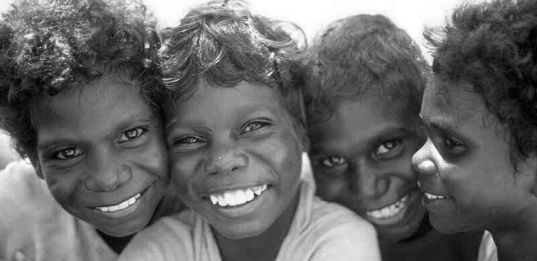

All: Lord, hear our prayer.
Reader: We pray for true reconciliation and genuine healing for both sides so that we can work together for a shared future.
Lord, hear us.

All: Lord, hear our prayer.
Leader: Loving God, with hope and faith we ask you to accept the prayers we make to you.

All: Amen.

Final Prayer
Leader: Let us pray.
Gracious God,
we want all people to live justly and peacefully together in this land.
We thank you for our First Nations sisters and brothers who have stood proudly and confidently,
wanting to promote their culture and history.
May we work together to embrace and celebrate all that is similar and all that is different between us.
We ask this prayer through Jesus, your Son. Amen.

Marist Litany
Mary Our Good Mother... pray for us St Marcellin Champagnat... pray for us
St Mary of the Cross MacKillop... pray for us
And may we always remember... to pray for one another.
In the name of the Father, the Son, and the Holy Spirit. Amen.

21

- Living in Poverty
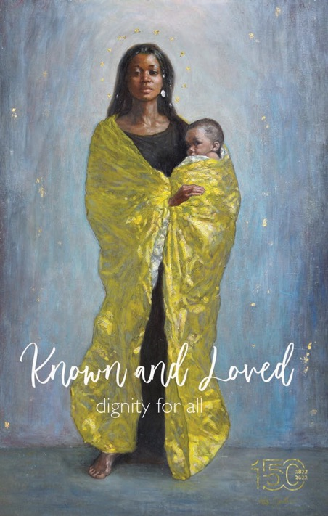
Student Leader: Let us begin our morning prayer by making the sign of the cross. In the Name of the Father, the Son and the Holy Spirit. Amen.
Student Leader: Our beautiful Marist prayer theme Known and Loved - Dignity for all reminds us of the love that God has for each one of us as God’s children. Take a moment to pause (3-4 sec). The words are a sacred reminder that we are made in God’s “image and likeness.” (Genesis 1:27).

Intentions
Reader 1: Gracious God, let us pray for the marginalised and unknown in our societies and the millions living in poverty in our world, especially the children who have no one to care for them. Lord hear us.

All: Lord hear our prayer
Reader 2: Creator God, let us pray for our school community, especially for those struggling or in need at present. Give them the
comfort and strength to know that they are loved unconditionally.
Lord hear us.

All: Lord hear our prayer
Reader 3: Loving God, let us pray that our Government and Church leaders work together with those living in poverty to help to make our world a more just and equitable place to live. Lord hear us.

All: Lord hear our prayer

Student Leader - Living in Poverty
Saint Mother Teresa gave up her former way of life and went to live amongst the poor and sick in the poorest areas of India. She is a great teacher; her example demonstrates how the poor should be treated. She often said, “what the poor need the most is not pity, but love. They need to feel respect for their human dignity, which is neither less nor different from the dignity of any other human being.” Mother Teresa lived the commandments and teachings of Jesus to “love one another”. How are we being invited by God to do the same?

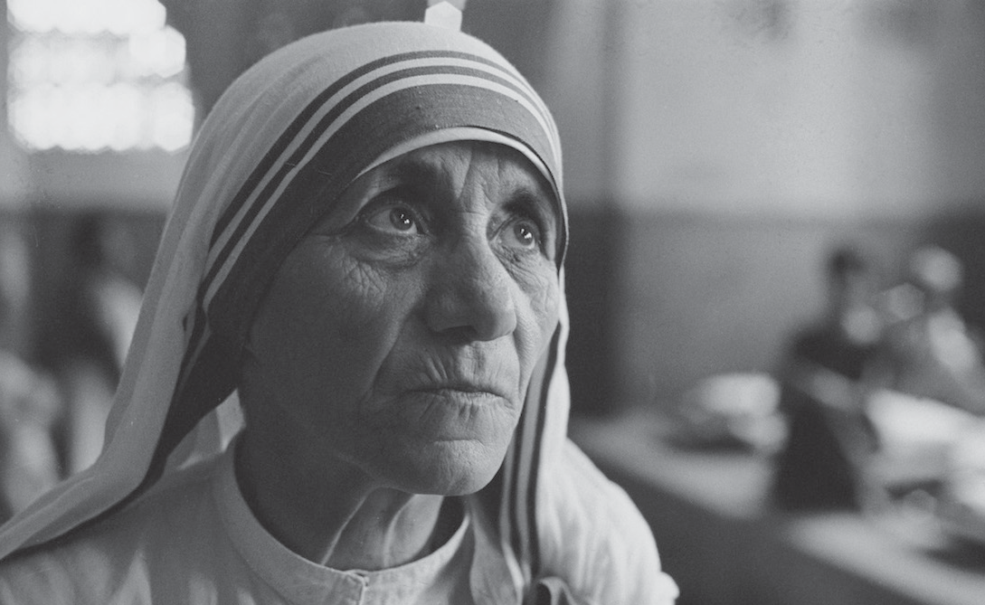

“I will never tire of repeating this: what the poor need the most is not pity, but love. They need to feel respect for their human dignity, which is neither less nor different from the dignity of any other human being.”

Prayer Response for Class
Reader 1: Creator God, Your image is alive in every human person in this room, giving to each of us an unbreakable dignity and bond.
Reader 2: Create in us a desire to act in solidarity, and to always look out for those in need in our community and world.
Reader 3: Gracious God, give us ears to hear, eyes to see and hearts to love, so that we always reflect you in our daily words and actions.
Reader 4: Jesus came to bring good news to the poor. As young people growing and learning in a Marist Catholic school in the 21st century, help us to recognise the call to be people of action. Amen.
Leader: Let us all pray together with Mary.

All: Hail Mary, full of grace, the Lord is with you; blessed are you amongst women, and blessed is the fruit of your womb, Jesus. Holy Mary, Mother of God, pray for us sinners, now and at the hour of our death. Amen.

Marist Litany
Mary Our Good Mother... pray for us St Marcellin Champagnat... pray for us
St Mary of the Cross MacKillop... pray for us
And may we always remember... to pray for one another.
In the name of the Father, the Son, and the Holy Spirit. Amen.

23

Staff Reflections

- Pope Francis on Poverty
As Marists, the following words of Pope Francis help us reflect more deeply on how our experience of God’s love can open our hearts to solidarity with our neighbours and move us to action.
Together, let us respond:

Holy Spirit, help us discern how we might be called to love-inspired action. Help us practice charity and promote justice and peace in our community and in our world.
Reader: “The times talk to us of so much poverty in the world and this is a scandal. Poverty in the world is a scandal. In a world where there is so much wealth, so many resources to feed everyone, it is unfathomable that there are so many hungry children, that there are so many children without an education, so many poor persons. Poverty today is a cry.” (Pope Francis, Meeting with Students of Jesuit Schools) RESPONSE.
Reader: “Poverty calls us to sow hope... Poverty is the flesh of the poor Jesus, in that child who is hungry, in the one who is sick, in those unjust social structures.” (Pope Francis, Meeting with Students of Jesuit Schools) RESPONSE.
Reader: “In today’s world, voices are being raised which we cannot ignore and, which implore [us] to live deeply our identity as disciples of the Lord Jesus Christ. The first of these voices is that of the poor. We cannot remain indifferent before the cries of our brothers and sisters. These ask of us not only material assistance – needed in so many circumstances – but above all, our help to defend their dignity as human persons, so that they can find the spiritual energy to become once again protagonists in their own lives. They ask us to fight, in the light of the Gospel. As Christians we are called together to eliminate that globalisation of indifference which today seems to reign supreme, while building a new civilisation of love and solidarity.” (Pope Francis, Address at Patriarchal Church of St. George, Istanbul) RESPONSE.
Reader: “Let us open our eyes to our neighbour, especially to our brothers and sisters who are forgotten and excluded, to the ‘Lazarus’ at our door. That is where the Church’s magnifying glass is pointed... By right but also by evangelical duty, it is our responsibility to care for the true riches which are the poor and marginalised.” (Pope Francis, Homily for Jubilee for Socially Excluded People) RESPONSE.
Reader: “If we do not want to live life poorly, let us ask for the grace to see Jesus in the poor, to serve Jesus in the poor” (Pope Francis in his Apostolic Letter, Misericordia et Misera, issued on 20 November 2016) RESPONSE.

Marist Litany
Mary Our Good Mother... pray for us St Marcellin Champagnat... pray for us
St Mary of the Cross MacKillop... pray for us
And may we always remember... to pray for one another.
In the name of the Father, the Son, and the Holy Spirit. Amen.

25

- The Widow’s Offering

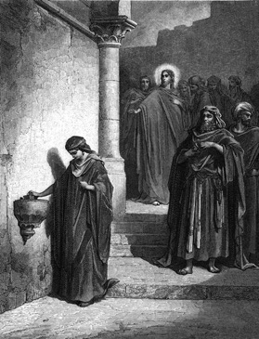
Scripture Reflection

Mark 12:38-44 (NRSV)
He sat down opposite the treasury and watched the crowd putting money into the treasury. Many rich people put in large sums. A poor widow came and put in two small copper coins, which are worth a penny. Then he called his disciples and said to them, “Truly I tell you, this poor widow has put in more than all those who are contributing to the treasury. For all of them have contributed out of their abundance; but she out of her poverty has put in everything she had, all she had to live on.”

Gospel Reflection
Jesus didn’t allow his listeners to forget about the poor. At one level, it was impossible to do so. Nearly everyone in the ancient world lived in poverty, often dire poverty. Jesus’ world included very few wildly wealthy people, but rather, lots of
people scratching a living off the land, and lots of people living on the margins of the economy.
Jesus, the Gospels tell us, moved among the poor. He told stories (we call them parables) about rich landowners and their poor and enslaved laborers. He warned the rich that they faced God’s judgment, while he demonstrated compassion by feeding the masses who followed him out into the wilderness.
Reader: In Mark 12:38-44 Jesus calls attention to a poor widow. She contributes two copper coins to the temple treasury, “her whole livelihood” according to Mark, and Jesus judges her contribution as greater than the large sums contributed by the rich.
The widow’s generosity places the reality of poverty before our eyes.
It reminds us that the poor do not drain society of its resources. We live in an economy that siphons its resources upward and leaves the vulnerable to face destitution on their own.
Whether our institutions and religious leaders recognise it or not, we have lots to learn from the poor and the vulnerable.
If we would just look.

(Pause for personal reflection)

Marist Litany
Mary Our Good Mother... pray for us St Marcellin Champagnat... pray for us
St Mary of the Cross MacKillop... pray for us
And may we always remember... to pray for one another.
In the name of the Father, the Son, and the Holy Spirit. Amen.

From: Huffpost: Greg Carey (Professor of New Testament, Lancaster Theological Seminary
)11/07/2012 03:19pm EST | Updated December 6, 2017) https://www.huffpost.com/entry/mark-12- 38-44-the-value-of-chump-change_b_2083237

- Loving Kindness

Leader: In the name of the Father, the Son and the Holy Spirit. Amen.
Let us begin with a moment of silence and put ourselves in the presence of God and quietly read and reflect on the words of the Brazilian Social Activist, Dom Helder Camara.
“God embraces all human beings. The heart of faith is the call to love one another.”
Reader 1: We all need to practice being kind, particularly to ourselves. It is only when we first reconnect with the unlimited love within each of us that we can extend that love to others.
Reader 2: When we remember that we are love, we can truly wish even our enemies well. The Buddhist practice of metta, or loving kindness, is a wonderful way to grow kindness for yourself and for others.
Reader 3: Let us take a moment now to practice this in a simple meditation. Settle yourselves, breathe, and be still to find the place of loving kindness within you. (Pause) Then speak the following statements in the silence of your heart. I will allow a couple of minutes to do this.

(Quietly repeat each statement to yourself 3 times)
May I be free from inner and outer harm and danger. May I be safe and protected.
May I be free of mental suffering or distress. May I be happy.
May I be free of physical pain and suffering. May I be healthy and strong.
May I be able to live in this world happily, peacefully, joyfully, with ease.
As you finish your meditation try to think of someone else, perhaps a family member, a student or colleague and replace the “I” in one of the statements with that person’s name that comes to mind for you.
Leader: Let us pray as a Marist faith community, that we always strive to show the loving and kind face of God to our students, especially those most in need in our care. In doing this we make Jesus Christ known to them. Amen.
Marist Litany
Mary Our Good Mother... pray for us St Marcellin Champagnat... pray for us
St Mary of the Cross MacKillop... pray for us
And may we always remember... to pray for one another.
In the name of the Father, the Son, and the Holy Spirit. Amen.

- A New Beginning!
We must learn to live each day, each hour, yes, each minute as a new beginning, as a unique opportunity to make everything new. Imagine that we could live each moment as a moment pregnant with new life. Imagine that we could live each day as a day full of promises.
Imagine that we could walk through the new year always listening to the voice saying to us: “I have a gift for you and can’t wait for you to see it!” Imagine.
Is it possible that our imagination can lead us to the truth of our lives? Yes, it can! The problem is that we allow our past, which becomes longer and longer each year, to say to us: “You know it all; you have seen it all, be realistic; the future will just be a repeat of the past. Try to survive it as best you can.”
So what are we to do? We must open our minds and our hearts to the voice that resounds through the valleys and hills of our life saying: “Let me show you where I live among my people. My name is ‘God-with-you.’ I will wipe all the tears from your eyes; there will be no more death, and no more mourning or sadness. The world of the past has gone” (Revelation 21:2–5).

- Henri Nouwen

Pause and reflect on a word or line that struck you.
Let us pray this week that we seek to live and express the Gospel message to our students always with imagination and excitement, reminding them that every day is a new beginning for them.

Marist Litany
Mary Our Good Mother... pray for us St Marcellin Champagnat... pray for us
St Mary of the Cross MacKillop... pray for us
And may we always remember... to pray for one another.
In the name of the Father, the Son, and the Holy Spirit. Amen.

- 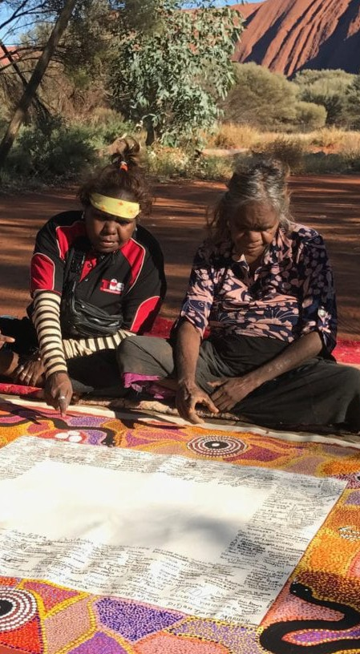Uluru Statement from the Heart
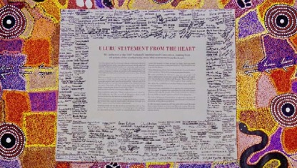
At this moment we take time to pause and remember we are in the presence of God. Amen.

Introduction
In 2017, the Uluru Statement from the Heart was released. It is a document written in its entirety by Indigenous people and it outlines the path forward for recognising Indigenous Australians in the nation’s constitution. Unlike historic documents of Indigenous aspirations that came before it and were addressed
to the Parliament, the Uluru Statement from the Heart is directed to the Australian public. This is significant because the responsibility to listen, learn and act is with all of us.
Today, our prayer is that all Australians will listen deeply to the themes of Voice, Treaty and Truth that are addressed in the statement. Let’s work together for a shared future and celebrate the invaluable
contributions that Aboriginal and Torres Strait Islander people have made – and continue to make – to our communities, our families, our rich history and to our nation. Let us continue to work together so that all people feel listened to, valued, respected and accepted.

Scripture Reflection
In the light of the Uluru Statement, take a moment to reflect on two simple but powerful statements from the Old and New Testaments:

We are all created in the image and likeness of God (Genesis 1:27)

Christ set us free, so that we should remain free (Galatians 5: 1)

Prayer
In the name of the Father, and of the Son and of the Holy Spirit.
Loving God, You have created all people equal and to be free. Set our hearts on fire with the fruits of the Spirit – love, joy, peace, patience, kindness, goodness, trustfulness, gentleness and self- control – so that we might promote the dignity and freedom of our Indigenous sisters and brothers and work for reconciliation and justice for all people.
We ask this in Jesus’ name, the one who came to ‘set us free, so that we should remain free.’ Amen.

Marist Litany
Mary Our Good Mother... pray for us St Marcellin Champagnat... pray for us
St Mary of the Cross MacKillop... pray for us
And may we always remember... to pray for one another.
In the name of the Father, the Son, and the Holy Spirit. Amen.

- Hope

The Pope concludes his book, Let Us Dream – the Path to a Better Future, with a beautiful reflection on Hope borrowed from a friend. The poem captures the path to a better future and the fullness of life that awaits all peoples (John 10:10).
When the storm has passed... and the roads are tamed And we are survivors... of a collective shipwreck.
With tearful heart... our destiny blessed We will feel joy... simply for being alive.
And we’ll give a hug... to the first stranger
And praise our good luck... that we kept a friend.
And then we’ll remember... all that we lost
And finally learn... everything we never learned.
And we’ll envy no one... for all of us have suffered And we’ll not be idle... but more compassionate.
We’ll value more what belongs to all... than what was earned We’ll be more generous... and much more committed.
We’ll understand how fragile... it is to be alive
We’ll sweat with empathy... for those still with us and those who are gone.
We’ll miss the old man... who asked for a buck in the market Whose name we never knew... who was always at your side.
And maybe the poor old man... was your God in disguise
But you never asked his name... because you never had the time.
And we’ll all become a miracle... and all will become a legacy And we’ll respect the life... the life we have gained.
When the storm passes... I ask the Lord, in shame That you return us better... as you once dreamed us.
I hope you reread this poem... and dream that you and I can be better as we embrace each other in fraternity and social friendship with arms that reach out with food for the poor, care for the earth and reverence for all of life.

Marist Litany
Mary Our Good Mother... pray for us St Marcellin Champagnat... pray for us
St Mary of the Cross MacKillop... pray for us
And may we always remember... to pray for one another.
In the name of the Father, the Son, and the Holy Spirit. Amen.

Source: https://www.h2h.nyc/hope-a-poem-by-alexis-valdes/

- God’s Work of Art
The brilliant blue sky overhead in the late afternoon of the rugby league Grand Final in Brisbane was remarked on by commentators and crowd alike. It was a fact. Everyone could agree it was a work of art and a joy to behold. But I’m quite sure if you asked the stadium crowd, the media and the players if every person present at the Grand Final was a work of art or more pointedly was made in the image and likeness of God — that probably would provoke a riot of laughter or worse! “Absolutely crazy. Impossible. Especially her! And him? What about them! No thanks.”
Looking at others, defining them by their bodily features, their sense of dress and undress, their attitudes, their walk, gestures and general demeanour is part and parcel of our way of life. Posting ourselves on social media and calling others to comment is ‘normal’ if there is such a thing. And it often provokes a derisive negative response from others.
So, when the Hebrew text of Psalm 139 hits us with the idea of a God, out there somewhere beyond that beautiful sky who could ‘form my inward parts’ and ‘knit me together in my mother’s womb’, it’s hard to take it all in.
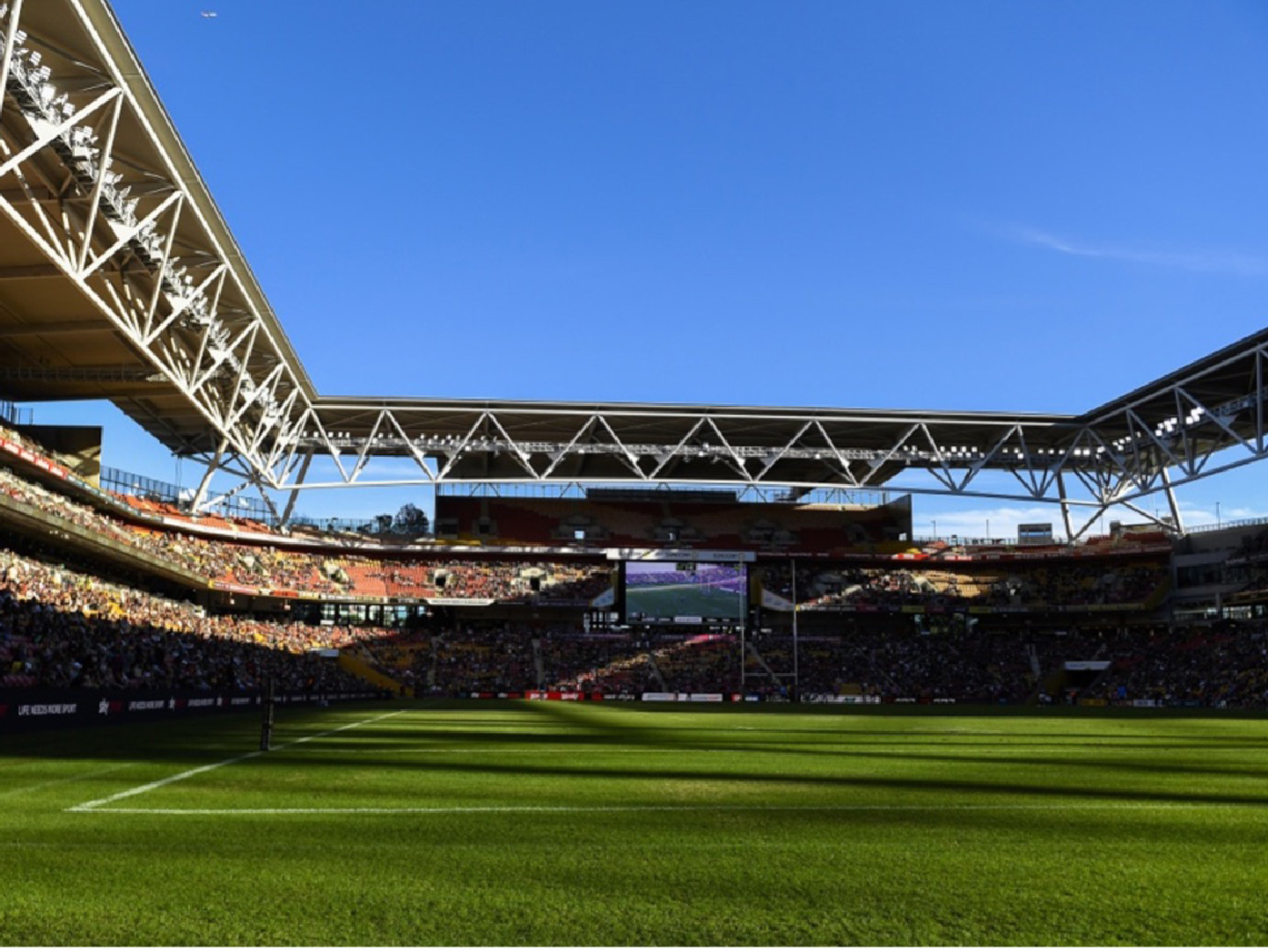
For it was you who formed my inward parts; you knit me together in my mother’s womb.
praise you, for I am fearfully and wonderfully made. (Psalm 139:13-14)

Similarly, we are shocked when we read in the book of Genesis, the first book of the Bible that God ‘created humankind in God’s image.’ That’s the idea: ‘in the image of God, God created them.’ And to complicate matters even further in the second chapter of Genesis there is another story of our creation stating
that humankind was formed from the dust of the ground and God breathed into the human’s nostrils the breath of life and the human became a living being.
In other words, a human being has God’s breath, God’s spirit dwelling in them. Impossible?
God is not only out there in the beautiful blue grand final sky but also living within us. No wonder St Paul in his letter to the Ephesians call us God’s work of art.
We are! God knit us together in our mother’s womb from all eternity. We were woven in the depths of the earth, known by our creator God since forever and no matter how bad or crazy are the people around us, God is there guiding us on the everlasting way (Psalm 139).
Are we all made in the image and likeness God? Let’s reflect on this question as we pray:

I praise you Lord for I am fearfully and wonderfully made. Wonderful are your works that I know very well. (Psalm 139)

Search me O God and know my heart; test me and know my thoughts. See if there is any wicked way in me, and lead me in the way everlasting. (Psalm 139)

We are what he has made us... a work of art. (Ephesians 2:9,10)

And so we are saved through faith, and this is not your own doing; it is the gift of God. (Ephesians 2:9,10)
The first gift at the grand final was the gift of the beautiful sky. The stadium was filled with God’s gifts too. We just have to have the right disposition, attitude and sense of the grandeur and wonder at a human being made in the image and likeness of God to see beyond the sometimes mundane and difficult. In other words, discover the presence of God in the world around us. St Marcellin practiced that every day.
Be the attitude you want for all of God’s creation. Put away negative comparisons and social media critiques. Let’s be linked together spiritually as a dwelling place for God. Just like Mary was and continues to be for Marists in the world today
as we celebrate 150 years of Marist education in Australia. Marcellin’s mission continues through us as we help our students recognise they are made in God’s image as a glorious work of art, each with the divine spark within.

Marist Litany
Mary Our Good Mother... pray for us St Marcellin Champagnat... pray for us
St Mary of the Cross MacKillop... pray for us
And may we always remember... to pray for one another.
In the name of the Father, the Son, and the Holy Spirit. Amen.

Scripture Suggestions

Being Made in the Image of God

Jeremiah 1:4-8
Before I formed you in the womb I knew you
Now the word of the Lord came to me saying, “Before I formed you in the womb I knew you, and before you were born I consecrated you; I appointed you a prophet to the nations.” Then I said, “Ah, Lord God! Truly I do not know how to speak, for I am only a child.” But the Lord said to me, “Do not say,
‘I am only a child; for you shall go to all to whom I send you, and you shall speak whatever I command you. Do not be afraid of them, for I am with you to deliver you, says the Lord.”

Ephesians 2:8-10
We Are God’s Work of Art (NJB)
Because it is by grace you have been saved, through faith; not by anything of your own, but by a gift from God; not by anything you have done, so that nobody can claim the credit. We are God’s work of art, created in Christ Jesus for the good works which God has already designated to make up our way of life.

3. Psalm 139: 1-4,13-14
I am fearfully and wonderfully made
O Lord, you have searched me and known me. You know when I sit down and when I rise up; you discern my thoughts from far away. You search out my path and my lying down, and are acquainted with all my ways. For it was you who formed my inward parts; you knit me together in my mother’s womb. I praise you, for I am fearfully and wonderfully made. Wonderful are your works...

4. Genesis 1:26-28, 31
Made in the image and likeness of God
Then God said, “Let us make humankind in our image, according to our likeness; and let them have dominion over the fish of the sea, and over the birds of the air, and over the cattle, and over all the wild animals of the earth, and over every creeping thing that creeps upon the earth.” So, God created humankind in God’s image, in the image of God they were created. God blessed them (and) saw everything that God had made, and indeed, it was very good.

5. Genesis 2:7-9
God beathed the breath of life
In the day that the Lord God made the earth and the heavens, when no plant of the field was yet in the earth and no herb of the field had yet sprung up— for the Lord God had not caused it to rain upon the earth, and there was no one to till the ground; but a stream would rise from the earth, and water the whole face of the ground— then the Lord God formed humankind from the dust of the ground, and breathed into the nostrils the breath of life; and the human became a living being. And the Lord God planted a garden in Eden, in the east; and there, God put the human whom God had formed.

On Kindness and Hospitality

Ephesians 4:32
Be kind and compassionate to one another, tender hearted, forgiving one another, as God in Christ forgave you.

Galatians 5:22-24
The fruit of the Spirit is love, joy, peace, patience, kindness, goodness, faithfulness, gentleness, self-control. There is no law against such things.

3. Romans 12:9-13
Make hospitality your special care. Let love be genuine.
Avoid what is evil, stick to what is good.
In love let your feelings of deep affection for one another come to expression and regard others as more important than yourself.
Do not lag in zeal, be ardent in spirit, serve the Lord. Rejoice in hope, be patient in suffering, persevere in prayer. Share with any of God’s holy people who are in need; make hospitality your special care.

4. Philippians 4:4-7
Let your kindness be known to everyone
Rejoice in the Lord always; again I say, Rejoice.
Let your kindness be known to everyone. The Lord is near to you. Do not worry about anything, but in everything by prayer and appeal with thanksgiving let your needs be made known to God. And the peace of God, which surpasses all understanding, will guard your hearts and your minds in Christ Jesus.

5. Mark 12:31
You shall love your neighbour as yourself.
There is no other commandment greater than these.

6. Mark 12:41-44
Out of her poverty has put in everything she had
He sat down opposite the treasury, and watched the crowd putting money into the treasury. Many rich people put in large sums. A poor widow came and put in two small copper coins, which are worth a penny. Then he called his disciples and said to them, “Truly I tell you, this poor widow has put in more than all those who are contributing to the treasury. For all of them have contributed out of their abundance; but she out of her poverty has put in everything she had, all she had to live on.”

7.Matthew 5: 13-16
You are the light of the world
You are the salt of the earth; but if salt has lost its taste, how can its saltiness be restored? It is no longer good for anything, but is thrown out and trampled under foot. You are the light of the world. A city built on a hill cannot be hid. No one after lighting a lamp puts it under the bushel basket, but on the lampstand, and it gives light to all in the house. In the same way, let your light shine before others, so that they may see your good works and give glory to your Father in heaven.
* Scripture passages from the NRSV unless otherwise stated

Themed Prayers

Known and Loved: Dignity for All

The Beauty of Nature
- Walter Rauschenbusch
O God, we thank you for this earth, our home; For the wide sky and the blessed sun,
For the salt sea and the running water, For the everlasting hills
And the never-resting winds,
For trees and the common grass underfoot. We thank you for our senses
By which we hear the songs of birds,
And see the splendor of the summer fields, And taste of the autumn fruits,
And rejoice in the feel of the snow, And smell the breath of the spring.
Grant us a heart wide open to all this beauty; And save our souls from being so blind
That we pass unseeing
When even the common thorn bush Is aflame with your glory,
O God our creator,
Who lives and reigns forever and ever.

3. Strangers in a Foreign Land
- Author Unknown
Lord God, help us to remember those who tonight will go to sleep unfed and unwelcome, strangers in foreign lands, people who have fled for their lives and are far from their homes.
We lift up to you those who are escaping persecution and conflict, having fled death, torture or ruthless exploitation. So many carry wounds, mental and physical. So many have suffered greatly.
Lord Jesus, give us more of your compassion for their plight, soften our hearts to their situation, and help us follow your lead in seeking justice and mercy on their behalf.
We pray for an end to the wars, poverty and human rights abuses that drive desperate people to become refugees in the first place.
We give thanks for people working in troubled countries and ask for more of your blessing so we can bring life, dignity and hope to those that remain.
We thank you that you are Lord of all the earth and all its people are loved by you. We pray these things in the name of your Son who was himself born into the troubled life of a refugee.

Christ has no Body but Yours
- St. Teresa of Avila, 1515-1582
Christ has no body but yours,
no hands, no feet on earth but yours.
Yours are the eyes with which he looks with compassion on this world.
Yours are the feet with which he walks to do good. Yours are the hands, with which he blesses all the world. Yours are the hands, yours are the feet, yours are the eyes, you are his body.
Christ has no body now but yours, no hands, no feet on earth but yours,
Yours are the eyes with which he looks with compassion on this world.
Christ has no body now on earth but yours. Amen.

A Pope’s Prayer for Immigrants
- Pope Francis
Merciful God, we pray to you for all the men, women and children who have died after leaving their homelands in search of a better life.
Though many of their graves bear no name, to you each one is known, loved and cherished.
May we never forget them, but honour their sacrifice with deeds more than words. We entrust to you all those who have made this journey, enduring fear, uncertainty and humiliation, in order to reach a place of safety and hope.
Just as you never abandoned your Son as he was brought to a safe place by Mary and Joseph, so now be close to these, your sons and daughters, through our tenderness and protection. In caring for them may we seek a world where none are forced to leave their home and where all can live in freedom, dignity and peace.
Merciful God and Father of all, wake us from the slumber of indifference, open our eyes to their suffering, and free us from the insensitivity born of worldly comfort and self-centredness. Inspire us, as nations, communities and individuals, to see that those who come to our shores are our brothers and sisters.
May we share with them the blessings we have received from your hand, and recognise that together, as one human family, we are all migrants, journeying in hope to you, our true home, where every tear will be wiped away, where we will be at peace and safe in your embrace.

Marist and Marian Themed

Praying with Saint Marcellin Champagnat
Saint Marcellin, through faith you accomplished what many thought was impossible. Help me to deepen my own faith so that my relationship with the Lord will always be an essential part of my life. Help me to listen for God’s voice in my own life so that I will have the confidence to share my faith and my love of the Lord with those making the Encounter. Like you, Marcellin, I place my trust in the Lord and in Mary, our Good Mother.
Amen.

A Morning Offering
Lord, I present myself to you at the beginning of a new day. I acknowledge my dependence on you for many daily blessings as you provide and care for me. Today I offer you my efforts to be your light, your witness, and your instrument in making your kingdom present the places I find myself and with the people I meet. Amen.

The Prayer of Marist Youth
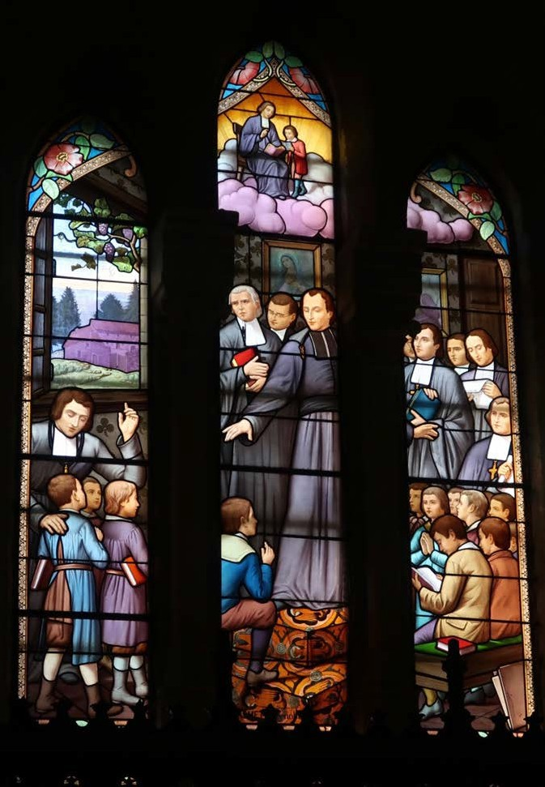God, you gave us Marcellin Champagnat as a fine example of how ordinary people can do extraordinary things when they make use of the gifts they have been given. In the same way, you expect us to use the gifts that you have given us so that we can make you present to the world. Help us to invite you into our lives and to allow you to work through us to touch the lives of the people we meet and serve. Amen.
  - Marcellin’s Prayer with Mary O Mary, Holy Virgin, my Sovereign Lady, I place myself under your protection. To you I commend the
special care of my whole being and throw myself with confidence on your mercy. I consecrate and confide to your maternal care my soul and body, this day, every day, and at the hour of my death. To you I commit all my hopes and consolations, my distresses and miseries, my life and its end, that through your most
holy intercession and your precious merits, I may constantly perform my actions, and dispose all things according to your will and that of your Son. Amen.

The Salve Regina
Hail Holy Queen
Hail Holy Queen, Mother of Mercy, our life our sweetness and our hope. To you do we cry, poor banished children of Eve; to you do we send up our sighs, mourning and weeping in this valley of tears. Turn then, most gracious advocate, your eyes of mercy toward us and after this our exile show unto us the blessed fruit of your womb, Jesus. O clement, O loving, O sweet Virgin Mary!

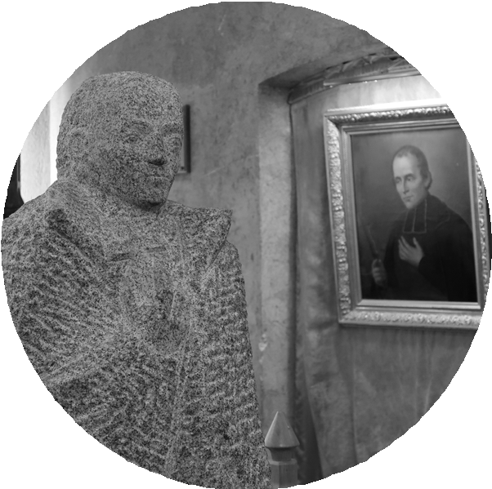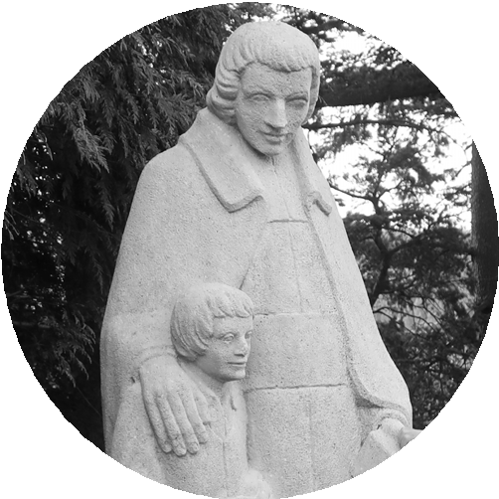

Mary, Our Good Mother
Mary, Our Good Mother, Mother of Jesus and Mother of the Church, walk with us now, sharing our joys and sorrows, our successes and failures. In our daily living, show us your Son, who lives in us. Help us to listen to Him, to act on His Word and do our part in building the kingdom of justice and peace. May we be all united in the fullness of His Kingdom forever. Amen.

Signed by the Spirit
God, creator and lover of the world, we offer to you our lives, our words and deeds, our hopes and fears, and our love for each other. Accept us as we are and make us what we shall be. Mary, you imagine for us the perfection of the church. You shine forth on earth, until the day of the Almighty One shall come, as a sign of sure hope and solace for the pilgrim people of God and for all your Marist sons and daughters. By the power of the Spirit, enable us to be a sign of your presence in the world so that through us others may come to consider the call to service.

Sent on Mission
We thank you, God, for all your gifts. Give us faith and conviction to meet the challenges of our world, inner peace in the face of misunderstanding and difficulty, and courage to accept all that is painful in our lives so that we might bring love and compassion to those with whom we live and work. Mary, mother and model, from the beginning we were given your name and taught to live your spirit. Ordinary Resource and First Superior, you inspire our ways of being and acting. Be for us as you were for Champagnat - guiding, caring, ever-present mother. We thank you for all who have followed Champagnat in his commitment to education and the poor, and for God’s love and concern which they reflect. Bless them and theirs and those they serve, wherever they are and whatever they do, now and always. Amen.

Dedication of the Day
Good and gracious God, I give you my hands to do your work today. I give you my feet to go your way.
I give you my eyes to see as you do. I give you my tongue to speak your words. I give you my mind that you may pray within me. Above all, I give you my heart that you may love within me. I give you my whole self that you may grow within me. It is always you, my God, who lives and works and prays within me. Blessed be your name throughout this day. Amen.

References: www.Champagnat.org and www.Jesuitresource.org

Words on Human Dignity

Pope Francis’ Reflections on Human Dignity

Introduction
The following are some direct words from the Holy Father from his recent book Let Us Dream – the Path to a Better Future (2021). In Part Three of the book, A Time to Act, he speaks at length on the role dignity plays for guiding all of humanity in a post-Covid world. It is a book to be read, shared, and discussed personally and in community with colleagues. It is a direct invitation from Francis to join in this plan for a better future for our planet and all of creation. These quotes may be a helpful way to reflect upon the theme of Known and Loved
– Dignity for All for your community.

Pope Francis speaking to us:
“In time of crisis and tribulation, when we are shaken out of our sclerotic habits, the love of God comes out to purify us, to remind us that we are a people. Once we were not a people; but now we are God’s people (1 Peter 2:10). The closeness of God calls us together. This time for action asks us to recover our sense of belonging, the knowledge that we are part of a people.” (Let Us Dream, p.97)
“When I speak of the dignity of the people, I mean this awareness that arises from the people’s ‘soul’, from its way of looking at the world. Where does that dignity come from? Does it stem from a people’s wealth, it’s victories in war? Such achievements may be the source of pride, or even arrogance. But the dignity of a people – even the poorest, most wretched, enslaved people – comes from God’s closeness. It is God’s love and closeness that confer dignity, and always raise up a people, offering it a horizon of hope.” (p.103).
“Jesus came to strengthen and deepen the bonds of belonging – of the people of God and to each other. That is why the one who matters most in the kingdom of God is whoever makes him/herself the least, serving others, and especially the poor.” (p.105)
“When I speak of solidarity I mean much more than then promotion of philanthropic works or financial assistance to help those who lose out. Because solidarity is not the sharing of crumbs from the table, but to make space at the table for everyone. The dignity of the people calls for communion: for the sharing and multiplying of goods, and for the participation of all for the sake of all.” (p. 111)
“The heart of Christianity is God’s love for all peoples and our love for our neighbours, especially those in need. To recover the dignity of the people we need to go to the margins of our societies to meet all those who live there. Hidden there are ways of looking at the world that can give us all a fresh start. We cannot dream of the future while continuing to ignore the lives of practically a third of the world’s population rather than seeing them as a resource.” (p.119)
“Jesus’ preaching evoked in them ancient promises they carried in their guts, in their blood: an ancestral awareness of God’s closeness in the way He spoke and touched and healed, Jesus showed that awareness was real. He opened for them a path of hope into the future, a path of liberation that was not merely political but something more: a human liberation, that conferred that dignity that only the Lord can give us. That’s why they followed Jesus. He gave them dignity.” (p.123)
“By making the restoration of our people’s dignity the central objective of the post-Covid world, we make everyone’s dignity the key to our actions. To guarantee a world where dignity is valued and respected through concrete actions is not just a dream but a path to a better future.” (p.133)

“Certainly the most decisive turning points in world history are substantially co-determined by souls whom no history book ever mentions.”
- Edith Stein

Electronic Resources

Electronic Resources

Video 1:

Introducing Known and Loved
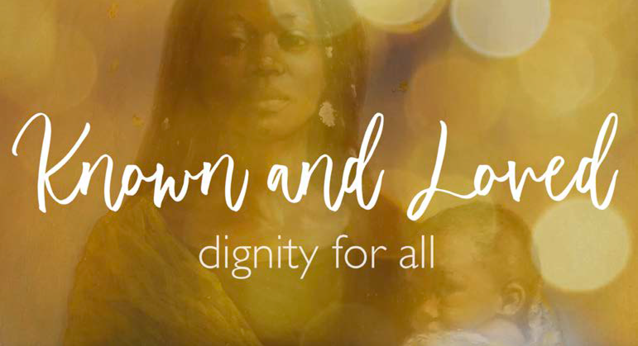

Video 2:

A Child’s Prayer: Be Kind

PowerPoint and Keynote Templates:
