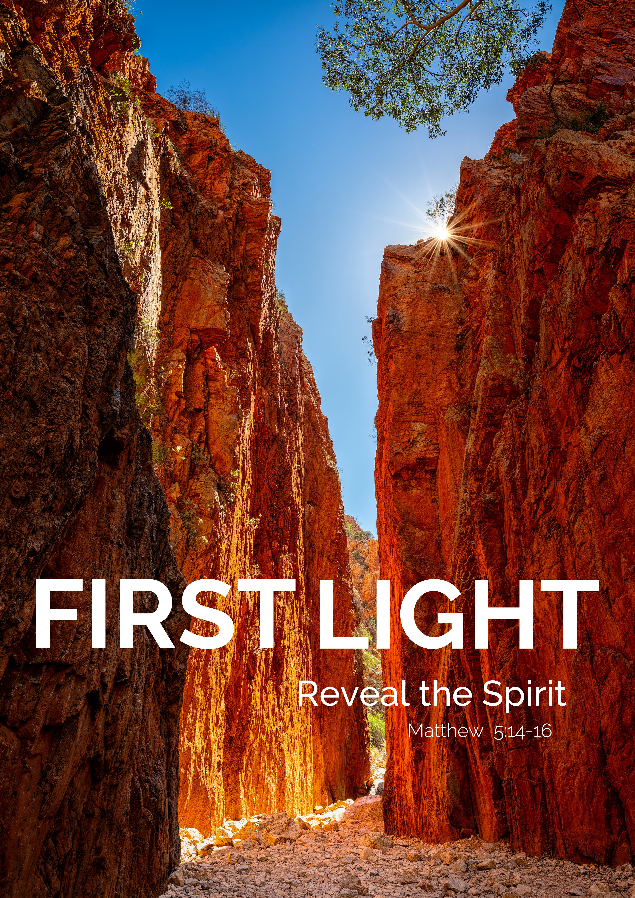

THEME RESOURCES 2024

Contents
Image Reflection 3
Theme Reflection 4
Beginning of Year Mass 5
Student Prayer Reflections
Breathe the Spirit of Life – Prayer Meditation 16
Gifts of the Spirit 17
God’s Light in Us 19
Shine Your Light 20
The First Light of Sunrise 21
With the Gifts of the Holy Spirit 23
Prayer to the Holy Spirit 24
A Prayer for the Year Ahead 25
Any-day Classroom Prayer 26
Short Prayers to Begin the Day 27
School/Class Liturgy
First Light: Reveal The Spirit 28
Staff Prayer Reflections
Beginning of a New Year 30
The Light of the World 31
First Light: Dawning Moments 32
Media Resource
I See You – I am here 34
Music Suggestions to Accompany the 2024 Theme 36

Image Reflection
God is revealed uniquely to each of us and just as the light falls on each rock in this 80-metre chasm, so too the Holy Spirit illuminates and reveals God’s presence to us – in the world and in each one of us.
The light and passageway of Standley Chasm draws you in, like a natural cathedral, but also invites you to look around the corner and explore further. The photographer,
Nick Psomiadis describes the scene … the sheer cliffs glowing in sunlight, a spectacular scene to behold as the sun passes over the chasm.
It took Nick three days to achieve this photo because the chasm only receives light directly at a particular moment. You can notice the presence of light as the narrow vista changes colour at dawn, but the full strength of the sun is only at an appointed time of the day.
The notion of visibility and invisibility is central to Aboriginal thinking and rays of light that rouse the spirit is central to their spirituality. Standley Chasm is known traditionally as Angkerle Atwatye, meaning ‘Gap of Water’ and is a place of deep
cultural significance to Western Arrernte people as a sacred site of women’s dreaming and birthing.
The chasm was later named after Ida Standley, the first school teacher in the West MacDonnell Ranges. For fifteen years, Ida Standley was the only government teacher in Central Australia and helped to give Aboriginal children a basic education. Ida was highly respected and described by the press as the ‘beloved lady’.

FIRST LIGHT Reveal the Spirit Matthew 5:14-16

In a classical rabbinic story, the teacher asks the disciples: “When do you know it is dawn?” One says, “when you can distinguish a white thread from a black one.” “No,” says the teacher. “When you can see the outline of a tree against the horizon,” ventures another. “No,” says the teacher — to this and all other efforts to answer the question. Finally, he says, “when you can look into the eyes of an ‘other’, a stranger, and see a brother or a sister, then it is dawn. Until then, it is still night.”
The theme FIRST LIGHT invites us to recognise the world as the place in which we discover God. God’s Spirit is in Creation. The first words of God were “Let there be light” (Gen 1:3), and with that our world dawned into
existence. We can recognise and experience God’s Spirit through the beauty and goodness of everything that the world holds and reveals, the spring buds on a tree, the warmth of the sun on your face, the sharing of a meal at a soup kitchen on a winter’s day, in the eyes of a stranger. Everything reveals the presence of God (1 Cor 10:26).
At times God’s Spirit can appear in dramatic bursts of light – through the brilliance of an electric sunrise that makes you fall momentarily still – when you recognise that the earth is indeed ‘charged’ with the glory of God!1 Often though, it may appear without much fanfare; a small act of kindness, an unexpected word of affirmation from a classmate, a healing gesture of forgiveness. For the prophet Elijah, God’s Spirit was experienced in the hush of a gentle breeze (1 Kings 19:12).
Sometimes it may be revealed in the darkest night when the weight of the world feels heaviest. Even the smallest light within us can shine brightest in the darkest times (2 Cor 4:6). We find further encouragement in the words of St Paul who reminds us that “everything brought into the light becomes light!”. Everything can be transformed into light.
This light is the dwelling of the Holy Spirit within each one of us, and if we can recognise the goodness and beauty within, it helps us to see it in others. It is said that we don’t see things as they are, but we see things as we are.
Eckhart Tolle wrote: “You do not become good by trying to be good, but by finding the goodness already within you, and allowing that goodness to emerge.” Through an awareness of the goodness within ourselves – God’s Spirit breathing through us – we too are transformed, and we become a gift of God’s light for the world. We are changed, and the world is changed by us.
Saint Marcellin Champagnat believed that God’s Spirit was always present and at work in the world, inspiring his mission and giving strength to his purpose. It is this gift of the Spirit that we as Marists want to share with others, the young, our colleagues, the stranger – of bringing people into the joy and freedom of the light of Christ – the Source of all Light:
“I am the Light of the world. Whoever follows me will never walk in darkness, but will have the Light of life.” (Jn 8:12)
We pray that the Holy Spirit illuminates our minds and hearts to recognise and know God’s presence in the breath-taking and ordinary encounters of our life. We pray that our lives will be transformed by God’s Spirit, making known the presence of God in the world and within us:
“You are the light of the world ... let your light shine.” (Mt 5:14-16) When do you know that it is dawn?
How is God’s Spirit being revealed to you?
Tony Clarke
Director, Mission and Life Formation

Beginning of School Mass 2024

It is suggested that School Leaders be invited to read the Acknowledgment of Country and Introduction.

ACKNOWLEDGEMENT OF COUNTRY:
Reader 1: As a Marist community, we acknowledge and pay our respects to the <Insert Name e.g. Whadjuk people of the Noongar Nation>, the traditional custodians of the sacred ground upon which we gather to pray today. We acknowledge any Aboriginal or Torres Strait Islander people present here today, and give thanks for their care of the earth and their leadership over thousands of years. We commit ourselves to walking with First Nations people in the spirit of ongoing understanding, reconciliation, and healing.

INTRODUCTION:
Reader 2: The 2024 Marist theme FIRST LIGHT invites us to recognise the world as the place in which we discover and know God. God’s Spirit is revealed through creation. The first words of God in the Genesis story in the Bible were “Let there be light”, and with that we understand that the universe came into being. As a member of this Marist school community, you are invited to recognise and experience God’s Holy Spirit through the beauty and goodness of everything that the world holds and reveals.
Saint Marcellin Champagnat believed that God’s Spirit was always present and at work in the world, inspiring his mission and giving strength to his purpose. It is this gift of the Spirit that we, as Marists, want to share with others, bringing people into the joy and freedom of the Light of Christ, the Source of all Light.
We pray that the Holy Spirit illuminates our minds and hearts to recognise and know God’s presence in the breath-taking and the ordinary encounters of our life. We pray that our lives will be transformed by God’s Spirit, making known the presence of God in the world and within us.
Please stand and join in the gathering hymn as we begin our Mass.

Gathering Hymn: [Local choice]

INTRODUCTORY RITES: [please stand]
It is suggested that School Leaders be invited to read the Acknowledgment of Country and Introduction.

Priest: In the name of the Father, and of the Son, (+) and of the Holy Spirit.
ALL: Amen.
Priest: The grace of our Lord Jesus Christ, and the love of God, and the communion of the Holy Spirit be with you all.
ALL: And with your spirit.
Priest: Sisters and brothers, let us acknowledge our sins,
and so prepare ourselves to celebrate the sacred mysteries.
Lord Jesus, you have revealed yourself as the way to the Father: Lord, have mercy.
ALL: Lord, have mercy.
Priest: You have poured out on your people the Spirit of truth: Christ, have mercy.
ALL: Christ, have mercy.
Priest: You are the Good Shepherd, leading us to eternal life: Lord, have mercy.
ALL: Lord, have mercy.
Priest: May almighty God have mercy on us,
forgive us our sins,
and bring us to everlasting life.
ALL: Amen.

Opening Prayer
Priest: Let us pray.
O God, who have taught the hearts of the faithful by the light of the Holy Spirit,
grant that in the same Spirit we may be truly wise and ever rejoice in his consolation.
Through our Lord Jesus Christ, your Son,
who lives and reigns with you in the unity of the Holy Spirit, God, for ever and ever.
ALL: Amen.

LITURGY OF THE WORD: [please sit]
First Reading: A reading from the book of Genesis (Gen 1: 1-6)
God saw all he had made, and indeed it was good.
In the beginning God created the heavens and the earth. Now the earth was a formless void, there was darkness over the deep, and God’s Spirit hovered over the water.
God said, ‘Let there be light’, and there was light. God saw that light was good, and God divided light from dark- ness. God called light ‘day’, and darkness he called ‘night’. Evening came and morning came: the first day.
The Word of the Lord.
ALL: Thanks be to God.

Responsorial Pslam (Psalm 26:1, 4, 8-9, 13-14)
Response: The Lord is my light and my salvation.
The Lord is my light and my help, whom shall I fear?
The Lord is the stronghold of my life;
before whom shall I shrink? R.
There is one thing I ask of the Lord, for this I long,
to live in the house of the Lord, all the days of my life,
to savour the sweetness of the Lord,
to behold his temple. R.
It is your face, O Lord, that I seek; hide not your face.
Dismiss not your servant in anger;
you have been my help. R.
I am sure I shall see the Lord’s goodness in the land of the living.
Hope in him, hold firm and take heart.
Hope in the Lord! R.

Gospel Acclamation: (John 8: 12)
Alleluia, alleluia!
I am the light of the world, says the Lord; whoever follows me will have the light of life. Alleluia!

Gospel (Matthew 5:13-16)
You are the light of the world.
Priest: The Lord be with you.
ALL: And with your Spirit.
Priest: A reading form the holy Gospel according to Matthew.
ALL: Glory to you O Lord.

Jesus said to his disciples: ‘You are the salt of the earth. But if salt becomes tasteless, what can make it salty again? It is good for nothing, and can only be thrown out to be trampled underfoot.
‘You are the light of the world. A city built on a hill-top cannot be hidden. No one lights a lamp to put it under a tub; they put it on the lamp-stand where it shines for everyone in the house. In the same way your light must shine, so that, seeing your good works, they may give praise to your Father in heaven.
The Gospel of the Lord
ALL: Praise to you, Lord Jesus Christ.

HOMILY: [please sit]

The Prayer of the Faithful
Priest: God’s Spirit is the source of our strength, our light and our hope. With confidence, let us bring our prayers before the Lord.
Reader: For the Church. Guided by the light of Christ, that all Christians reveal the Spirit of God through their words and actions. We pray to the Lord.
ALL: Lord hear our prayer.
Reader: For our Church and Civic Leaders. That those who are called to this vocation are inspired by the Holy Spirit to lead with justice, mercy and compassion. We pray to the Lord.
ALL: Lord hear our prayer.
Reader: For the needs of the world. That we seek a just society where wealth is shared, the sick and vulnerable are cared for and the environment is protected. We pray to the Lord.
ALL: Lord hear our prayer.
Reader: For Marist communities. That all young people educated in Marist communities across the world retain a vibrant hope for the future, be touched by God’s immense love and seek a spirituality centred in Christ. We pray to the Lord.
ALL: Lord hear our prayer.
Reader: For our own school community. That we be ever more fully instruments of Christ’s light and love in the world. We pray to the Lord.
ALL: Lord hear our prayer.
Priest: God of peace, you are all light, and in you there is no darkness. Let your light shine upon all for whom we pray today, and may we walk gladly in your ways.
We ask this through Christ our Lord.
ALL: Amen.

THE LITURGY OF THE EUCHARIST
Offertory Hymn: [Local choice]

Prayer over the Offerings [please stand]
Priest: Pray, sisters and brothers, that my sacrifice and yours may be acceptable to God, the almighty Father.
ALL: May the Lord accept the sacrifice at your hands for the praise and glory of his name,
for our good and the good of all his holy Church.
Priest: Sanctify, we pray, O Lord, the offerings made here, and cleanse our hearts by the light of the Holy Spirit. Through Christ our Lord.
ALL: Amen.

The Eucharistic Prayer
Eucharistic Prayer II, Preface I of the Holy Spirit: The sending of the Spirit by the Lord upon the Church.
Priest: The Lord be with you.
ALL: And with your spirit.
Priest: Lift up your hearts.
ALL: We lift them up to the Lord.
Priest: Let us give thanks to the Lord our God.
ALL: It is right and just.
Priest: It is truly right and just, our duty and our salvation, always and everywhere to give you thanks,
Lord, holy Father, almighty and eternal God, through Christ our Lord.
Ascending above all the heavens and sitting at your right hand,
he poured out the promised Holy Spirit on your adopted children.
Therefore, now and for ages unending, with all the host of Angels,
we sing to you with all our hearts, crying out as we acclaim:

ALL: Holy, Holy, Holy Lord God of hosts.
Heaven and earth are full of your glory. Hosanna in the highest.
Blessed is he who comes in the name of the Lord.
Hosanna in the highest. [please kneel/sit]

Priest: You are indeed Holy, O Lord, the fount of all holiness.
Make holy, therefore, these gifts, we pray,
by sending down your Spirit upon them like the dewfall, so that they may become for us
the Body (+) and Blood of our Lord, Jesus Christ.
At the time he was betrayed
and entered willingly into his Passion,
he took bread and, giving thanks, broke it, and gave it to his disciples, saying:
Take this, all of you, and eat of it, for this is my Body,
which will be given up for you.
In a similar way, when supper was ended, he took the chalice
and, once more giving thanks, he gave it to his disciples, saying:
Take this, all of you, and drink from it, for this is the chalice of my Blood,
the Blood of the new and eternal covenant which will be poured out for you and for many for the forgiveness of sins.
Do this in memory of me.
The mystery of faith.

ALL: Save us, Saviour of the world,
for by your Cross and Resurrection you have set us free.

Priest: Therefore, as we celebrate
the memorial of his Death and Resurrection, we offer you, Lord,
the Bread of life and the Chalice of salvation, giving thanks that you have held us worthy
to be in your presence and minister to you.
Humbly we pray
that, partaking of the Body and Blood of Christ, we may be gathered into one by the Holy Spirit.
Remember, Lord, your Church, spread throughout the world,
and bring her to the fullness of charity,
together with Francis our Pope and N our Bishop
and all the clergy.
Remember also our brothers and sisters
who have fallen asleep in the hope of the resurrection, and all who have died in your mercy:
welcome them into the light of your face. Have mercy on us all, we pray,
that with the Blessed Virgin Mary, Mother of God, with blessed Joseph, her Spouse,
with the blessed Apostles,
and all the Saints who have pleased you throughout the ages, we may merit to be coheirs to eternal life,
and may praise and glorify you through your Son, Jesus Christ.
Through him, and with him, and in him, O God, almighty Father,
in the unity of the Holy Spirit, all glory and honour is yours, for ever and ever.
The mystery of faith.
ALL: Amen.

The Communion Rite [please stand]
Priest: At the Saviour’s command
and formed by divine teaching, we dare to say:
ALL: Our Father who art in heaven, hallowed be your name;
your kingdom come, your will be done
on earth as it is in heaven.
Give us this day our daily bread, and forgive us our trespasses,
as we forgive those who trespass against us; and lead us not into temptation,
but deliver us from evil.
Priest: Deliver us, Lord, we pray, from every evil, graciously grant peace in our days,
that, by the help of your mercy, we may be always free from sin and safe from all distress,
as we await the blessed hope
and the coming of our Saviour, Jesus Christ.
ALL: For the kingdom,
the power and the glory are yours now and forever.
Priest: Lord Jesus Christ,
who said to your Apostles:
Peace I leave you, my peace I give you, look not on our sins,
but on the faith of your Church,
and graciously grant her peace and unity in accordance with your will.
Who live and reign for ever and ever.
ALL: Amen.
Priest: The peace of the Lord be with you always.
ALL: And with your spirit.
Priest: Let us offer each other the sign of peace.

ALL: Lamb of God, you take away the sins of the world, have mercy on us.
Lamb of God, you take away the sins of the world, have mercy on us.
Lamb of God, you take away the sins of the world,
grant us peace. [please kneel/sit]

Invitation to Communion
Priest: Behold the Lamb of God,
behold him who takes away the sins of the world. Blessed are those called to the supper of the Lamb.
ALL: Lord, I am not worthy
that you should enter under my roof, but only say the word
and my soul shall be healed.

Communion Hymn: [Local choice] Thanksgiving Hymn: [Local choice]
Prayer After Communion [please stand]
Priest: Let us pray.
May the outpouring of the Holy Spirit cleanse our hearts, O Lord,
and make them fruitful by the inner sprinkling of his dew. Through Christ our Lord.
ALL: Amen.

THE CONCLUDING RITES
Blessing
Priest: May almighty God bless you,
the Father, and the Son, (+) and the Holy Spirit.
ALL: Amen.

Dismissal
Priest: Go in peace, glorifying the Lord by your life.
ALL: Thanks be to God.

Recessional Hymn: [Local choice]

Acknowledgements

The prayers of the Mass are from the Votive Mass of the Holy Spirit, Roman Missal p.1404. Responsorial Psalm from Lectionary III p.849.

The scriptural quotations are taken from the Jerusalem Bible, published and copyright © 1966, 1967 and 1968 by Darton, Longman and Todd Ltd. And Doubleday & Co Inc.

The prayers are from the English Translation of the Roman Missal © 2010 International Committee on English in the Liturgy Inc. (ICEL). All rights reserved.

Breathe the Spirit - Prayer Meditation
Instructions: This meditation is most effective when it is read slowly and reflectively. It can be led by the teacher or a suitable student(s). Students should be encouraged to adopt a comfortable position, ideally sitting up straight, both feet grounded, eyes closed and hands resting on their knees. Gentle instrumental music may be played in the background. The reader should be pausing at the four dots “.…”
Reader:
Scripture uses the imagery of ‘breath’ to describe how we can feel the presence of God in our lives, through the Holy Spirit. There is even an ancient Greek word for it: pneuma, (new-ma) which means both ‘breath’ and ‘spirit’.
We can imagine then, that when we breathe, we are taking the Spirit of God into our bodies. Breath prayer helps us physically experience God’s presence, bringing together the physical and spiritual parts of our lives.
Focusing on our breath slows down our breathing, which has the effect of slowing down and stilling our bodies. It gives us the stillness and silence to experience God’s goodness in our lives.
One way to engage in breath prayer is to imagine that as you breathe in, you are taking in the God’s Spirit of life and love. And, as you breathe out, you are filling the space around you with joy and peace.
Let us begin ….
In the Name of the Father, and of the Son, (+) and of the Holy Spirit. Amen.
As you become still, close your eyes and focus on your breathing. Take a deep breath to practice now; inhale slowly and feel your lungs fill with air …. and exhale, let that breath out again.
Repeat this action, slowly breathing in …. and breathing out …. Now, think about a person in your life who loves you .…
Recall what it is like receiving a hug or a smile from that person. Remember that feeling of love …. breathe in …. and breathe out ….
Breathe in and imagine this love is God’s love for you ….
Breathe out, and imagine you are sharing that same love with all those around you .... Breathe in .... feeling loved .... breathe out .... giving joy and peace ....
Continue your slow gentle breathing for a few minutes .... [teacher to determine length of time]
Slowly open your eyes and come back into the presence of the other people in the room. Wiggle your toes and fingers a little and become conscious of your body once again.
In the name of the Father, and of the Son, (+) and of the Holy Spirit. Amen.

Gift of the Spirit
Reader 1: Let us pause and remember we are in the holy presence of God.
In the name of the Father, and of the Son, (+) and of the Holy Spirit, Amen.
When we read the Gospels, we marvel at the words and deeds of Jesus and imagine what it would have been like to be one of his disciples. We don’t need to only imagine, because the risen Jesus co-missioned his disciples to continue his work after he had left them. To be co-missioned means we are sharing together in the mission of Jesus. Even today, we are co-missioned when we receive the gifts of the Holy Spirit, and in turn offer them to the world through how we live and relate to each other.
Let us pray:
Loving God,
We are always in need of your love and light.
Help us to be open to the gifts of the Holy Spirit that you give us so generously.
Give us the courage to share them with the people in our lives, especially all who are suffering.
ALL: Amen.

Reader 2: On the evening of that first day of the week, when the disciples were together, with the doors locked for fear of the Jewish leaders, Jesus came and stood among them and said, “Peace be with you!” After he said this, he showed them his hands and side. The disciples were overjoyed when
they saw the Lord. Again Jesus said, “Peace be with you! As the Father has sent me, I am sending you.” And with that he breathed on them and said, “Receive the Holy Spirit.” (John 20:19-23)

Reader 3: The Holy Spirit is given to each of us in a special way. To some people the Spirit gives a message of wisdom. To others the same Spirit gives a message of knowledge. To others the same Spirit gives faith. All the gifts are produced by one and the same Spirit. (1 Corinthians 12:7-11)
Consider the gifts of the Holy Spirit:
- Wisdom
- Understanding
- Good judgement
- Courage
- Knowledge
- Reverence
- Wonder and awe
Choose one of these gifts and spend a moment in silence to consider how you can use this gift to be the best classmate, friend, and family member you can be. Think of one thing you can do today, to use that gift to brighten someone else’s day.
(pause for 2 minutes: Students may wish to journal, write their idea on a post-it note for display somewhere in the classroom or near a prayer focus, or sit in silence.)

Reader 4: Let us pray:
18
Loving God,
Thank you for the many good things in my life. Fill me with an openness to receive your Spirit. When I am uncertain, grant me wisdom.
When I am confused, grant me understanding. When I am misled, grant me good judgement. When I am afraid, grant me courage.
When I am ignorant, grant me knowledge.
When I am separated from you, remind me of your loving presence.
When I am selfish, fill me with a sense of wonder for the beauty of your world. I ask this in the name of your son Jesus, who calls me to discipleship every day.

ALL: Amen.

Marist Litany
Mary Our Good Mother … pray for us.
St Marcellin Champagnat … pray for us.
St Mary of the Cross MacKillop … pray for us.
And let us always remember … to pray for one another.
In the name of the Father, and of the Son, (+) and of the Holy Spirit. Amen.

God’s Light in Us

Leader: In the name of the Father, and of the Son, (+) and of the Holy Spirit. Amen.
Reader 1: A reading from the Holy Gospel
according to St Matthew.
“You are the light of the world. A town built on a hill cannot be hidden. Neither do people light a lamp and put it under a bowl. Instead, they put it on its stand,
and It gives light to everyone in the house. In the same way, let your light shine before others, that they may see your good deeds and glorify God in heaven.” (Mt 5:14-16)
Reader 2: The light in each of us is the Spirit of
God living in us.
How can we make sure that our light shines for ourselves and for others?
[pause for 3 seconds]
Let us close our eyes and think about some ways we can do this.
[pause for 3 seconds]
Let us examine our hearts.
[pause for 3 seconds]
It cannot be light and dark in the same place. Light always breaks through darkness. When our problems or worries are brought
to the light, they can’t hide anymore. We must remember that we can always share our thoughts with God, our parents, or a friend.
[pause for 3 seconds]
Reader 1: We aim to be authentic.
[pause for 3 seconds]
We all know how important it is to be real and genuine in ourselves and in our relationships with others. Our light shines brightly when we show interest in other people, when we care about them and are willing to stand up for them when we need to.
[pause for 3 seconds]
19
Reader 1: It is easy to encourage others.
[pause for 3 seconds]
One way to let our light shine is to be an encouragement to the world. We are called to be a light in our world which is sometimes struggling, and to be the light shining for people who are suffering or sad.
[pause for 3 seconds]
Reader 2: God has given us an incredible gift
in God’s light which can glow within us and then shine out into the world. When we are our authentic selves, we demonstrate to the world that light is possible in the darkness.
As we shine our lights, let us be thankful for the opportunities we have, to be these beacons of hope for people and the world in which we live.
[pause for 3 seconds]
We pray with Mary who brought light into the world with the birth of Jesus.
Please join me in the prayer we know well:
ALL: Hail Mary, full of grace.
The Lord is with you.
Blessed are you among women,
and blessed is the fruit of your womb, Jesus.
Holy Mary, Mother of God, pray for us sinners, now and at the hour of our death.
Amen.
Marist Litany
Mary Our Good Mother … pray for us.
St Marcellin Champagnat … pray for us.
St Mary of the Cross MacKillop … pray for us.
And let us always remember … to pray for one another.
In the name of the Father, and of the Son, (+) and of the Holy Spirit. Amen.

Shine Your Light

Leader: Let us remember that we are always in the presence of an ever-loving God as we make the Sign of the Cross.
In the name of the Father, and of the Son, (+) and of the Holy Spirit. Amen.
Reader 1: Light to See:
Have you ever woken up in the middle of the night and fumbled in the darkness looking for the light switch? Some say this is like the journey of faith searching for God and meaning in life, and when you finally turn on the light you have discovered God, and you are able to ‘see’.
[pause for 3 seconds]
ALL: Lord, help us to have the eyes to see you alive in our world, all around us every minute of every day and for us to reflect this light for others.
Reader 2: Light of Delight:
It is in the flare of a firework and the flicker of a candle – the light of delight – that calls us to create celebrations and honour personal milestones. It encourages us to share happiness with those in our lives.
[pause for 3 seconds]
ALL: Lord, we pray and give thanks for the gift of our friends when we gather, the spark of laughter that ignites connections between kindred spirits and we gasp in awe at joy the experiences we share.

Reader 3: Light of Possibility:
“Let there be light!” Creation began with the possibility of an impossibility. Our hearts, minds and souls are eager to join in the act of dreaming something breathtaking into being.
[pause for 3 seconds]
ALL: Help us to be a light of possibility, of endless hope and goodness for our world, making God’s dream a reality through our little daily actions.
Reader 4: Light of Faith:
The beacon of faith illuminates our souls and fills the corner of our hearts where doubt and darkness might want to reside. God’s love for us embraces us when we are stubborn, scared or feeling down. The good news is that we cannot outdo or use up faith becomes it comes from an endless source.
[pause for 3 seconds]
ALL: Lord, continue to shine bright in our lives like the stars in the sky like a living hymn written in light. Help us to share this gift of faith with all we encounter in our school and wider community. We ask all these prayers through Christ Our Lord.
Amen.

Marist Litany
Mary Our Good Mother … pray for us.
St Marcellin Champagnat … pray for us.
St Mary of the Cross MacKillop … pray for us.
And let us always remember … to pray for one another.
In the name of the Father, and of the Son, (+) and of the Holy Spirit. Amen.

[Source: Hope Lyda, This Little Light of Mine, Eugene, Oregon: Harvest House Publishers, 2013]
20

The First Light of Sunrise

Leader: In the name of the Father, and of the Son, (+) and of the Holy Spirit. Amen.
Reader 1: This year’s Marist theme FIRST LIGHT invites us to recognise the world as the place in which we discover God, for God’s Spirit is seen and experienced in all of Creation.
Let us reflect – where do you see God’s Spirit in the world?
[pause for 5 seconds]
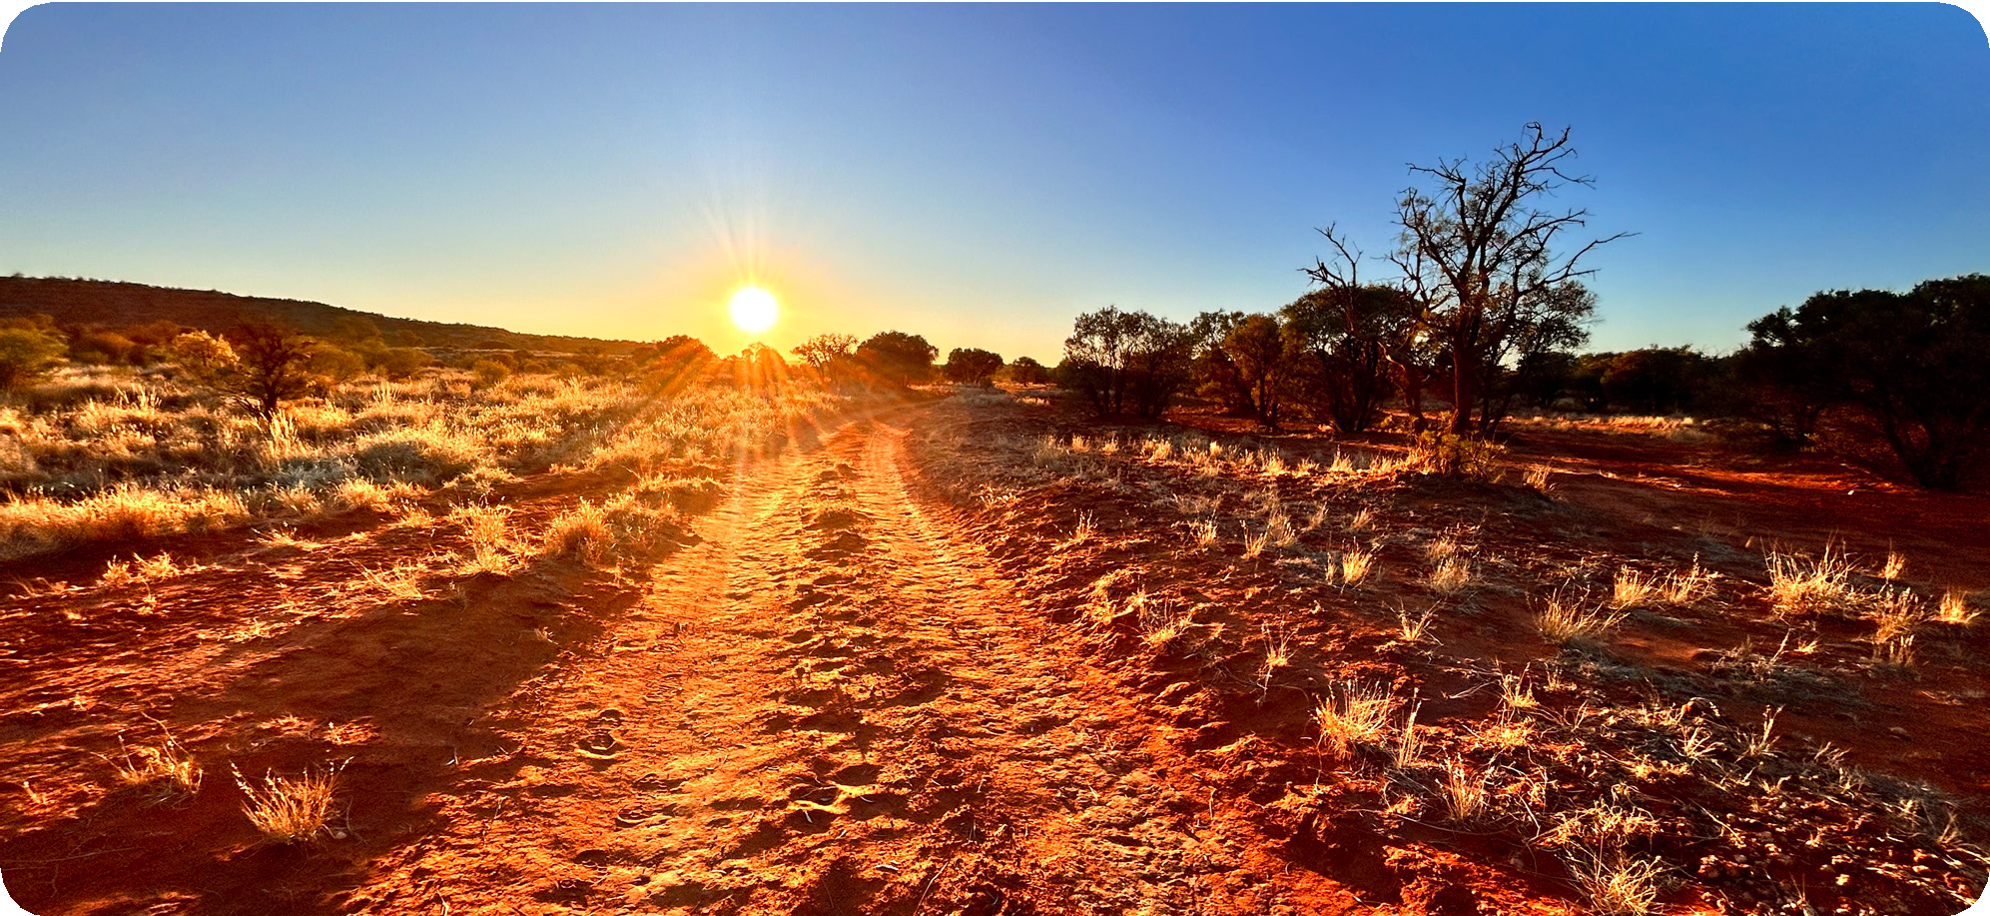
First Light, Santa Teresa, NT 2023

Reader 2: Have you ever watched the first light of a morning as the sun peers over the horizon illuminating the morning sky with its golden rays?
Where do you see God in the world?
[pause for 5 seconds reflecting on the image]
Reader 3: “Let there be light” are the first words God speaks in the Bible to bring light to a world covered in darkness.
Where do you hear God’s voice in the world?
[pause for 5 seconds]
Reader 4: Have you ever sat a on beach, gone for a walk and felt the warmth of the sun on your face?
Where do you experience God’s Spirit through the beauty and goodness of creation?
[pause for 5 seconds]
Reader 5: Often God’s Spirit appears in other ways without much fanfare; a small act of kindness, an unexpected word of affirmation from a classmate, a healing gesture of forgiveness.
Where have you felt this healing presence in your life recently?
[pause for 5 seconds]
21

Teacher: Let us pray for humanity; that despite the problems in our world even the smallest light shines bright in the darkest of times. As Christians we are encouraged by the words of St Paul who reminds us that, “everything brought into the light becomes light!” Everything can be transformed into light for our world revealing God’s loving spirit for all of creation.
[pause for 5 seconds]

We pray to our loving God that we each become ‘light’ for our world:
ALL: Our Father who art in heaven, hallowed be your name;
your kingdom come, your will be done
on earth as it is in heaven.
Give us this day our daily bread, and forgive us our trespasses,
as we forgive those who trespass against us; and lead us not into temptation,
but deliver us from evil.

Marist Litany
Mary Our Good Mother … pray for us.
St Marcellin Champagnat … pray for us.
St Mary of the Cross MacKillop … pray for us.
And let us always remember … to pray for one another.
In the name of the Father, and of the Son, (+) and of the Holy Spirit. Amen.

With the Gifts of the Holy Spirit

Leader: Let us remember that we are always in the presence of an ever-loving God as we make the Sign of the Cross.
In the name of the Father, and of the Son, (+) and of the Holy Spirit. Amen.

Reader 1: Holy Spirit, with your gift of Wisdom, I am able to recognise God working through everyone, everywhere.
Reader 2: With your gift of Understanding, I am able to apply reason
in the apprehension of truth, and to know how I am meant to live my life in accordance with Christ.
Reader 3: With your gift of Good Judgement, I am able to determine right and wrong, and to choose the right path.
Reader 4: With your gift of Courage, I am able to overcome fear, endure difficulties, and work towards the common good.
Reader 5: With your gift of Knowledge, I am able to understand God as best I can.
Reader 6: With your gift of Reverence, I am able to maintain a deep sense of respect for God, and for myself as a humble servant.
Reader 7: With your gifts of Wonder and Awe, I am able to be fully aware of God’s majesty and glory.
ALL: I am grateful to you, Holy Spirit, for all of these gifts which you have bestowed upon me. Amen.

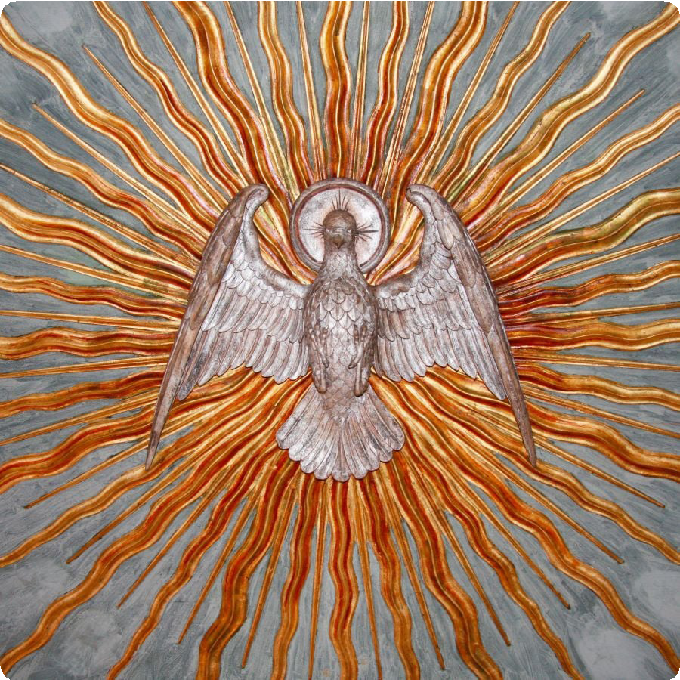
Marist Litany
Mary Our Good Mother … pray for us.
St Marcellin Champagnat … pray for us.
St Mary of the Cross MacKillop … pray for us.
And let us always remember … to pray for one another.
In the name of the Father, and of the Son, (+) and of the Holy Spirit. Amen.

The Seven Gifts of the Holy Spirit | Catholic Answers Magazine

[Source: www. champagnat.org/e_maristas/livros_recebidos/Marist_Illuminations_Prayer_Book_Vol_I.pdf]

Prayer to the Holy Spirit
(Based on Galatians 5:22-23 – The Fruit of the Spirit)
Leader: Let us remember that we are always in the presence of an ever-loving God as we make the Sign of the Cross.
In the name of the Father, and of the Son, (+) and of the Holy Spirit. Amen.

Reader: Trinity of love, may we bear the fruit of your Spirit:
R: Give us love, ALL: that boundless, healing energy that transforms the world.
R: Give us joy, ALL: because no darkness or evil can overcome you.
R: Give us peace, ALL: to quieten our hearts, and to free us from bitterness.
R: Give us patience, ALL: to go on following you even when it is hard.
R: Give us kindness, ALL: to reach out to our neighbour and to the person who needs to be loved.
R: Give us goodness, ALL: to give with a generous heart and without ulterior motive.
R: Give us faithfulness, ALL: to remain true to our commitments.
R: Give us gentleness, ALL: to respect the freedom and integrity of others.
R: Give us self-control, ALL: to see our weaknesses and overcome them in your strength.
R: Trinity of love, ALL: may we bear the fruit of your Spirit. Amen.

Marist Litany
Mary Our Good Mother … pray for us.
St Marcellin Champagnat … pray for us.
St Mary of the Cross MacKillop … pray for us.
And let us always remember … to pray for one another.
In the name of the Father, and of the Son, (+) and of the Holy Spirit. Amen.

[Source: https://www.maristbrothers.org.nz/spirituality/prayers-for-champagnat-marists-2/prayers-to-the-holy-spirit/]

A Prayer for the Year Ahead
Leader: We begin in the name of the Father, and of the Son, (+) and of the Holy Spirit. Amen.

Left side: Heavenly Father,
As I look towards the future Bright hope drives this prayer, For I know the plans
You have for me
Were wrought with divine care.
Right side: Holy Spirit, lead me.
Let me run at Your command, Yet be still and know that
You are God
When trouble is close at hand.
Left side: Our Word will be a lamp for me,
A guide to light my way,
A solid place to set my feet, A compass when I stray.
Right side: May I live my life to praise You,
Not for fortune, nor for fame, May everything I say and do Bring glory to Your name.
Left side: May my eyes stay fixed upon You
As I seek the way that’s pure, Tasting Your love and goodness Sleeping and rising secure.
Right side: Planted by Your living streams
I’ll delight in all Your ways, Hidden by Your sheltering wings With new mercies for each day.
Left side: Even in a dangerous land
When storms threaten to destroy,
At the cross I’ll stand upon the Rock
My Strength, my Hope, my Joy.
Right side: Dear Lord, show me Your favour,
At all times keep me blessed,
May Your face ever shine upon me,
With peace and perfect rest.
ALL: Amen.

Marist Litany
Mary Our Good Mother … pray for us.
St Marcellin Champagnat … pray for us.
St Mary of the Cross MacKillop … pray for us.
And let us always remember … to pray for one another.
In the name of the Father, and of the Son, (+) and of the Holy Spirit. Amen.

[Source: https://www.maristc.act.edu.au/newsletter-articles/a-prayer-for-year-12-2021]

Any-day Classroom Prayer
Following is an example of a template that can be adapted to suit the needs of everyday classroom prayer.
Lighting of a candle
A student is chosen to light a small candle in the classroom’s sacred space. The same student may also be the leader of the prayer time.
Prayer
Leader: Let us remember that we are always in the presence of an ever-loving God as we make the Sign of the Cross.
In the name of the Father, and of the Son, (+) and of the Holy Spirit. Amen. Let us pause in silence to thank God for all that is good in our lives.
[pause for 10 seconds]
We pray now for our own intentions, bringing to Jesus the needs of those in our lives, the needs of those in our community and the needs of others in the world.

Prepared Prayer
Include a short prayer that is pre-written by a student or taken from a prayer resource. Example:
Reader: God of us all,
we come before you
to make a simple offering of our lives to you.
In the events of this day
may we be attuned to receive your Word and respond generously as Mary did.
May the gifts that you continue to give us,
be a source of new life and hope to all we meet. Amen.
Traditional Prayer
[pause for 10 seconds]

Conclude with a traditional prayer such as the Our Father, Hail Mary, Salve Regina or other simple prayer that students are familiar with.
Example:
ALL: Our Father who art in heaven, hallowed be your name;
your kingdom come, your will be done
on earth as it is in heaven.
Give us this day our daily bread, and forgive us our trespasses,
as we forgive those who trespass against us; and lead us not into temptation,
but deliver us from evil.

Marist Litany
Mary Our Good Mother … pray for us.
St Marcellin Champagnat … pray for us.
St Mary of the Cross MacKillop … pray for us.
And let us always remember … to pray for one another.
In the name of the Father, and of the Son, (+) and of the Holy Spirit. Amen.

A Prayer of Marist Youth

Short Prayers to Begin the Day
The Salve Regina (Hail Holy Queen)

God, you gave us St Marcellin Champagnat as a fine example
of how ordinary people can do extraordinary things when they make use of the gifts they have been given.
In the same way, you expect us to use the gifts that you have given us so that we can make you present to the world.
Help us to invite you into our lives and to allow you to work through us
to touch the lives of the people we meet and serve. Amen.

Offering Our Day to God
God of us all,
we come before you
to make a simple offering of our lives to you.
In the events of this day
may we be attuned to receive your Word and respond generously as Mary did.
May the gifts that you continue to give us,
be a source of new life and hope to all we meet. Amen.

A Student Prayer
God, give us the courage to get through this day, the power to overcome any obstacles,
the heart to let us love those around us, the wisdom to accept other people, and the ability to make each day great.
God, protect those around us. Help me to help those in need and bless us all with your spirit.
God, give us your divine protection today, and always. Amen.
Hail Holy Queen, Mother of Mercy, hail our life our sweetness and our hope.
To you do we cry, poor banished children of Eve; to you do we send up our sighs,
mourning and weeping in this valley of tears. Turn then, most gracious advocate,
your eyes of mercy toward us and after this our exile
show unto us the blessed fruit of your womb, Jesus. O clement, O loving, O sweet virgin Mary.

The Lord’s Prayer
Our Father,
who art in heaven, hallowed be your name; your kingdom come;
your will be done on earth as it is in heaven. Give us this day our daily bread;
and forgive us our trespasses
as we forgive those who trespass against us; and lead us not into temptation,
but deliver us from evil. Amen.

Hail May
Hail Mary, full of grace. The Lord is with you.
Blessed are you among women,
and blessed is the fruit of your womb, Jesus. Holy Mary, Mother of God, pray for us sinners, now and at the hour of our death. Amen.

[Source: www.champagnat.org/e_maristas/livros_recebidos/Marist_Illuminations_Prayer_Book_Vol_I.pdf]

27

School/Class Liturgy

First Light: Reveal The Spirit
Preparation: Prepare a sacred space for the liturgy with a large candle as its centrepiece. The space should contain some symbols which represent the Catholic identity of the school community, for example – a Bible, a crucifix cross, a contemporary image of Mary, an image of St Marcellin Champagnat, a school crest, a Marist heart. These should be raised on plinths or blocks which are suitably covered if the original construction material is not aesthetically pleasant. A space is left beside each symbol for an additional candle/lantern. The 2024 Theme Image – First Light – is projected as a slide or displayed as a canvas.
Optional Song #1: You are the Light (Joshua Blakesley and Ed Cash)
Words and Music: Josh Blakesley and Ed Cash© 2010, 2012. All rights reserved. Administered at Spirit & Song®, a division of OCP, and CapitolCMGPublishing.com. Lyrics available HERE.
Optional Song #2: The Beatitudes (Mike Balhoff and Darryl Ducote)
Words: Mike Balhoff, Music: Darryl Ducote © 1973 Franciscan Communications Center © 1978 Damean Music. OCP. All rights reserved.
https://www.ocp.org/en-us/songs/6821/beatitudes
Opening Prayer
Leader: In the name of the Father, and of the Son, (+) and of the Holy Spirit.
ALL: Amen.
Leader: Ever-loving God, be with us as we place all that we are in your hands.
In our world today, we always look for the promise of a new dawn, and when the sun rises, we are once again blinded by your light and all its beauty. Today we gather to give thanks for the gift of Light in our lives, and for the people who are examples of the Light of Christ for us.
Reader 1: A reading from the Holy Gospel according to Saint Matthew (Mt 5:14-16)
“You are the light of the world. A town built on a hill cannot be hidden. Neither do people light a lamp and put it under a bowl. Instead, they put it on its stand, and it gives light to everyone in
the house. In the same way, let your light shine before others, that they may see your good deeds and glorify your Father in heaven.”
The Gospel of the Lord.
ALL: Praise be to you, Lord Jesus Christ.

Reader 2: The Lamplighter
Before the age of electricity, city streets were lit by gas lamps. Lamplighters lit these lamps with a flaming torch. One night an old man stood looking across a valley to a town on a hillside. He could see the torch of the lamplighter lighting lamps as he went. But because of the darkness, he could not see the lamplighter. He could see only his torch and the trail of lights he left behind.
The old man said to a friend standing next to him, “That lamplighter is a good example of how the Christian ought to live. You may never know them, but you know that they passed through the world by the trail of lights they leave behind.”
(Mark Link, SJ)

The Principal, a student leader, a teacher and a school officer, one at a time, process 4 x lanterns or large lit candles into the space. As each light is placed next to one of the symbols the text below is said.

Reader 1: For our school, may it continue to be a beacon of light to the students, teachers, staff, and parents involved in this community.

We pray to the Lord.
Response: Lord, hear our prayer.
[the light is placed beside one of the symbols]

Reader 1: For the Church, may it continue to bring light to those in darkness.
[the light is placed beside one of the symbols]
We pray to the Lord.
Response: Lord, hear our prayer.
Reader 1: For all the people who form the light of our school community, especially all who work in and for our school. Bless their work now and throughout this school year.
[the light is placed beside one of the symbols]
We pray to the Lord.
Response: Lord, hear our prayer.
Reader 1: For all the students, may we be the light of Christ in unity and support of one another in the classroom, in the yard, in our service and on our sporting fields.
[the light is placed beside one of the symbols]
We pray to the Lord.
Response: Lord, hear our prayer.

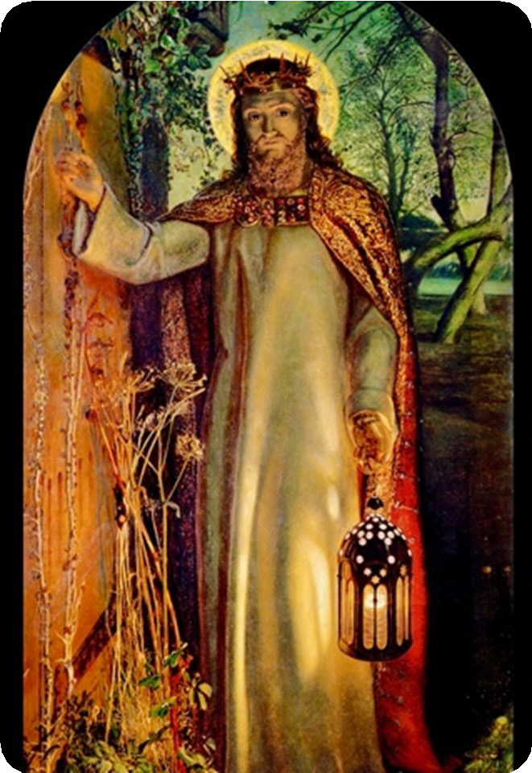
[A high quality image of the painting “Light of the World” by William Holman Hunt is shown on the screen.]
Reader 2: “Light of the World” is a phrase that Jesus used to describe himself and his disciples in the New Testament. This famous William Holman-Hunt
painting of the same name, “Light of the World”, is of Christ standing at the door of our lives.
Notice there is no door handle on the outside. This door, to the human heart, can only be opened from the inside. Jesus is always there, waiting for us to invite him in.
When Jesus enters our lives, we become light bearers in our communities.
Let us always remember that each of us carries the Light of Christ in our hearts; may we shine this light in all that we do, sharing what is good, and witnessing through our lives the love of Jesus.
ALL: Amen.

Marist Litany
Mary Our Good Mother … pray for us.
St Marcellin Champagnat … pray for us.
St Mary of the Cross MacKillop … pray for us.
And let us always remember … to pray for one another.
In the name of the Father, and of the Son, (+) and of the Holy Spirit. Amen.

Beginning of a New Year
Leader: Let us remember that we are always in the presence of an ever-loving God as we make the Sign of the Cross.
In the name of the Father, and of the Son, (+) and of the Holy Spirit. Amen.
Leader: Gracious God,
we thank you for calling us together to serve the students confided to our care.
We thank you for the opportunities you give us to create with you.
Our world is not perfect and so there are many occasions in which we can help to build up your Kingdom.
A Kingdom of justice and peace, of truth and love.
Reader 1: We thank you for the opportunity of being in solidarity with our students,
to provide opportunities for growth, to support their creativity,
to experience their brokenness, to challenge their values
to cultivate their generosity.
Reader 2: St. Marcellin reminds us that if we
wish to educate young people we must love them, and love them all equally.
We ask that we may have the wisdom and patience, the courage and perseverance, to love, guide, support and challenge our students as you need us to.
We ask this through the intercession of Mary and St Marcellin.
ALL: Amen.

Marist Litany
Mary Our Good Mother … pray for us.
St Marcellin Champagnat … pray for us.
St Mary of the Cross MacKillop … pray for us.
And let us always remember … to pray for one another.
In the name of the Father, and of the Son, (+) and of the Holy Spirit. Amen.

[Source: maristbrothers.org.nz/assets/Uploads/Meeting-Prayers.pdf]

The Light of the World
Leader: In the name of the Father, and of the Son, (+) and of the Holy Spirit. Amen.
Reader: Behold,
I am the Light of the World,
I’m standing at your closed door which never opened before.
The hinges rusted, grass untamed surrounds it. Your soul,
has lost its simple inner trust, but, from today on, you must unbolt and let me in. I knock, although no latch, no lock can ever keep me outside;
no gate, no fence, no wall can hide you from my view –
I am your God. I want that you could make at last your own choice and upon hearing my voice
without hiding anything and welcome me.

An extract of the poem The Light of the World by Albina Kumirova (inspired by the Pre-Raphaelite painting above with the same title by William Holman Hunt, painted between 1851-1854)

Leader: Jesus told His followers to “let your light shine before others,” calling them to live an active faith, not a passive one. As part of our Marist community, we are encouraged to put our light on show and to take the opportunity to shine brightly for those around us, especially our young people in Marists schools.
God is light, and since God sent the Spirit to live inside us, so are we.
[pause]
We spend a moment contemplating how the Holy Spirit does reveal God’s presence and action in our lives.
[pause 30 secs]
God of light, continue to shine brightly in us and through us so that we may be models of faith to young people, to each other and to the world.
We ask this through the name of Jesus, who is Lord of Light.

ALL: Amen.

Marist Litany
Mary Our Good Mother … pray for us.
St Marcellin Champagnat … pray for us.
St Mary of the Cross MacKillop … pray for us.
And let us always remember … to pray for one another.
In the name of the Father, and of the Son, (+) and of the Holy Spirit. Amen.

First Light: Dawning Moments
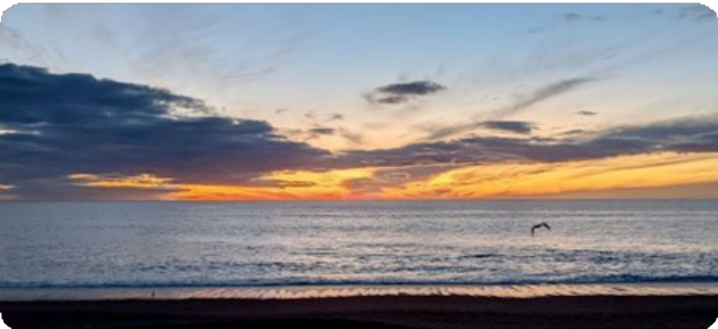
Image: First Light |Thursday September 28 2023 |Napier New Zealand.
Leader: In the name of the Father, and of the Son, (+) and of the Holy Spirit. Amen. Reader 1: In a classical rabbinic story, the teacher asks the disciples:
“when do you know it is dawn?” One says,
“when you can distinguish a white thread from a black one.” “No,” says the teacher.
“When you can see the outline of a tree against the horizon,” ventures another. “No,” says the teacher — to this and all other efforts to answer the question.
Finally, he says,
“when you can look into the eyes of an ‘other’, a stranger,
and see a brother or a sister, then it is dawn.
Until then, it is still night.”

Let us focus on the word ‘dawn’.
When something ‘dawns’ on you, the revelation often takes you by surprise. The ‘penny drops’, you see a new perspective, gain a fresh understanding or, simply, you are filled with a sense of awe.
We say things like “I get that now”, or “I can see that more clearly” or, sometimes, excitedly “I can see the light!”

For reflection:
Recall a moment when something has recently dawned on you…. what was the revelation? (Share in pairs for two minutes)

Reader 2: Thomas Merton (1915-1968) was an American Trappist monk, writer and theologian. He is widely recognised as an important 20th-century Catholic mystic and thinker. He shares an experience of a ‘dawn’ moment:
“In Louisville, at the corner of Fourth and Walnut, in the centre of the shopping district, I was suddenly overwhelmed with the realisation that I loved all these people, that they were mine and
I theirs, that we could not be alien to one another even though we were total strangers. It was like waking from a dream of separateness, of spurious self-isolation in a special world …
This sense of liberation from an illusory difference was such a relief and such a joy to me that I almost laughed out loud … I have the immense joy of being a member of a race in which God became incarnate. As if the sorrows and stupidities of the human condition could overwhelm me, now that I realise what we all are. And if only everybody could realise this! But it cannot be explained. There is no way of telling people that they are all walking around shining like the sun.
Then it was as if I suddenly saw the secret beauty of their hearts, the depths of their hearts where neither sin nor desire nor self-knowledge can reach, the core of their reality, the person that each one is in God’s eyes. If only they could all see themselves as they really are. If only we could see each other that way all the time. There would be no more war, no more hatred, no more cruelty, no more greed … But this cannot be seen, only believed and ‘understood’ by a peculiar gift.”
Thomas Merton, Conjectures of a Guilty Bystander (1966)

As we approach this day, and every day, let us remember as Saint Marcellin did, that the Spirit of God is always present and at work in the world - working in and through each of us.
May we constantly remind ourselves to take the time to allow God’s Spirit to be revealed to us through the ordinary moments and the ordinary people of the ordinary day.
ALL: Amen.

Marist Litany
Mary Our Good Mother … pray for us.
St Marcellin Champagnat … pray for us.
St Mary of the Cross MacKillop … pray for us.
And let us always remember … to pray for one another.
In the name of the Father, and of the Son, (+) and of the Holy Spirit. Amen.

TEACHER’S NOTES

Media Resource

I See You ... I Am Here

“Sawu Bona” is the Zulu equivalent of “hello” in the English language. Literally translated, this word means “I See You.” If you lived in the northern parts of Kwazulu-Natal in South Africa, this is how someone would greet you. In turn, you would reply by saying “Sikhona,” which means “I Am Here.” Senge, indicates that the order of the greeting is fundamental to the premise of the Ubuntu philosophy; You must be seen before you can exist.
Our 2024 Marist theme, First Light – Reveal the Spirit, encourages reflection on how we see our brothers and sisters in Australia, across the eleven countries in our Star of the Sea Marist Province and the wider world.
Pope Francis reminds us:
If every human being possesses an inalienable dignity, if all people are my brothers and sisters, and if the world truly belongs to everyone, then it matters little whether my neighbour was born in my country or elsewhere… Prepare our hearts to encounter our brothers and sisters, so that we may overcome our differences found in political thinking, language, culture and religion.
(Fratelli Tutti 125, 254)
The future of humankind isn’t exclusively in the hands of politicians, of great leaders, of big companies. Yes, they do hold an enormous responsibility. But the future is, most of all, in the hands of those people who recognise the other as a ‘you’ and themselves as part of an ‘us.’
(Pope Francis - ‘Why the only future worth building includes everyone’ 2017)
Play the ‘I See You’ media clip. The three reflection questions are embedded in the media clip. Students are encouraged to respond to the questions with follow up class discussion.
Download Media Link HERE
Reflection Questions:
- How do you see yourself as part of the human family?
- What would our neighbours see in this Marist community?
- Name some of the small things we can do to show love to those in need.
Music Track background:
‘Small Things’ speaks to our longing for divine connection while also validating our human experience. Bella Taylor Smith invites us to nestle into God’s warm embrace, allowing His tender mercies and compassion to envelop us with each note on the piano.
The lyrics of ‘Small Things’ remind us that God’s love can be found in the smallest of details, the most subtle whispers, and the flicker of grace-filled light. As the message of this song begins to penetrate our hearts, we realise that His love can be found in the most unexpected places in our lives. Related scripture: 1 Corinthians 1:27-28; Matthew 6:33; Psalm 46:10

[Source: https://www.christiandance.eu/2023/09/small-things-by-bella-taylor-smith.html]

Music Track
Small Things
Sung by Bella Taylor Smith (EMI Recorded Music Australia Pty Ltd)
Tell me what I look like through your eyes Tell me did I ever cross your mind?
Wonder if I have to wonder why
There’s so many things that you could say
Why can’t you just come and set things straight? Tell me did you look the other way?
Chorus
They say it’s in the small things that I can see your love And I got all these big things and they’re messing me up
And maybe it’s perspective and that could change my mind And one day all these small things they will add up over time ‘Cause that happens all the time
Did you mean to teach me something new Or show me how to love the way you do?
Everyone keeps telling me you only want the best for me But that’s just something new to me that I believe
They say it’s in the small things that I can see your love But I’ve got all these big things and they’re messing me up
And maybe it’s perspective, and that could change my mind And start seeing the small things how they add up over time I know it will take some time
Once in a while when my heart stops beating I hear you say: “If you just keep breathing You’ll be alright promise I’m not leaving” Now I believe it
They say it’s in the small things That I can see your love
And I got all these big things and they still mess me up And I know it’s perspective
And that has changed my mind
Now I can see the small things how they add up over time It just takes a little time
One step and you’ll be fine

Music Suggestions to Accompany the 2024 Theme

I am the Light of the World (available in the collection ‘As One Voice I’ and at https://ocp.org/en-us) Text and music © 1978, 1979, Greg Hayakawa. Published by OCP. All rights reserved.
Lead, Kindly Light (available from https://www.giamusic.com/)
Text: St John Henry Newman. Music © 2001, Steven C. Warner. Published by World Library Publications. All rights reserved.
Stand in the Light (available from https://www.giamusic.com/)
Text and music © 2007, John Angotti and Kevin Page. Published by World Library Publications. All rights reserved.
You are the Light (available in the collection ‘Choose Christ’)
Text and music © 2015, Sarah Hart. Published by Spirit & Song®, a division of OCP. All rights reserved.
You are the Light (available in the collection ‘Choose Christ’ and at https://ocp.org/en-us)
Text and music © 2010, 2012, Josh Blakesley. Published by Alletrop Music (BMI). All rights reserved. Administered at Spirit & Song®, a division of OCP, and CapitolCMGPublishing.com. Used with permission.
You are the Light (available at https://ocp.org/en-us)
Text and music © 2001, Robert F. O’Connor, SJ. Published by OCP. All rights reserved.
Beatitudes (Let Your Light Shine) (available at https://www.ocp.org/en-us/songs/6821/beatitudes) Words: Mike Balhoff, Music: Darryl Ducote © 1973 Franciscan Communications Center © 1978 Damean Music. OCP. All rights reserved.

