Feast of Saint Marcellin Champagnat

School Resources 2023

CONTENTS PAGE

INTRODUCTION
Responding with Tenderness and Love in the World Page 3
ST MARCELLIN CHAMPAGNAT
The Story of St Marcellin Champagnat Page 4
STAFF PRAYERS
Marcellin’s Spiritual Testament Page 6
Marcellin’s Vision Page 7
Created + Called with Love Page 9
STAFF REFLECTIONS
Contemplation in Action Page 10
Feast of St Marcellin Champagnat Page 12
STUDNEY PRAYERS
Prayer for Our Marist Family Page 14
The Prayer of Marist Youth Page 15
A Prayer to St Marcellin Champagnat Page 16
Marcellin Champagnat, Our Model Page 17
Extended Prayer - Teacher Instructions Page 19
STUDENT REFLECTIONS
Stage 3 and above – Years 5 - 12 Page 24
Stage 4/5 – Years 11-12 Page 25
Stage 6 – Years 11-12 Page 27
MASS
Mass for the Feast of St Marcellin Champagnat Page 29
MUSIC
Music Suggestions Page 35

Responding with Tenderness and Love in the World
Doesn’t it feel good when you have a big clean- up or decide to organise something that’s been in a mess for quite a while? Shelves dusted, a garage neatly arranged, plants re-potted, kitchen cupboards relieved of out-of-date items. The
end product can be most satisfying, but if you’re anything like me you may not look forward to the project with as much smiling anticipation as the ever-smiling television show renovators. Perhaps you are able to develop all sorts of justifications about why the project might start next week, or the week after, or “when I have time.”
It’s just as well that we have a Pope who’s learnt to deal effectively with procrastination. In fact he specialises in forward, collaborative movement which involves the voices of many. The Catholic Church calls this a “synodal” way of acting. He gets people to help him “clean up the garage” by involving everyone with a stake in the outcome. Pope Francis’ repeated theme of mercy and the radical call to act with love and tenderness is his explanation of what this synodal way looks like. It’s obvious to anyone who sees him in action.
He practises being the face and hands and feet of mercy, trying to help you and me to understand clearly what kind of a revolution he is proposing.
He’s suggesting that a true conversion to the gospel message will look like love and mercy. Every day.
Each action. Your face and hands and feet. And your scorecard will showcase justice and fairness –no hasty judgement, discounting of certain people or selective hearing and vision.
Like any good leader, Pope Francis doesn’t oversimplify how we should achieve this revolution of love and tenderness by handing out the blueprint on business cards or oversimplifying it in a tweet. Each one of us has our own circumstances and family and friends, so we’re invited to make it real in those known places
and familiar relationships first, before reaching beyond. As we recall our own encounter with the risen Christ it surely reminds us of how we are changed for the better by this radical experience of love and intimacy. Those despondent disciples walking along the road to Emmaus didn’t expect what happened, and maybe we didn’t either.
How incredible that we have the opportunity to lead people to encounter the surprise and joy of a relationship with Jesus, even if that’s not what they are seeking?
The resources for assisting in the celebration of the Feast of St Marcellin which follow provide some terrific inroads to engage staff and students and young people of Marist schools, social and
solidarity works with the St Marcellin way of being and acting in the world. Fr Champagnat was a man of deep compassion and quick action, responding
to the revolution of his day with an educational antidote open to all.
He and his early followers knew what it meant to respond to others promptly and tenderly. Most likely your attraction to the Marist way means you feel called to respond in a similar way, and you find yourself living your journey of Christian responsiveness with a creative fidelity that inspires. I trust these resources equip you in your role and support God’s mission in your place of work.
Next time the garage needs a clean up, grab a friend – you might find the experience more satisfying when you share the load. And no doubt they’ll enjoy asking for the favour in return. A revolution in practice!

Br Michael Callinan fms Associate Director
Mission and Life Formation

The Story of St Marcellin Champagnat
The teacher sat at his place in front of the class and looked around for a boy to read to him.
His eye lit on a newcomer and he beckoned him to come up. Timidly, the child approached, but just as he arrived, another pupil pushed in front of him. The teacher reacted angrily, boxing the boy’s ears and sending him sobbing to the back of the room. The newcomer shook all over and, as he revealed much later, was more inclined to cry than to read. The incident shook him so badly, in fact, that he refused to return to school, despite the entreaties of his parents. Marcellin Champagnat’s first day in school was also his last.
Years later, applying to King Louis-Philippe in 1834 for legal authorisation for his congregation of teaching brothers, Fr Champagnat was to mention the lack of capable teachers in the country areas as the major reason for founding his brothers.
Joseph Benedict Marcellin Champagnat was born in the parish of Marlhes in the hill country of the Loire in south-east France on 20 May 1789. He was one of the youngest children of a farming family and, under normal circumstances, would probably have grown up to become a hardworking and successful farmer himself.
But the times were hardly normal. His first 10 years of life coincided with the decade of the French Revolution and its accompanying social and religious turmoil and revolutionary wars. When
he made his first communion in 1800 at the age of 11, the Church had just recovered relative freedom under the rule of Napoleon Bonaparte and was looking to replace the clergy decimated or scattered by the Revolution. Thus, the recruiter who came to Marlhes in the summer of 1803 was inclined to look with favour on this intelligent and pious youth, if unpromising student.
In his letter to the King, Champagnat revealed that he had learned to read and write only after making tremendous efforts. And to enter the seminary, he also needed to study Latin. He spent a year in nearby St Sauveur with his brother-in-law who tried to teach him Latin and ended up telling him he was wasting his time. And at the end of his first year in the minor seminary, he was told he did not have the talent to continue with his studies. Yet, with characteristic obstinacy and tenacity of purpose, he persevered and made sufficient progress over the years to enter the major seminary in Lyon in November 1813.
It was there that he became involved with a small group of seminarians, including one Jean-Claude Colin, who had the idea of forming a religious society dedicated to Mary, which would work for the renewal of the Church in France and for the spread of the Gospel in other parts of the world. This society would comprise men and women in vows and dedicated lay people working together under a common leadership. Champagnat’s contribution was to stress the need for catechist or teaching brothers and this became his responsibility.
Most of the group, the nucleus of what was to become the Society of Mary, were ordained in July 1816. Shortly after, on the 23rd of that month, they gathered at the famous Marian shrine of Fourvière, on the hill overlooking the city, and pledged themselves to work towards founding the new congregation.
Three weeks later, the new priest arrived in Lavalla, a small village in his home area, the centre of a sprawling and mountainous parish. France was once again recovering from crisis, the Napoleonic Wars and their aftermath, the effects visible in this parish in undermanned farms, demobilised soldiers, orphans, food shortages, and erratic schooling. So there was plenty of work for a young and energetic curate.
Children died young in that period, and it was the death of one, an adolescent almost entirely ignorant of his religion, that pushed Champagnat to set up what he hoped would be the brothers’ branch of the projected Society. On 2 January 1817 he was joined by two youths, virtually uneducated, one a 22 year old ex-soldier, the other a boy of 14, looking to join the Brothers of the Christian Schools. Within five years, he had eight brothers and two in training, running four schools and teaching catechism in the surrounding hamlets.
The parish priests of the area were happy to have reliable and inexpensive teachers for their schools, but bridled at the idea that an upstart curate could tell them how to run them. When that same upstart curate was released from parish work to commit himself full-time to the guidance of a growing religious congregation, undertaking the building of a monastic establishment capable of housing some 150, he faced a veritable storm of criticism, some even from his friends. He was judged imprudent, overambitious, full of pride, even crazy, to take on such a project with so few resources.
Over the years he had to face the mockery and obstruction of government officials, the opposition of diocesan authorities, the criticism and defections of priests working with him at the Hermitage, the opposition and defection of some of his senior brothers. Yet, time and again, he found the resources required – finances, recruits, patrons, authorisations – to solve a problem and continue with his work. And he had no doubt about the origin of those resources and that help. As he was to confide to Bishop Pompallier towards the end
of his life, in May 1838: “How powerful is the holy name of Mary! Mary – there you have the whole resource of our society”. Worn out from his labours, St Marcellin Champagnat died in June 1840. He left a congregation of 250 brothers teaching over 5,000 children in 43 establishments ranging from the far northwest to the southeast of France.
He died as a member of a Society of Mary registered and recognised by Rome, with nine of his brothers already on the other side of the world working with Marist priests in the evangelisation of the Pacific. The mustard seed had indeed become a flourishing tree.
We celebrate and thank God for St Marcellin Champagnat on 6 June.

Marcellin’s Spiritual Testament
In the name of the Father, and of the Son, and of the Holy Spirit. Amen.
Reader 1
In solidarity with the global Marist community, we pray in thanksgiving for the legacy and witness that Marcellin Champagnat has for us. Marcellin demonstrated that the gospel message of love and tenderness was truly a revolutionary response to the needs of the young in his time.
We listen to his final message, words that speak to us today.
Reader 2
… also, dear Brothers, I beg of you with all the love of my heart, and by all the love you bear me, keep ever alive among you the charity of Christ. Love one another as Jesus Christ has loved you. Be of one heart and one mind. Have the world say of the Little Brothers of Mary, what they said of the first Christians: ‘See how they love one another!’ That is the desire of my heart and my burning wish, at this last moment of my life. Yes, my dearest Brothers, hear these last words of your Father, which are those of our Blessed Saviour: ‘Love one another!
Pause for personal prayer and reflection
Together we pray
God, creator, and lover of the world;
we offer you our lives, our words and deeds, our hopes and fears, and our Christian love for one another.
By the power of the spirit,
and by the example of your servant St Marcellin Champagnat,
enable us to be a sign of your presence and love in the world;
called in our vocation to the education and welfare of the young people in our care.
Amen.
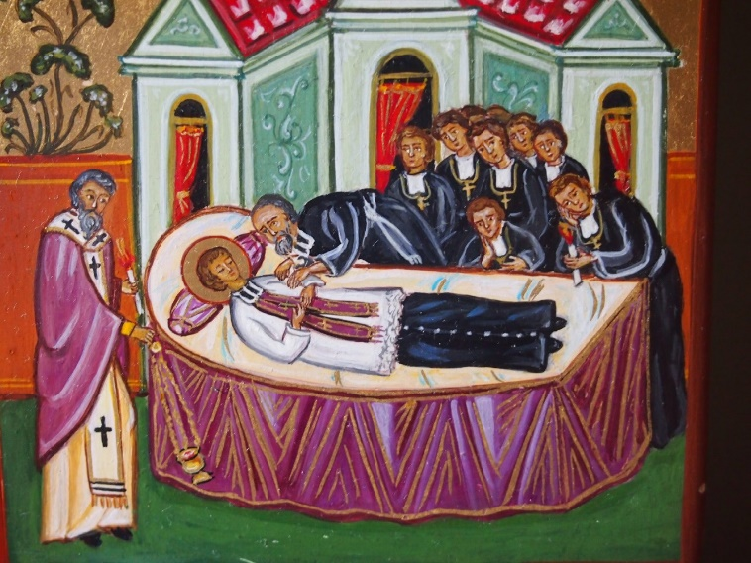
Mary Our Good Mother, pray for us.
St Marcellin Champagnat, pray for us.
St Mary of the Cross MacKillop, pray for us. And let us always remember to pray for one another.
In the name of the Father, and of the Son, and of the Holy Spirit. Amen.

Marcellin’s Vision
In the name of the Father, and of the Son, and of the Holy Spirit. Amen.
Reading
Champagnat, who encountered difficulties in his studies, who spent most of his life living in rural villages, who wore himself out until he died so that the children and young people could experience the love of God, is today an example which inspires not just the Marist family. The Church, by proclaiming him ‘saint’, has declared him to be a model for all Christians.
The Church recognises that the insight of Saint Marcellin continues to be alive in us today and that he is a gift of God for the world. The Marist mission is called upon to multiply itself until, in all the dioceses of the world, the children and young people experience God’s tenderness. As Marists, we believe that God calls us to carry on this insight in history as followers of Christ in the style of Champagnat.

Prayer: Marcellin’s Vision
God of rock,
in Marcellin Champagnat you give us a firm foundation, a guide and support in our work of education.
We ask you loving God to give us the courage, determination and zeal
that Marcellin showed in establishing the first Marist schools.
May Mary be for us as she was for Marcellin, the one who inspires our mission.
May we learn from her how to accompany with love, perseverance and discretion,
the young people who are confided to our care.
We make this prayer in the name of Jesus who teaches us about your love. Amen.
We pause in silent reflection to ponder our role in the lives of the young people in our care and how we might be inspired by the vision of St Marcellin
Pause for 30 seconds

We pray with Mary, who St Marcellin called ‘Our Good Mother’ as we say together:
Hail Mary, full of grace. The Lord is with you.
Blessed are you among women,
and blessed is the fruit of your womb, Jesus.
Holy Mary, Mother of God, pray for us sinners,
now and at the hour of our death. Amen

Mary Our Good Mother, pray for us.
St Marcellin Champagnat, pray for us.
St Mary of the Cross MacKillop, pray for us. And let us always remember to pray for one another.
In the name of the Father, and of the Son, and of the Holy Spirit. Amen.

Created + Called with Love

In the name of the Father, and of the Son, and of the Holy Spirit. Amen.
Reader
In his 2013 Apostolic Exhortation Evangelii Gaudium, Pope Francis reminded us of the central place of Mary in the mission of the Church:
“Whenever we look to Mary, we come to believe once again in the revolutionary nature of love and
tenderness. In her we see that humility and tenderness are not virtues of the weak but of the strong who need not treat others poorly in order to feel important themselves… Mary is able to recognize the traces of God’s Spirit in events great and small.” (EG288)
As you listen to the words of the poem “In Grace”, consider how the traces of God’s spirit may be appearing in your life presently, in events great and small.

In Grace
By Marlene Marburg, in An Ordinary Woman (2017)

God waits. Mary prays. Her veil falls.
At this moment there is no fear,
even though she does not know the outcome of her bearing towards God.
Her heart whispers yes to God-with-her,
yes,
compelling love.

Together we pray...
Star of the new evangelisation,
help us to bear radiant witness to communion, service, ardent and generous faith,
justice and love of the poor, that the joy of the Gospel
may reach to the ends of the earth, illuminating even the fringes of our world.

Mary Our Good Mother, pray for us.
St Marcellin Champagnat, pray for us.
St Mary of the Cross MacKillop, pray for us. And let us always remember to pray for one another.
In the name of the Father, and of the Son, and of the Holy Spirit. Amen.
Contemplation in Action
Reader 1
‘As Jesus and his disciples were on their way, he entered a village and a woman called Martha
welcomed him to her house. She had a sister named Mary who sat down at the Lord’s feet to listen to his words. Martha, meanwhile, was busy with all the serving and finally she said, “Lord, don’t you care that my sister has left me to do all the serving?” But the Lord answered, Martha, Martha, you worry and are troubled about many things, whereas only one thing is needed. Mary has chosen the better part, and it will not be taken away from her.’ (Luke 10:38-42)
Reader 2
Luke’s story of Mary and Martha of Bethany, sisters of Lazarus, teaches us about hospitality, service, action, contemplation…all qualities of being a true Marist. Martha and Mary welcome Jesus to their home, but they seek to welcome him in two different ways.
Martha’s response is very recognisable, especially by those familiar with Marist culture. “Bring out the coffee, the wine (what kind do you prefer?), get the glasses, china and silverware ready and enjoy our assortment of hot and cold snacks.” Whereas Mary thought that the supreme compliment that she could pay to Jesus, even more than tasty refreshments, was to give him her full attention.
St Marcellin Champagnat’s desire for his early brothers was to grow their spiritual consciousness and deepen their relationship with God while actively strengthening their compassionate engagement with the world. Hence our call
to be ‘contemplatives in action’. Action and contemplation do not exist one without the other.
Reader 3
Being Martha and Mary, not Martha or Mary can be a good lesson for us. We don’t have to choose. We can be both pray-ers and doers.
Like Martha, we are called to work hard serving others, especially the young people in our care, and we aim to do it with the spirit of Mary. It means having Martha’s reliable hands and Mary’s contemplative heart. The last thing Jesus would want would be for all of us merely to sit at his feet and allow everyone else to work to serve us.
That’s certainly not the Christian way or the way Jesus adopted. We know it is not the Marist way.
To conclude our prayer - you are invited to close your eyes. Pause.
Sit with the story of Mary and Martha. Stay with the image for a moment. Pause.
In our very busy lives, we are prone to have a bit more of Martha’s attitude. We invite God into our lives but get busy when God shows up. We don’t set up time to simply sit with God and listen. We stay busy, and even though the things we stay busy with are good, they still get between our sitting at the feet of Jesus for a while.
This Gospel story invites reflection on God’s presence in our everyday life. The call is to be open to the presence of Christ and the Holy Spirit, in the challenging, busy or boring reality of ordinary life. Marist spirituality is both contemplative
and missionary but grounded in this blessed ordinariness.
Hence our call to be contemplatives in action.
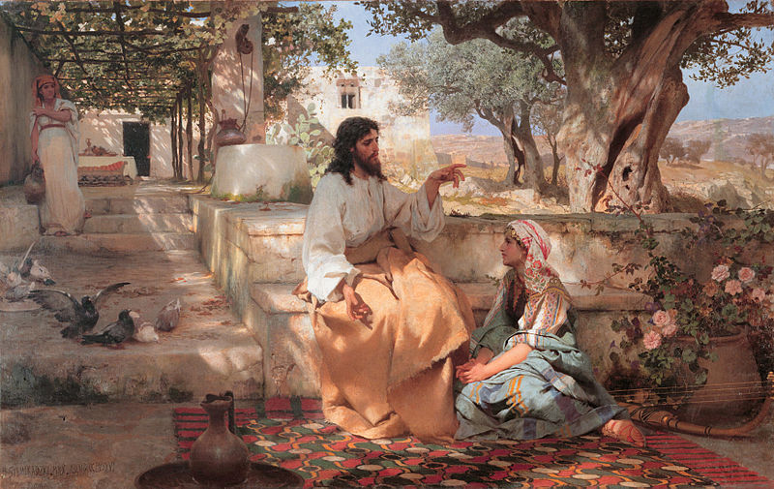
Christ With Martha and Maria, by Henryk Siemiradzki, 1886. Public Domain

Feast of St Marcellin Champagnat
Created in the image and likeness of God
+
Called to “a wonderful and sublime occupation”
St Marcellin was a prolific letter writer and a study of his letters reveals a real insight into his deep spirituality, his empathy for others, and his unceasing capacity to encourage and support the Brothers in the early days of the Marist Project. One letter in particular, to Br Barthelemy in January 1830, highlights this encouragement but also paints a beautiful picture of the privilege of being a Christian educator.

Reflection
Read through the letter, particularly the bold sections, and take a moment to reflect on St Marcellin’s words in relation to your own vocation in a Marist school. (5 minutes)
Dear Brother Barthélemy,
I was very glad to hear from you and to know that you are in good health. I also know that you have many children in your school; you will consequently have many copies of your virtues, because the children will model themselves on you, and will certainly follow your example.
What a wonderful and sublime occupation you have! You are constantly among the very people with whom Jesus Christ was so delighted to be since he expressly forbade his disciples to prevent children from coming to him. And you, dear friend, far from preventing them, are making every effort to lead them to him. What a reception you will have in your turn,
from this divine and generous master, who does not let even a glass of cold water go without its reward!
Tell your children that Jesus and Mary love them all very much: those who are good because they resemble Jesus Christ, who is infinitely good; those who are not yet good, because they will become so. Tell them that the Blessed Virgin also loves them, because she is the mother of all the children in our schools. And tell them that I love them very much too; and that I never once say Mass without thinking of you and your dear children.
How happy I would be if I could be a teacher and devote myself even more directly to educating these impressionable children!
Things are going fairly well in all the other establishments. Pray for me and for everyone here.
I have the honour to be your very devoted father in Jesus and Mary,
Champagnat
Superior of the Bros. of Mary
Let us pray together
Loving God
You set St Marcellin’s heart on fire and inspired him to found Marist Education with a mission to make Jesus Christ known and loved.
As we pause to acknowledge his great legacy, inspire us to continue to make that mission a reality for our students, their families and our colleagues by following his example.
We pray that through our commitment to our Marist spirituality and values, we may continue to provide hope, support and an outstanding Marist Education for all in our care.
Mary Our Good Mother, pray for us.
St Marcellin Champagnat, pray for us.
St Mary of the Cross MacKillop, pray for us. And let us always remember to pray for one another.
In the name of the Father, and of the Son, and of the Holy Spirit. Amen.

Prayer for Our Marist Family
Prayer Leader
In the name of the Father, and of the Son, and of the Holy Spirit. Amen.
Reader 1
Dear Lord
St Marcellin was inspired by Jesus and Mary to create loving and caring schools for children.
Help us to make our Marist school a place where everyone is known and cared for.
Reader 2
We pray in gratitude for our teachers who are full of Your wisdom. May we show them respect and love as they model Saint Marcellin’s care for us.
Reader 3
May we support our friends and classmates by being friendly and kind.
Reader 4
Give us courage to stand up for others when we need to and strength when we are feeling weak ourselves. When we feel unseen, remind us that no moment goes unnoticed and Jesus is always with us.
Reader 5
We pray with Mary, the mother of Jesus, who looks upon us with love.
Hail Mary, full of grace, The Lord is with you.
Blessed are you among women,
and blessed is the fruit of your womb, Jesus.
Holy Mary, Mother of God, pray for us sinners,
now and at the hour of our death. Amen.
Prayer Leader
Mary Our Good Mother, pray for us.
St Marcellin Champagnat, pray for us.
St Mary of the Cross MacKillop, pray for us. And let us always remember to pray for one another.
In the name of the Father, and of the Son, and of the Holy Spirit. Amen. 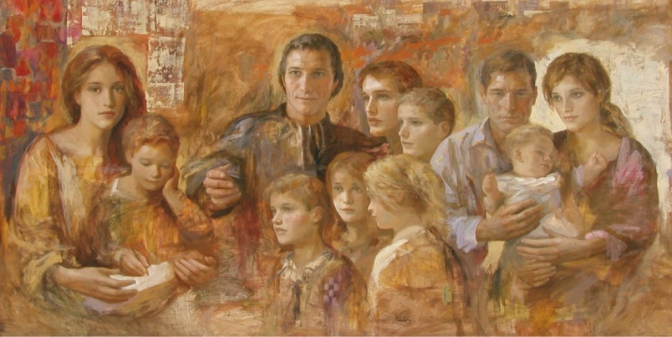
The Prayer of Marist Youth
Prayer Leader
In the name of the Father, and of the Son, and of the Holy Spirit. Amen.
Reader 1
Marcellin Champagnat knew how to recognise the needs and fears, hopes and plans of the young. Being a man of prayer and action, he summed up their visions and dreams in the words, “May they become good Christians and good citizens”, and “Every time I see young people I can’t help but tell
them, ‘how greatly Jesus loves you!’”. For Marcellin, that was God’s dream for every young person.
Reader 2
The Prayer of Marist Youth
God, you gave us Marcellin Champagnat as a fine example of how ordinary people can do extraordinary things when they make use of the gifts they have been given.
In the same way, you expect us to use the gift that you have given us so that we can make you present in the world.
Help us to invite you into our lives and to allow you to work through us to influence the lives of the people we meet and serve.
Amen.
Prayer Leader
We pause in silence to thank God for the gifts and talents that we each have been given and for our own prayers and intentions.
We bring all these prayers and intentions to God who loves each and every one of us, as we pray in confidence the words that Jesus taught us.
Our Father,
who art in heaven, hallowed be your name; your kingdom come;
your will be done on earth as it is in heaven. Give us this day our daily bread;
and forgive us our trespasses
as we forgive those who trespass against us; and lead us not into temptation,
but deliver us from evil.
Mary Our Good Mother, pray for us.
St Marcellin Champagnat, pray for us.
St Mary of the Cross MacKillop, pray for us. And let us always remember to pray for one another.
In the name of the Father, and of the Son, and of the Holy Spirit. Amen.
A Prayer to St Marcellin Champagnat
In the name of the Father, and of the Son, and of the Holy Spirit. Amen.
Reader 1
For the people we meet each day we seek to be reflections of God. Our desire is to be a visible and permanent memory of the loving and merciful presence of God in the midst of people: living signs of the Father’s tenderness. In some mysterious way, God works through us and in us. Despite our limitations, which we well know, our goodness is able to come through. By being with God we learn our way of being like him: shepherd, friend, faithful companion.
Reader 2 Prayer to St. Marcellin Champagnat
Saint Marcellin, through faith you accomplished what many thought was impossible. Help me to deepen my own faith
so that my relationship with the Lord will always be an essential part of my life.
Help me to listen for God’s voice in my own life
so that I will have the confidence to share my faith
and my love of the Lord with those open to encountering Jesus. Like you, Marcellin, I place my trust in the Lord and in Mary, our Good Mother.
Amen.
Prayer Leader
We pause in silence to ask God to deepen our own faith and experience of God, and for our own prayers and intentions.
We pray with Mary, who St Marcellin called ‘Our Good Mother’ as we say together:
Hail Mary, full of grace. The Lord is with you.
Blessed are you among women,
and blessed is the fruit of your womb, Jesus.
Holy Mary, Mother of God, pray for us sinners,
now and at the hour of our death. Amen.
Mary Our Good Mother, pray for us.
St Marcellin Champagnat, pray for us.
St Mary of the Cross MacKillop, pray for us. And let us always remember to pray for one another.
Prayer Leader
In the name of the Father, and of the Son, and of the Holy Spirit. Amen.
Marcellin Champagnat, Our Model
Prayer Leader
In the name of the Father, and of the Son, and of the Holy Spirit. Amen.
Reader 1
Lord, God, you raise up saints from age to age to speak anew your word to us,
to guide us in your ways.
And so, in days when the vision faded you inspired Marcellin Champagnat with a vision that leads towards you.
In days when we can lose courage, you give us a man of strength
to walk before us with conviction.
In days when our faith is challenged by winds of change you present us with a prophet whose faith remained firm.
May Champagnat’s vision, strength and faith, so firmly fixed on those same virtues of Mary, our Good Mother, continue to inspire us
as we reach towards you in our daily lives.
Prayer Leader
When we are facing difficult moments in our lives, let us be inspired by the faith of St Marcellin who trusted in God and often asked Mary for her prayers and intercession.
Reader 2
Prayer of St. Marcellin Champagnat
Mary, my Good Mother, I am called here to do good:
I can achieve nothing without the assistance of your divine son, and yours as well.
This is why I ask you to help me.
I ask you to be with me, directing my hands, my words, my heart, my whole person.
And when I am faced with some difficulties, Good Mother, I will entrust them to you, though I myself will do all that depends on me. I offer and commend to you, all that will be entrusted to me.
Amen.
Prayer Leader
We pause in silence and thank God for all that is good in our lives, for the people who love and
care for us, our teachers and all who work in our school.
Let us never fail to remember God’s love for each of us as we pray in the words that Jesus gave us:
Our Father,
who art in heaven, hallowed be your name; your kingdom come;
your will be done on earth as it is in heaven. Give us this day our daily bread;
and forgive us our trespasses
as we forgive those who trespass against us; and lead us not into temptation,
but deliver us from evil.
Mary Our Good Mother, pray for us.
St Marcellin Champagnat, pray for us.
St Mary of the Cross MacKillop, pray for us. And let us always remember to pray for one another.
In the name of the Father, and of the Son, and of the Holy Spirit. Amen.

Extended Prayer - Teacher Instructions
This prayer for students explores the theme of Created + Called through the question, ‘Who’s doing the creating and who is doing the calling?’
At times, we are prone to think that we are doing the creating and calling. When things do not go according to (our) plans, we think our world is collapsing around us.

“I did not get the result I wanted.” “I did not make the cut.”
“I did not get the job.” “He / she rejected me.”

This prayer is to take time to reflect that there is someone greater than us, personally and
communally, who is doing the creating and calling.
When things do not go according to (my) plan it often turns out surprisingly better!
There is a beautiful and sobering quote from the attached blog link:
“Many of the greatest gifts and deepest
joys that God gives us
come wrapped in painful packages.”¹
https://www.desiringgod.org/articles/the-unexpected-answers-of-god

The Created + Called prayer on page 19 card can be used as a slide or printed as a memento.

The prayer card begins with simple reading by Sufi teacher Hazrat Inayat Khan. This reminds us of not judging too quickly in how life is turning out for us.
The second quote is from Fr Richard Rohr OFM, who reminds us that Christ is the Light that reveals all. If we can see all the experiences we are living with the light of Christ, we may be able to recognise that every opportunity in life is chance to see God’s work.
The reference to Marcellin’s reflection about this topic from Water from the Rock (Para: 63) can be used here:

Marcellin sees God in all things and believes all things
come from God.
He experiences God’s presence
in both the tranquillity of the Hermitage and in the noisy streets of Paris.
For him, every place and circumstance was an opportunity to meet God.

If this is a longer prayer, this Gospel reference may be useful.

What father among you, if his son asks for a fish, will instead of a fish give him a serpent; or if he asks for an egg, will give him a scorpion? If you then, who are evil, know how to give good gifts to your children, how much more will the Heavenly Father give the Holy Spirit to those who ask him.
Luke 11:11-13

Depending on the setting of this prayer, there may be a good opportunity for students to share some experiences of their surprise of how things turned out despite not getting what they had asked for.
Allow the Spirit to guide the leader in how they wish to conclude the prayer.
Perhaps a prayer to see all things, regardless of how we view them as blessings.
For further exploration of this theme of the daily surprises in God’s creation and call we encounter each day, here are some other options:
The song Unanswered Prayers by Garth Brooks is a simple Country & Western ballad but carries the same theme of blessings in disguise.
The quote about perseverance (The Credit Belongs To…) from President Theodore Roosevelt is also very apt to suggest that regardless of the results of what we asked for, how hard we work, the credit belongs to the person who perseveres.

UNANSWERED PRAYERS
Garth Brooks
Just the other night at a hometown football game My wife and I ran into my old high school flame And as I introduced them the past came back to me
And I couldn’t help but think of the way things used to be She was the one that I’d wanted for all times
And each night I’d spend prayin’ that God would make her mine And if he’d only grant me this wish I wished back then
I’d never ask for anything again.
Sometimes I thank God for unanswered prayers Remember when you’re talkin’ to the man upstairs
That just because he doesn’t answer doesn’t mean he don’t care Some of God’s greatest gifts are unanswered prayers.
She wasn’t quite the angel that I remembered in my dreams And I could tell that time had changed me
In her eyes too it seemed
We tried to talk about the old days There wasn’t much we could recall
I guess the Lord knows what he’s doin’ after all And as she walked away and I looked at my wife And then and there I thanked the good Lord
For the gifts in my life.
Sometimes I thank God for unanswered prayers Remember when you’re talkin’ to the man upstairs
That just because he may not answer doesn’t mean he don’t care Some of God’s greatest gifts are unanswered
Some of God’s greatest gifts are all too often unanswered Some of God’s greatest gifts are unanswered prayers

THE CREDIT BELONGS TO …
President Theodore Roosevelt (1858 - 1919)
It is not the critic who counts,
not the one who points out how the strong person stumbled, or where the doer of deeds could have done better.
The credit belongs to the person who is actually in the arena; whose face is marred by the dust and sweat and blood;
who strives valiantly;
who errs and comes up short again and again, because there is no effort without error or shortcoming,
but who knows the great enthusiasms, the great devotions;
who spends oneself in a worthy cause;
who at the best, knows in the end the triumph of high achievement, and who at the worst, if they fail, at least fail while daring greatly, so that their place shall never be with those cold and timid souls who know neither victory nor defeat.

CREATED + CALLED
I asked for STRENGTH...
And God gave me difficulties to make me strong.
I asked for WISDOM...
And God gave me problems to solve.
I asked for PROSPERITY...
And God gave me a brain and energy to work.
I asked for COURAGE...
And God gave me danger to overcome.
I asked for LOVE...
And God gave me troubled people to help.
I asked for FAVOURS...
And God gave me opportunities.
I received nothing I wanted, But I recieved everything I needed.
Hazart Inayat Khan

CHRIST IS THE LIGHT
that allows people to see things in their fullness. The precise and intended effect of such a light is to see Christ everywhere else.
In fact, that is my only definition of a true Christian.

A mature Christian sees Christ in everything and everyone else.
That is a definition that will never fail us,
always demand more of us, and give us no reasons
to fight, to exclude,
or reject anyone.
Richard Rohr (The Universal Christ)

Student Reflection 1 –
Responding to Calls in Your Life – Lesson Plan

Resource Download Link

Student Reflection 2 - Stage 3 and above – Years 5 - 12
“For nothing will be impossible with God” (Luke 1:37)
Our Marist Schools Australia theme for 2023 invites us to consider the ways God invites each of us, in a personal and unique way, to a life that makes use of our gifts and talents.
It is not unusual for us to question whether we are suited to anything special in life. Like Mary, we often ask “How can this be?”, imagining that someone else is much better suited to a task. Self-
doubt can be our biggest obstacle from chasing our dreams and following our heart’s desires. In these moments, the story of young Marcellin can be of great inspiration to us.
As a young boy Marcellin had little interest in formal education, preferring to work on the family farm. When he decided to become a priest, he could barely read or write which made the task almost impossible. Tutors and family members did their best to persuade him to give up his dream, but he persisted. Even so, after one year at the seminary he was asked to leave after achieving poor results. It seemed that very few people believed that Marcellin had the necessary skills and talents to become a priest.
It would have been very easy for Marcellin to turn his back on his dream and immerse himself in life on the family farm.
But Marcellin had some very important assets he could draw on in pursuit of his goal to become a priest:
• His mother supported him every step of the way, encouraging to continue and advocating on his behalf;
•He excelled at manual work, was very talented with his hands and took on any physical challenge with gusto;
•He had a strong work ethic and sought to enjoy the difficult tasks he was assigned;
•He had a warm, generous nature and built strong relationships;
•Most importantly, he was inspired by his faith in God, and especially the example of Mary the mother of Jesus who, when confused by the direction her life was taking, heard the angel Gabriel say, “nothing will be impossible with God.”
This well-known image of St Marcellin, painted by Australian artist Paul Newton, depicts a key
moment in the life of Marcellin. He encountered a very ill boy and spent time with him shortly before he died. Upon hearing of his death, Marcellin became fired up by the thought of other children dying without knowing how much they are loved by God. It inspired him to bring to life his vision of schools now thriving in over 80 countries across the world led by teaching Brothers, a vision which is now thriving across the world.

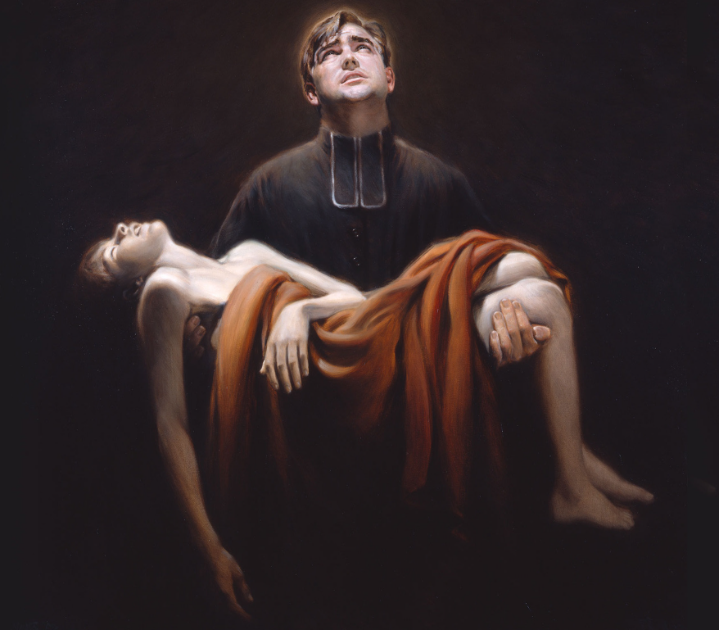

The Dying Child by Paul Newton, 1997

Questions for personal reflection:
1. Look at the painting of St Marcellin and the dying child. What personal qualities of Marcellin has the artist portrayed?
2. What unique gifts do you have that will help you chase your dreams?
3. Who are the key people in your life who support and encourage you to be all you can be? What are the ways in which these people bring out the best in you?
4. When you encounter obstacles, what do you draw on within yourself to overcome them?

Group discussion:
When Marcellin was being discouraged from entering the seminary, and again when he was asked to leave at the end of his first year, his mother took him to the shrine of St John Regis, a 3-day round trip journey from his home. Marcellin’s mother Marie Thérèse was a woman of deep faith, and she instilled this faith in Marcellin including his profound love for Mary, the mother of Jesus. Throughout the course of his training to become a priest, Marcellin became increasingly open to the power of God’s love to transform the course of his life.
Read the stories of The Annunciation and The Visitation (Luke 1:26-56). How does the Scripture describe Mary’s emotional responses throughout this journey? What does it say about Mary’s faith in God? How can these stories continue to inspire us today?

Student Reflection 3 Stage 6 – Years 11/12
Jesus Visits Martha and Mary - Luke 10: 38-42.
Now as they went on their way, he entered a certain village, where a woman named Martha welcomed him into her home. She had a sister named Mary, who sat at the Lord’s feet and listened to what he was saying. But Martha was distracted by her many tasks; so she came to him and asked, “Lord, do you not care that my sister has left me to do all the work by myself? Tell her then to help me.” But the Lord answered her, “Martha, Martha,
you are worried and distracted by many things; there is need of only one thing. Mary has chosen the better part, which will not be taken away from her.
In this Gospel story Martha welcomed Jesus. And then she got very busy. She got caught up in what she was doing. And in her eyes Mary should have been caught up too. Martha seemed to become more concerned about her busyness and her sister Mary sitting at Jesus’ feet, than her honoured guest.
In today’s culture of hectic schedules and our pursuit of success, how many of us, like Martha, are tempted to measure our worth by how busy we are, by how much we accomplish, or by how well we meet the expectations of others? Perhaps we could benefit by being a little more like Mary who is happy to take some time away from the busyness to be present to the moment she is spending with her guest.
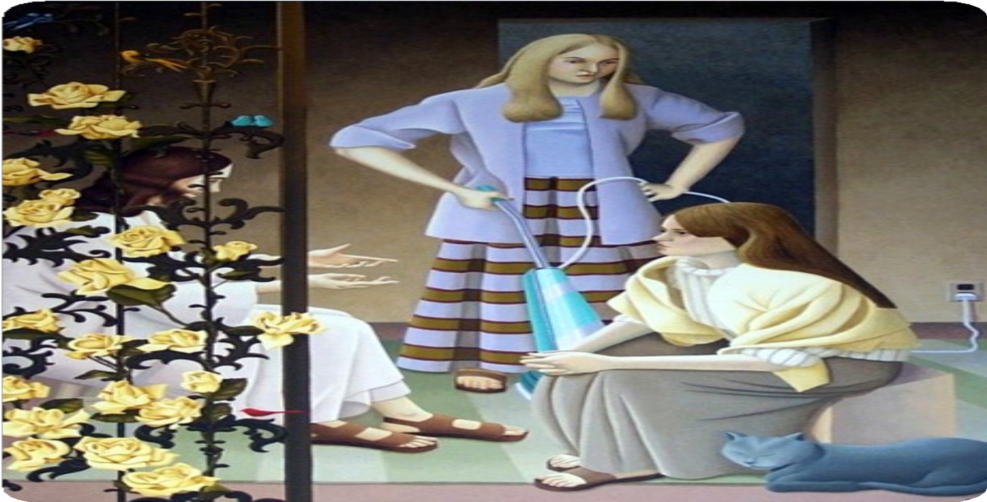
Knowing the gifts of both Martha and Mary, Jesus is using Martha’s busyness and Mary’s quiet time to make a point about the balance that is essential in our lives.
• Mary and Martha
• Being and Doing
• Work and Study
• Stress and Rest
These are the opposites that mark out our lives.

When Martha Leaves the Kitchen to Do the Hoovering! by Eileen Kennedy

It does not have to be either-or. None of us are either Mary or Martha. We get to be both.
Actually, they were them and we get to be who we are. You are just who you are, and Jesus knows you and Jesus loves you; knows your every worry, every distraction, Jesus just knows. He knows you in the quiet spaces and draws you aside and sits close with you and speaks to you quietly about how precious
you are.
You probably miss it most of the time, but he’s reaching out and drawing you in all the time. Listen for the sound of your name.
“Come in, relax with me. Stop working for a moment. Stop worrying. Be fully present.
Be here. Now.”
The story of Mary and Martha illustrates that the proper response to the teachings of Jesus is, first, to sit and listen, to reflect, but then “to go and do.” Jesus’ teachings challenge
us to act; they demand that we act … especially for the good of others.
Now let’s take some time to pause for a moment or a couple minutes. Going Deeper …
Read the passage again, slowly. Now some questions for discussion:
- What’s your feeling about this scene? With whom do you most identify? What do you like? Do you have any questions?
- Remember Martha is doing what was expected of her as the host. What are some expectations, social pressures or roles that you feel or have felt pressure to conform to.
- What inanimate object best describes how your life currently feels?
- List at least two things you learn about Martha in this passage and at least two things you learn about Mary. How would you sum up Martha in one word? How would you sum up Mary?
As a closing thought, imagine Jesus holding up a sign, “There is need of only one thing…” What comes next?

Mass for the Feast of St Marcellin Champagnat
Note: The Mass for the Feast of St Marcellin Champagnat was made a Solemnity by the Church for the Canonisation of Marcellin which occurred in 1999. The readings were originally used for the Beatification in 1955. Readings of the day may also be selected. The readings and Prayers of Intercession could be adapted to suit other liturgical settings.
Acknowledgement
We acknowledge the First Nations people of this land, the <INSERT NAME> eg: Ngunnawal people> and pay our deep respect to them as the original and ongoing custodians of the land upon which we gather. May we actively work together to build a future based on compassion, justice, healing and reconciliation.
As Marists, we acknowledge that each one of us is called by a loving Creator who has created us and claims us by name. May we build communities where all people are welcomed, known and loved.
Empower us to celebrate differences as your great gift to the human family. Enable us to be the architects of understanding, a revolution of love and tenderness.
Introduction
Celebrating Mass together today connects us with Marist tradition across 80 countries around the globe, and young people from pre-school right through to university students will be gathering like us to give thanks for the life and witness of St Marcellin Champagnat. He was truly a man of faith and had a belief in the value of every single person, especially those who were struggling in life for whatever reason.
This year the Marist theme ‘Created + Called: a revolution of love and tenderness’, has invited each of us to stop and think about the direction in which our lives are heading. Each one of us, students and staff members alike, has a unique opportunity to discover the gifts God has given us and work out how best to use them in the service of others and for God’s glory. That’s how we can change the world for the better, one small action after another, creating a revolution of love and tenderness. It starts with me, and you, and people will notice the positive effect you have on their lives.
Let’s remember to use the quiet and prayerful times provided during this Mass to give thanks for the lives we have.
Please stand to begin our celebration and join in the singing of the gathering hymn, [insert hymn name].

Collect
Holy Father, you have revealed the commandment of the new law through your Only Begotten Son, and shown us how to put it into practice by the inspiring example of Saint Marcellin; grant us, we pray, the grace to persevere in loving all our brothers and sisters as he taught, and to lead our world to the knowledge of the truth of Jesus Christ, who lives and reigns with you in the unity of the Holy Spirit, God, forever and ever. Amen.

First Reading (Sirach 24: 28-31)
A reading from the Book of Sirach.
I, wisdom, poured forth rivers. I, like a rivulet from her stream, channelling the waters into paradise,
said to myself, “I will water my plants, my flower bed I will drench”; and suddenly this rivulet of mine became a river,
and this stream of mine, a sea.
Thus, do I send my teachings forth shining like the dawn, to become known afar off.
I shall penetrate the lower parts of the earth, and I shall look upon all who sleep,
and enlighten those who hope in God.
Thus, do I pour out instruction like prophecy and bestow it on generations to come,
and I shall continue in their descendants forever.
See, I have worked not for myself alone, but for all who seek instruction. The Word of the Lord.
All
Thanks be to God.

Responsorial Psalm (Psalm 112: 1-9)
Reader
Happy the one whom the Lord instructs.
Response
Happy the one whom the Lord instructs.
Reader
Happy the one whom the Lord instructs, Who greatly delights in God’s commands.
Their posterity shall be mighty upon the earth; The upright generation shall be blessed.
Response
Happy the one whom the Lord instructs.
Reader
Wealth and riches shall be in their house. Their generosity shall endure forever.
They dawn through the darkness, a light for the upright; They are gracious and merciful and just.
Response
Happy the one whom the Lord instructs
Reader
Well for the one who is gracious and lends, Who conducts their affairs with justice; They shall never be moved;
The just one shall be in everlasting remembrance.
Response
Happy the one whom the Lord instructs.
Reader
An evil report they shall not fear;
Their heart is firm, trusting in the Lord. Their heart is steadfast; they shall not fear Till they look down on his foes.
Response
Happy the one whom the Lord instructs.
Reader
Lavishly they give to the poor;
Their generosity shall endure forever; Their horn shall be exalted in glory.
Response
Happy the one whom the Lord instructs.

Second Reading (Acts 1:12-14; 2:44-47)
A reading from the Acts of the Apostles.
The Apostles returned to Jerusalem from the mount called Olivet, which is near Jerusalem, a sabbath day’s journey away. When they had entered the city, they went to the room upstairs where they were staying, Peter, and John, and James, and Andrew, Philip and Thomas, Bartholomew and Matthew, James son of Alphaeus, and Simon the Zealot, and Judas son of James. All these were constantly devoting themselves to prayer, together with certain women, including Mary the mother of Jesus, as well as his brothers.
All who believed were together and had all things in common; they would sell their possessions and goods and distribute the proceeds to all, as any had need. Day by day, as they spent much time together in the temple, they broke bread at home and ate their food with glad and generous hearts, praising God and having the goodwill of all the people. And day by day the Lord added to their number those who were being saved.
The Word of the Lord.
All
Thanks be to God.

Gospel Acclamation
(Matthew 5:3)
Alleluia, Alleluia.
How blessed are the poor in spirit: the reign of God is theirs. Alleluia.

Gospel (Matthew 18:1-7,10)
A reading from the Holy Gospel according to Matthew.
All
Glory to you, O Lord.
At that time the disciples came to Jesus and asked, “Who is the greatest in the kingdom of heaven?” He called a child, whom he put among them, and said, “Truly I tell you, unless you change and become like children, you will never enter the kingdom of heaven. Whoever becomes humble like this child is the greatest in the kingdom of heaven. Whoever welcomes one such child in my name welcomes me. If any of you put a stumbling block before one of these little ones who believe in me, it would be better for you if a great millstone were fastened around your neck and you were drowned in the depth of the sea. Woe to the world because of stumbling blocks! Occasions for stumbling are bound to come, but woe to the one by whom the stumbling block comes!
“Take care that you do not despise one of these little ones; for, I tell you, in heaven their angels continually see the face of my Father in heaven.
The Gospel of the Lord.
All
Praise to you, Lord Jesus Christ.

Prayers of Intercession
Celebrant
Guided by the Holy Spirit, Jesus recognises the dignity of every person, and reaches out especially to those most in need of love and tenderness. As a Marist community, we ask that with your inspiration our hearts may be responsive, as we pray for the needs of our world.
Reader
For the Church:
We pray for Pope Francis and all our spiritual and Church leaders, that they be blessed with the courage and wisdom to face the challenges of leading the Church in this modern world.
Together we pray.
Response
Lord, hear our prayer.
Reader
For World Leaders:
May the Holy Spirit guide and inspire our leaders to care for the most vulnerable in our world. May they put in place policies with the intention of bringing peace and justice while protecting and preserving our common home.
Together we pray.
Response
Lord, hear our prayer.
Reader
For our country:
We pray that we may all contribute to being a voice for generations, as united in reconciliation and justice, our nation Australia comes together to listen, support and respond respectfully and whole- heartedly to the voice of the First Nations people of the land. Together we pray.
Response
Lord, hear our prayer.
Reader
For Marist Communities:
We pray in thanksgiving for the generations of Marist people whose dedication and generosity of spirit are the shoulders we stand upon today; as people called and chosen may we boldly and daringly carry on the mission of making Jesus Christ known and loved, in the way of Mary, as St Marcellin did.
Together we pray.
Response
Lord, hear our prayer.
Reader
For those whose lives are troubled by sickness, mental illness or physical violence:
May their families, friends and supporters renew their trust and security in loving relationships. May all members of the Church be instruments of healing.
Together we pray.
Response
Lord, hear our prayer.
Reader
For our planet and all its people especially those affected by war, violence, climate change and natural disasters.
We pray for all who are suffering. Teach us to respect all that is created. Humble us to hear the cry of the earth and the cries of the poor. May we stand in solidarity and support, willingly responding with all our heart and mind and spirit.
Together we pray.
Response
Lord, hear our prayer.
Reader
For our own intentions: (pause)
We pray with Mary, Our Good Mother and Mother of the Church, that she walk with us, sharing our joys and sufferings of every day, and modelling a total trust in God.
Together we pray.
Response
Lord, hear our prayer.
Celebrant
Loving God, source of all blessing and hope of the world, you shine your merciful and healing light in all places. Hear the prayers we offer for all your people and for your world. We ask that you graciously fulfill our needs and guide our actions into the future as we continue your mission of love in and for the world. We ask this through Christ, our Lord.
All
Amen.
Prayer over the Gifts
May our offering be pleasing to you, O Lord; and grant that, filled with the spirit of your love,
we may persevere in the teaching of the Apostles,
in communion, in the breaking of bread, and in prayer. Through Christ our Lord.
Amen.
Prayer after Communion
Nourished with the Body and Blood of your Son, we pray, O Lord,
that we who celebrate the great work
that you have accomplished in your Church through Saint Marcellin,
may be strengthened by the power of this Sacrament and inspired to undertake ever greater apostolic works. Through Christ our Lord.
Amen.
Music Suggestions
It’s true that we have our ‘favourites’ as a College community, or there are hymns which we can do without too much practice or which the musicians and lead singers already know, but you’re encouraged to consider choosing one or two new hymns from the options below.
They are all tried and tested and work well for school congregations (except the piece marked otherwise). Follow the links to GIA Music or OCP for purchase, or access through ‘As One Voice’ collections which are commonly available in parishes and schools.

Gathering Hymns
All Are Welcome (All Belong) (available in Spirit and Song or from OCP) Words and Music by Jesse Manibusan and Jennah Manibusan © 2016, OCP Publications.
Be Still For the Presence of the Lord (available from GIA Music) Words and Music by David Evans © 1986, Thankyou Music.
Gather Your People (available in As One Voice Vol. 1) Word and Music by Bob Hurd © 1991, OCP Publications.
Our God Is Here (available in Spirit and Song or from OCP) Words and Music by Chris Muglia © 2001, spiritandsong.com.

Communion Hymns
So Beautiful (available from GIA Music) Words and Music by Jacob Israel Villalobos, Matthew Leon, and Michael Paul Leon © 2009, World Library Publications. (Suitable for solo or choir performance.)
Take and Eat, This Is My Body (available from GIA Music) Words and Music by Ian Callanan © 2006, GIA Publications
Taste and See (available in As One Voice Vol. 1) Words and Music by Bob Hurd © 1988, OCP Publications.

Thanksgiving Hymns
I Will Lift My Eyes to the Mountains (available from GIA Music) Words and Music by Tony Alonso, Arr. by Chris de Silva © 2014, GIA Publications.
Remembrance (available from OCP) Words and Music by Matt Maher and Matt Redman © 2009, sixsteps Music.
Sacred Silence (available in Spirit and Song or from OCP) Words by Tom Booth, Jenny Pixler and Anthony Kuner; Music: Tom Booth and Jenny Pixler © 2003, 2004, spiritandsong.com.

Recessional Hymns
A New Heart For a New World (available in As One Voice Vol. 1) Words and Music by Trisha Watts and Monica O’Brien. Arr. Kevin Hunt © 1985, Willow Connection Pty Ltd.
Bring Forth the Kingdom (available in As One Voice Vol. 2) Words and Music by Marty Haugen © 1986, GIA Publications.
Set Your Hearts on the Higher Gifts (available from GIA Music) Text and music: Steven C. Warner, b. 1954, © 1992, 1994, World Library Publications.
Sub Tuum Praesidium (available free from Marist Schools Australia) Text: Coptic Text; earliest known Christian hymn to Mary. Music: Louise Lambillotte SJ.

Extract of the Spiritual Testament of Marcellin Champagnat May 18, 1840
Gathered Around the Same Table: The Vocation of Champagnat’s Laity, n32-33
Source: www. maristbrothers.org.nz/Prayers for Champagnat Marists
Evangelii Gaudium, 2013
Notre Dame de l’Hermitage, 21 January 1830
Evangelizers in the Midst of Youth, n.207
Water from the Rock: Marist Spirituality, n. 137
Marist Illuminations Prayer Book Vol. 1
Marist Illuminations Prayer Book Vol. 1

