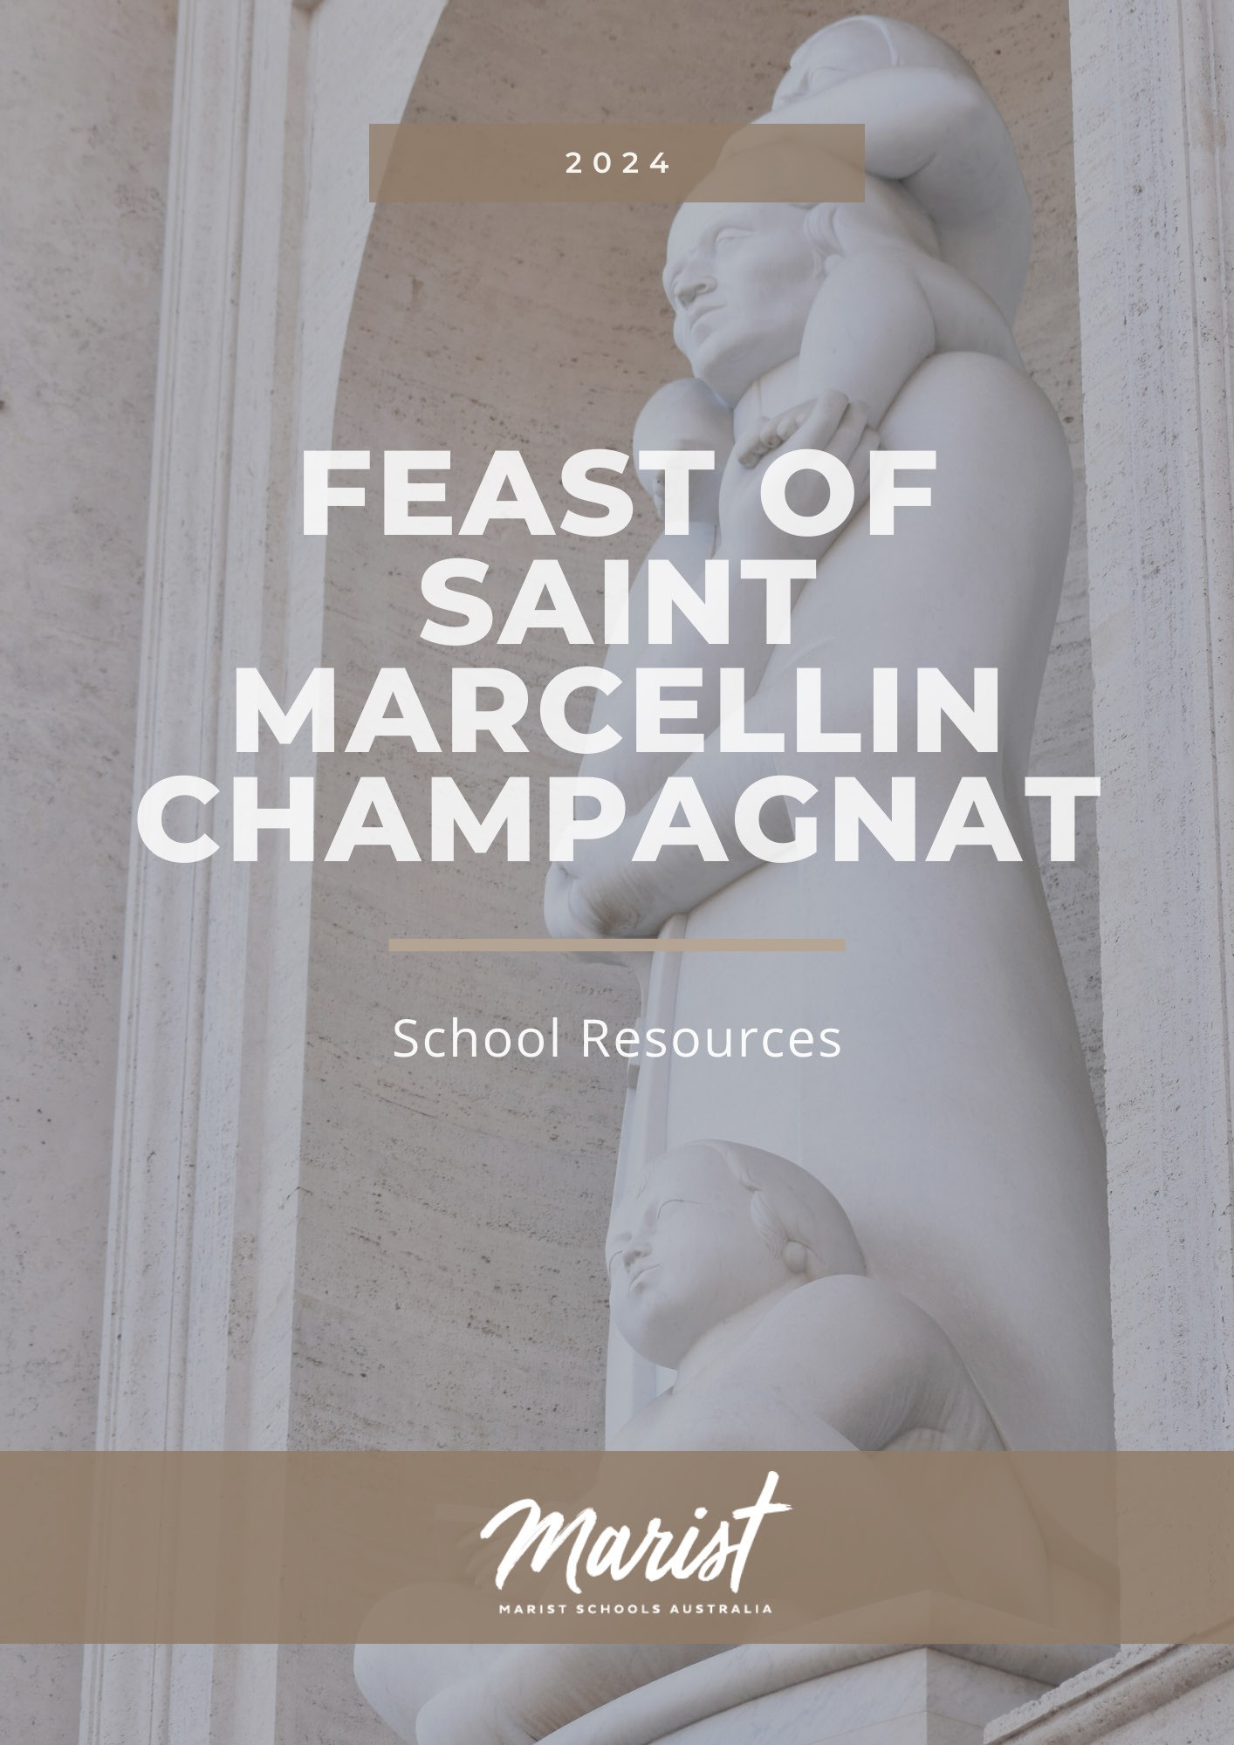

TABLE OF

CONTENTS

INTRODUCTION
MASS FOR THE FEAST OF SAINT MARCELLIN CHAMPAGANT LITURGICAL MUSIC SUGGESTIONS
LITURGY OF THE WORD
STAFF PRAYER REFLECTION
CANONISATION STATUE OF SAINT MARCELLIN CHAMPAGNAT MARCELLIN - OUR INSPIRIATION
FIRST LIGHT REVEALED AT THE VISITATION IN THE WAY OF MARY - THE LIGHT BEARER
STUDENT PRAYERS - PRIMARY LIVING IN THE LIGHT OF GOD OUR MARIST WAY
GOD’S LIGHT IN OUR LIVES
STUDENT PRAYERS - SECONDARY
IN THE FOOTSTEPS OF SAINT MARCELLIN PRAYER TO THE HOLY SPIRIT
STUDENT REFLECTION ACTIVITES
STAGES 1-2 (YEARS 1-4) - GATHERED AROUND MARCELLIN’S TABLE STAGES 1-2 (YEARS 1-4) - VISIO DIVINA FOR CHILDREN
STAGE 3 (YEARS 5-6) - GUIDED BY THE LIGHT
STAGES 4/5 (YEARS 7-10) - GOD SAID, “LET THERE BE LIGHT” STAGE 6 (YEARS 11-12) - A GREATER EXPECTATION
PRAYERS FROM THE MARIST STAR OF THE SEA PROVINCE 2024 PRAYER BOOK
3

4
9

11

12
14
15
16

17
18
19

20
21

22
24
25
29
31

32

COVER IMAGE
The Vatican commissioned Jorge Jimenez Deredia to create the statue of Saint Marcellin Champagnat to be placed inside a niche of the left transept of the southern façade of St. Peter’s Basilica in Vatican City. https://www.flickr.com/photos/fms_champagnat/53140455786/in/album-72177720299439470/

FEAST OF SAINT MARCELLIN CHAMPAGNAT

INTRODUCTION

We are now a couple of generations into using the title ‘Saint’ Marcellin Champagnat, but it’s worth remembering that just 25 years ago there was a great deal of excitement across the whole Marist world about Fr Marcellin’s canonisation. In 1999 Saint Peter’s Basilica was eerily clad in scaffolding and protective mesh, with enormous building cleaning and restoration works taking place in preparation for the Great Jubilee Year, the new millennium, 2000. I remember thinking that the newly proclaimed Saint Marcellin probably would have felt ‘at home’ in what resembled a building site, given his life story of perpetual building and expansion.
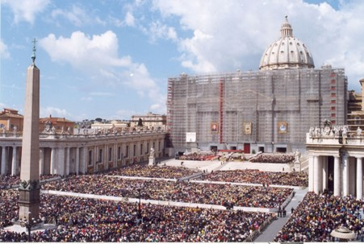
Canonisation of Fr Champagnat, St Peter’s Basilica Vatican City, 18 April 1999.

Whilst the Marist Litany and the use of Marcellin’s saintly title might roll off our tongues routinely and comfortably, let’s pause for a moment to give thanks for the whole Marist project whose beginnings emerged in the aftermath of a revolution and great societal upheaval. The early days of Marist life were simple, yet clear in their purpose – to bring young people to the knowledge and love of Jesus, through a compelling and compassionate style of relating. We find ourselves continuing that original dream with purpose and joy, with incredible diversity and individuality expressed in the types of ministries and by the young people being educated and cared for.
As students, parents and educators across the network of Marist schools in Australia and beyond, delve into the 2024 Resources for the Feast of Saint Marcellin Champagnat, my hope is that the experiences of prayer and learning create an echo in each person’s heart of the encounter which Marcellin had with Jesus. And just like him, I pray we might desire to bear witness unreservedly to Jesus because of that encounter. Coming to know Jesus has its challenges in busy societies with much ‘noise’ – perhaps during these days of celebration of the Feast of Saint Marcellin we can actively seek solitude and space to truly listen for God’s Holy Spirit.
I recommend a new resource, “Teach Us To Pray”, produced in the lead up to the Jubilee which the Catholic Church celebrates in 2025. The booklet is inspired by the teachings of Pope Francis and is written as an invitation to intensify prayer experiences, understood as a personal dialogue with God. I hope it might lead you to reflect on your faith in and commitment to Jesus.
Listening to God’s Holy Spirit has been the clear message of the Marist theme for 2024 – that we are awakened to encounter Jesus in experiences of ‘First Light’ and prepare ourselves for the Spirit to be revealed in the everyday and the ordinary. Once we recognise the experience, we are called to act justly, to serve without counting the cost, and to love with hearts that know no bounds. A place which calls itself Marist will have these gospel imperatives readily on show.
We know and celebrate that the great gift of Marist spirituality which the Holy Spirit has given us through Saint Marcellin and so many brothers and lay people throughout history, is alive and well today. Let us joyfully share responsibility for transmitting this gift to future generations of Marists.
Brother Michael Callinan fms Associate Director,
Mission and Life Formation Team

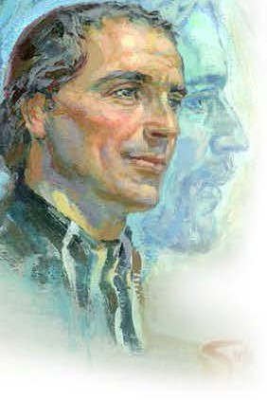
FEAST OF SAINT MARCELLIN CHAMPAGNAT

MASS FOR THE FEAST OF SAINT MARCELLIN CHAMPAGNAT
Note: The Mass for the Feast of St Marcellin Champagnat was made a Solemnity by the Church for the Canonisation of Marcellin which occurred in 1999. The readings were originally used for the Beatification in 1955. Readings of the day may also be selected. The readings and Prayers of Intercession could be adapted to suit other liturgical settings.

Acknowledgement of Country
Reader: We acknowledge the First Nations people of this sacred and holy land, the
<INSERT NAME> people, and pay our respect to them as the traditional custodians. May we all walk together actively seeking to build a future based on understanding, healing and reconciliation.
Introduction
Reader: Today we celebrate with Marists from across the globe, the Feast of Saint Marcellin Champagnat. Twenty-five years ago, in 1999, Marcellin was made a Saint of the Catholic Church for his dedication, leadership and inspiration to generations of Marists. This recognition was for Marist ministry in the education, care, and faith formation of young people, especially those most in need.
Here at <INSERT NAME OF SCHOOL> we continue the legacy of St Marcellin and the countless students and staff who have gone before us. May we, as the present Catholic community in the Marist tradition, continue to let our light shine, revealing God’s Spirit in the world through our actions and care for one another.
Let us use this time of celebration for prayer and thanksgiving for our lives and
for the needs of the world.
Please stand and join in the singing of the gathering hymn, <INSERT HYMN NAME>.

Opening Prayer
Priest: Holy Father, you have revealed the commandment of the new law through your Only Begotten Son, and shown us how to put it into practice
by the inspiring example of Saint Marcellin;
grant us, we pray, the grace to persevere in loving all our sisters and brothers as he taught,
and to lead our world to the knowledge
of the truth of Jesus Christ, who lives and reigns with you
in the unity of the Holy Spirit, God, forever and ever.
All: Amen.

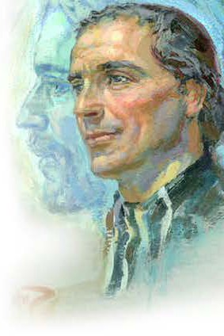
First Reading (Sirach 24: 28-31)
Reader: A reading from the book of Sirach.
I, wisdom, poured forth rivers.
I, like a rivulet from her stream, channelling the waters into paradise, said to myself, “I will water my plants, my flower bed I will drench”; and suddenly this rivulet of mine became a river, and this stream of mine, a sea.
Thus, do I send my teachings forth shining like the dawn, to become known afar off.
I shall soak into the lower parts of the earth, and I shall look upon all who sleep,
and enlighten those who hope in God.
Thus, do I pour out instruction like prophecy
and bestow it on generations to come,
and I shall continue in their descendants forever.
See, I have worked not for myself alone, but for all who seek
instruction.
The Word of the Lord.
All: Thanks be to God.

Responsorial Psalm (Psalm 112: 1-9)
Reader: Happy the one whom the Lord instructs. All: Happy the one whom the Lord instructs. Reader: Happy the one whom the Lord instructs,
Who greatly delights in God’s commands. Their posterity shall be mighty upon the earth; The upright generation shall be blessed.
All: Happy the one whom the Lord instructs.
Reader: Wealth and riches shall be in their house.
Their generosity shall endure forever.
They dawn through the darkness, a light for the upright;
They are gracious and merciful and just.
All: Happy the one whom the Lord instructs.
Reader: Well for the one who is gracious and lends, Who conducts their affairs with justice; They shall never be moved;
The just one shall be in everlasting remembrance.
All: Happy the one whom the Lord instructs.
Reader: An evil report they shall not fear;
Their heart is firm, trusting in the Lord. Their heart is steadfast; they shall not fear Till they look down on their foes.
All: Happy the one whom the Lord instructs.

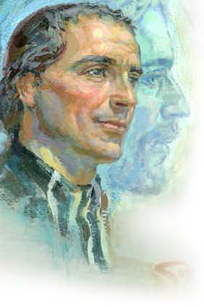
Reader: Lavishly they give to the poor;
Their generosity shall endure forever; Their horn shall be exalted in glory.
All: Happy the one whom the Lord instructs.

Second Reading (Acts 1:12-14; 2:44-47)
Reader: A reading from the Acts of the Apostles.
The Apostles returned to Jerusalem from the mount called Olivet near Jerusalem - a mere Sabbath’s journey away. Entering the city, they went to the upstairs
room where they were staying: Peter and John and James and Andrew; Philip and Thomas, Bartholomew and Matthew; James, son of Alphaeus; Simon, the Zealot party member, and Judas son of James. Together they devoted themselves to constant prayer. There were some women in their company, and Mary the mother of Jesus, and his brothers.
Those who believed shared all things in common; they would sell their property and goods, dividing everything on the basis of each one’s need. They went to the temple area together every day, while in their homes they broke bread. With generous and sincere hearts they took their meals in common, praising God and winning the approval of all the people. Day by day the Lord added to their number those who were being saved.
The Word of the Lord.
All: Thanks be to God.

Gospel Acclamation (Matthew 5:3)
All: Alleluia, Alleluia.
How blessed are the poor in spirit: the reign of God is theirs. Alleluia.

Gospel (Matthew 18:1-5,10)
Anyone who welcomes a little child in my name welcomes me.
Priest: A reading from the holy Gospel according to Matthew.
All: Glory to you, O Lord.
Priest: The disciples came to Jesus and said, “Who is the greatest in the kingdom of
heaven?”
So he called a little child to him and set the child in front of them. Then he said,
“I tell you solemnly, unless you change and become like little children you will never enter the kingdom of heaven. And so, the one who makes themself as little as this little child is the greatest in the kingdom of heaven. Anyone who welcomes a little child like this in my name welcomes me.
“See that you never despise any of these little ones, for I tell you that their angels in heaven are continually in the presence of my Father in heaven.”
The Gospel of the Lord.
All: Praise to you, Lord Jesus Christ.

The Prayer of the Faithful
Priest: God is the source of all goodness whose spirit is revealed to all people. We pray with St Marcellin and Mary our Good Mother, for our needs and the needs of our world.
Reader: For women and men who are leaders in our Church and school communities [pause]: That they, like St Marcellin, call upon God’s spirit to strengthen them in difficult times and continue to be faithful to the call of the Gospel.
We pray to the Lord.
All: Lord, hear our prayer.
Reader: For people experiencing war and displacement [pause]: That governments strive to find peaceful solutions to conflict and all nations reach out with compassion to those members of our human family who are suffering.
We pray to the Lord.
All: Lord, hear our prayer.
Reader: For Marist schools and communities around the world [pause]: That on this Feast Day of St Marcellin, we stand in solidarity with our global sisters and brothers as we pray in thanksgiving for the gift of a Catholic education in the Marist tradition.
We pray to the Lord.
All: Lord, hear our prayer.
Reader: For our own community here at <INSERT SCHOOL NAME> [pause]: That God’s spirit and light is recognised and revealed in the lives of all students, staff and our families.
We pray to the Lord.
All: Lord, hear our prayer.
Reader: For our own intentions [pause]: We pray with Mary, Our Good Mother and Mother of the Church, that she walk with us, sharing our joys and sufferings of every day, and models for us a total trust in God.
We pray to the Lord.
All: Lord, hear our prayer.
Priest: Loving God, we are brought to life through the Gospel. Hear our prayers and help us to embrace our faith as we proclaim the light of Jesus’ Good News in all we do. We ask this through Christ our Lord.
All: Amen.

Prayer over the Gifts
Priest: May our offering be pleasing to you, O Lord; and grant that, filled with the spirit of your love,
we may persevere in the teaching of the Apostles,
in communion, in the breaking of bread, and in prayer.
Through Christ our Lord.
All: Amen.
Prayer after Communion
Priest: Nourished with the Body and Blood of your Son, we pray, O Lord, that we who celebrate the great work
that you have accomplished in your Church through Saint Marcellin, may be strengthened by the power of this Sacrament
and inspired to undertake ever greater apostolic works.
Through Christ our Lord.
All: Amen.

FEAST OF SAINT MARCELLIN CHAMPAGNAT

LITURGICAL MUSIC SUGGESTIONS

FIRST LIGHT - Reveal the Spirit
Alive Again
Matt Maher and Jason Ingram https://www.youtube.com/watch?v=qX5HP0aYo98 Available at https://www.ocp.org/en-us
© 2009 Thankyou Music (PRS) (admin. worldwide at CapitolCMGPublishing.com excluding Europe which is admin. by kingswaysongs.com) / Spirit & Song®, a division of OCP (administered at CapitolCMGPublishing. com) / So Essential Tunes (SESAC) / West Main Music (SESAC) / Windson Hill Music (SESAC) All rights reserved. Used with permission. (can be used effectively as a gathering or recessional hymn)
Alleluia! Love Is Alive
(great Easter hymn, and suitable at other times of the year as a gathering or recessional hymn) https://www.youtube.com/watch?v=ZQ9oAgFn7l8
Available at https://www.ocp.org/en-us
© 2012, Steve Angrisano, Sarah Hart, and Jesse Manibusan. Published by Two by TwoMinistries and Spirit & Song®, a division of OCP. Administered by Spirit & Song®, a division of OCP. All rights reserved.
Be Still and Know That I Am God
Refrain text based on Psalm 46:11 https://www.youtube.com/watch?v=T_GJfd27i3k Available at https://www.ocp.org/en-us
© 2017, Tom Booth, Sarah Hart and Carl Herrgesell. Published by Spirit & Song®, a division of OCP. All rights reserved. (good for a ‘haunting’ gathering hymn, or another time when you want to encourage prayer, such as thanksgiving after communion, since the lyric is simple enough to not need words. Can transition into becoming a powerful a capella hymn)
Beautiful Is Your Love https://www.youtube.com/watch?v=WF6O1A2Bze0 Available at https://www.ocp.org/en-us
Josh Blakesley, Sarah Hart and Marc Byrd
© 2012, Blue Raft Music and Meaux Mercy, both administered at CapitolCMGPublishing.com, and Josh Blakesley and Sarah Hart, both published by Spirit & Song®, a division of OCP. All rights reserved. Used with permission.
Beatitudes (Let Your Light Shine)
Mike Balhoff and Darryl Ducote
Available at https://www.ocp.org/en-us/songs/6821/beatitudes
Words: Mike Balhoff, Music: Darryl Ducote © 1973 Franciscan Communications Center © 1978 Damean
Music. OCP. All rights reserved.
Great Man of God (Tune: For All the Saints)
Music: R Vaughan Williams and Lyrics: Br Tony Butler fms https://static1.squarespace.com/static/52422a6fe4b06209130d02bd/t/56299b7ce4b0c11a7cc7eb12/144 5567356258/12.+Great+Man+of+God.pdf
© Br Tony Butler fms
I am the Light of the World
Greg Hayakawa
Available in the collection ‘As One Voice I’ and at https://www.ocp.org/en-us
Text and music © 1978, 1979, Greg Hayakawa. Published by OCP. All rights reserved.

Lead, Kindly Light
Steven C. Warner
Available from https://giamusic.com/sacred-music
Text: St John Henry Newman. Music © 2001, Steven C. Warner. Published by World Library Publications. All
rights reserved.
Remembrance of You https://www.youtube.com/watch?v=gQue1PHofR0 Available at https://www.ocp.org/en-us
© 2019, 2020, Sarah Hart, Sarah Kroger and Fiat Music LLC.
Published by Spirit & Song®, a division of OCP. All rights reserved. Used with permission. (great for Preparation of the Gifts or Communion Hymn)
Stand in the Light
John Angotti and Kevin Page
Available from https://giamusic.com/sacred-music
Text and music © 2007, John Angotti and Kevin Page. Published by World Library Publications. All rights
reserved.
You are the Light
Sarah Hart https://www.youtube.com/watch?v=A1amaPGwwa8 Available at https://www.ocp.org/en-us
© 2015, Sarah Hart. Published by Spirit & Song®, a division of OCP. All rights reserved. Used with
permission.
(good lyrics and theology for this year’s ‘First Light’ theme, and usable into the years ahead)
You are the Light
Robert F. O’Connor, SJ
Available at https://ocp.org/en-us
Text and music © 2001, Robert F. O’Connor, SJ. Published by OCP. All rights reserved.

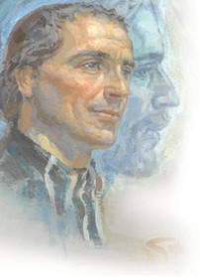
FEAST OF SAINT MARCELLIN CHAMPAGNAT
LITURGY OF THE WORD CELEBRATING OUR MARIST STORY FOR THE FEAST OF
SAINT MARCELLIN CHAMPAGNAT 6TH JUNE
With thanks to St Thomas More Catholic Primary School, Sunshine Beach Qld, for the creation and sharing of this Liturgy of the Word. Local adaptions are encouraged to suit the class or local school setting.

Resources (with links)
Litugry Outline Presentation Outline

Liturgy of the Word Celebrating our Marist Story
Sharing stories of St Marcellin
for the Feast of
St Marcellin Champagnat 6th June

With thanks to St Thomas More Catholic Primary School, Sunshine Beach Qld, for the creation and sharing of this Liturgy of the Word. Local adaptions are encouraged to suit the class or local school setting.

Acknowledgement of Country
Adult Leader: As a Marist family, we pay our respects to the traditional custodians of this land on which we gather today, the <INSERT NAME> people, who hold the traditions, memories, and wisdom of this sacred space. We acknowledge the elders, past, present and emerging and commit ourselves to being a community committed to reconciliation.

Welcome
Student reader(s): We gather today as a Marist community to celebrate the feast of St Marcellin Champagnat. St Marcellin started schools in the country areas of France over 200 years ago because he believed strongly in the importance of young people having the opportunity to learn.

St Marcellin’s life is an example of how to show love by following Jesus and learning from the example of Mary the mother of Jesus. Marists call Mary ‘Our Good Mother’ because they believe in Mary’s strong and gentle example for the world.

Today, many wonderful adults work in Marist schools in over 80 countries around the world. They are committed to continuing St Marcellin’s important work of educating and caring for young people as well as teaching them about God’s love for them.

As we light our school candle, we recognise that we are called to live in St Marcellin’s way through our words and actions each day.

Please join us to sing our opening song.

Opening Song: Let the Words You Speak – Andrew Chinn and Drew Lane. (Students to create sacred space during song)
Greeting
Adult Leader: I invite you to join me to make the sign of the cross together.

FEAST OF SAINT MARCELLIN CHAMPAGNAT

STAFF PRAYER REFLECTION

STATUE OF SAINT MARCELLIN CHAMPAGNAT

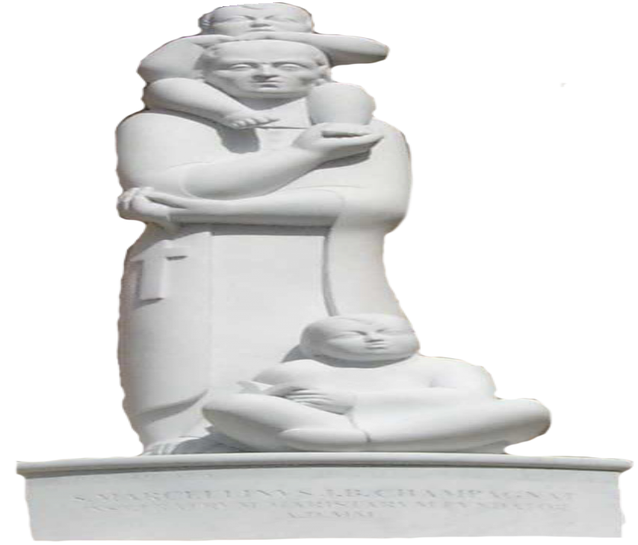
You might be familiar with this statue? It was commissioned for the Canonisation of Fr Champagnat.
In July 1998, the Marist Brothers (General House, Rome) presented a request to the Vatican for a statue to commemorate their soon to be canonised Founder. In August 1999, The Costa Rican ambassador to the Holy See requested to gift the Vatican a work of Art. In the same year a Costa Rican artist, Jiménez Deredia, was awarded the Beato Angelico Prize for recognition of the spiritual strength in his art. On 28 October 1999, Pope John Paul II gave the commission of the statue of Marcellin Champagnat to Jiménez Deredia.
Thoughts from the Artist:
The statue of Marcellin portrays his strength and determination.
Upon his shoulders he bears the burden of universal childhood with tenderness and sensitivity. His essential human traits are given a Christian dimension though the
symbol of the crucifix that he holds in his left hand.
Children, especially those who are poor and neglected, are waiting upon the kind of educational setting that will assure them of being secure and loved. To create such a setting was Marcellin’s goal, and it radiates from the statue that brings to mind the image of the Good Shepherd.
The positioning of feet and hands expresses an affective interplay, the good soil that receives both the word of God and the formative experiences of education.
The child on the shoulders leans upon the head of Marcellin, a position from which to look out upon life. At the same time, the child’s foot reposes secure on Marcellin’s right hand. In its turn the child-figure at the sculpture’s base leans against Champagnat’s foot to express a personal relation.

The open book in the child’s hand recalls the educational opportunity in which the child will find delight; and the countenance bespeaks a special way of viewing life.
The message: Marcellin’s humility and simplicity.
The statue is not overburdened with elements; rather, the essentials stand out. The work allows one to discern the most elevated mysteries of Christian faith: the unity of love expressed in a trinity of persons. Everything else is non-essential. The sculpture could not have been otherwise; it had altogether to depict the subject’s reality, each of its parts had to be in harmony with the whole.
On the subject’s clothing, the light had to fall soft and white so as not to falsify that oneness with the universe of which dreamt both Michelangelo and Marcellin.
- Jiménez Deredia
Artist’s website: www.deredia.com/en/
The statue resides in an alcove opposite the Papal Apartments where Pope Francis resides. A comment, often attributed to Pope Francis, about the statue:
The image is of Marcellin Champagnat, who is neither reading a book to his students or praying with closed eyes, but who is carrying one child on his shoulders and has another at his foot.
The mission of the educator is just that: to support young people in their lives, to be with through their successes, their failures, and their aspirations.

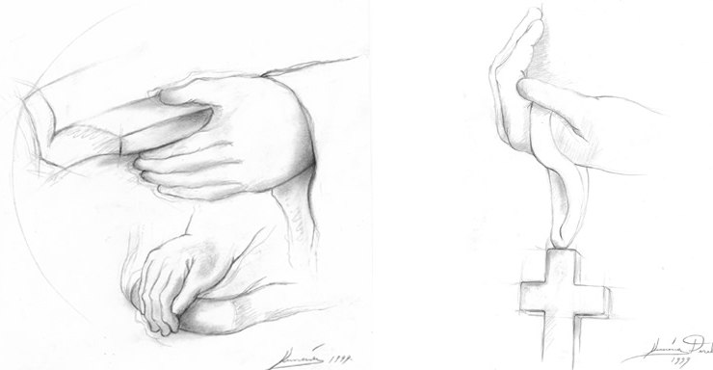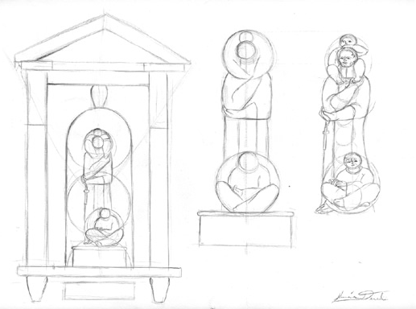
Original sketches by Jiménez Deredia
For discussion / reflection
1/ What elements of the statue stand out for you?
2/ What words of the artist or Pope Francis resonate with you?

FEAST OF SAINT MARCELLIN CHAMPAGNAT

STAFF PRAYER REFLECTION

MARCELLIN – OUR INSPIRATION
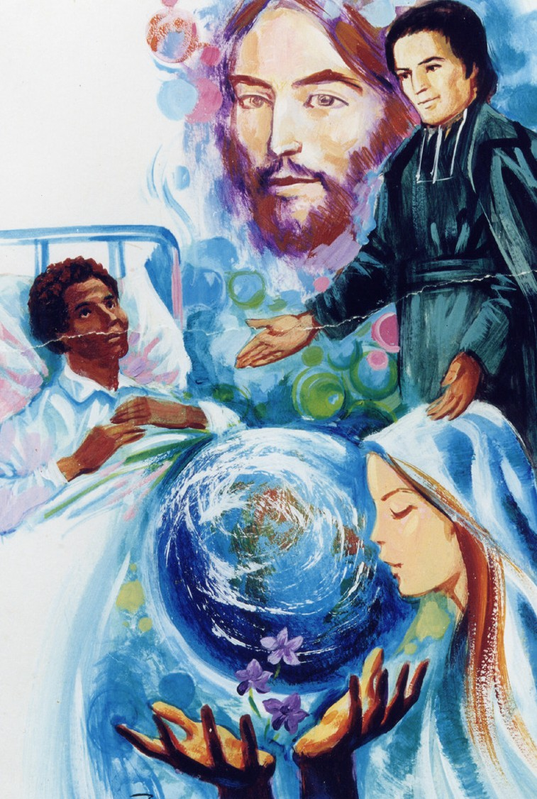
In the name of the Father, and of the Son, (+) and of the Holy Spirit. Amen.
Leader: Loving God, as teachers and carers entrusted with the sacred task of shaping the hearts and minds of young people, we are grateful for the example of Saint Marcellin Champagnat, whose life continues to inspire us in our vocation.
[pause]
We pray for the spirit of compassion.
Reader 1: Like Marcellin Champagnat, who saw each student as a beloved child of God, help us to approach our students with empathy and understanding. Grant us the grace to see beyond their academic achievements and challenges, and to minister to their spiritual and emotional needs with love and compassion.
[pause]
We ask for the gift of perseverance.
Reader 2: Saint Marcellin faced many obstacles and uncertainties
in his mission to provide education to young people, yet he remained
steadfast in his commitment to making Jesus known and loved. Give us the strength
Lord, to persevere in the face of challenges and setbacks, knowing that you are always with
us, guiding and sustaining us along the way. [pause]
We seek the virtue of humility.
Reader 3: Saint Marcellin attributed all his accomplishments to God’s loving grace, recognising that he was merely an instrument of God’s love and mercy. Help us to cultivate humility in our hearts, Lord, so that we may always acknowledge your presence and your spirit at work in our lives and in the lives of our students.
All: Lord, may the spirit of Saint Marcellin Champagnat continue to inspire and guide us in our work as educators. May we be lights of hope and compassion to our students, leading them closer to you through our words and actions.
Leader: We make this prayer through Christ our Lord, who lives and reigns with you and the Holy
Spirit, one God, forever and ever.
All: Amen.
Mary Our Good Mother, pray for us.
St Marcellin Champagnat, pray for us.
St Mary of the Cross MacKillop, pray for us.
And let us always remember to pray for one another.
In the name of the Father, and of the Son, (+) and of the Holy Spirit. Amen.

FEAST OF SAINT MARCELLIN CHAMPAGNAT

STAFF PRAYER REFLECTION

FIRST LIGHT REVEALED AT THE VISITATION
In the name of the Father, and of the Son, (+) and of the Holy Spirit. Amen.
Reader: In the first chapter of the Gospel of Luke we are told that Mary went “with haste” to visit her cousin Elizabeth, who upon hearing Mary’s greeting was filled with the Holy Spirit, crying out, “As soon as I heard the sound of your greeting, the child in my womb leaped for joy.”
(Luke 1:44)
For many centuries, artists such as Michael Galovic in his icon ‘The Visitation’ (for which the Chapel at the Hermitage at Mittagong is named), have depicted this familial scene from Luke’s Gospel. Through art, we can imagine how the pregnant Elizabeth reaches out to embrace the pregnant Mary, speaking words of welcome and blessing. It is a moment intense with intimacy and joy.
Elizabeth, through the grace of the Holy Spirit, recognises the light of Christ that Mary bears in her womb. She reaches out to Mary in welcome and deep delight. Mary and Elizabeth find in one another not just understanding of a shared experience, and not just hospitality, but a shelter for one another.
“In the relief and release she finds in Elizabeth’s welcome, Mary is freed to let loose with her words about the Word that is within her, and to pour forth her poetic proclamation of what God has wrought in her and in the world.”
(Jan Richardson).1

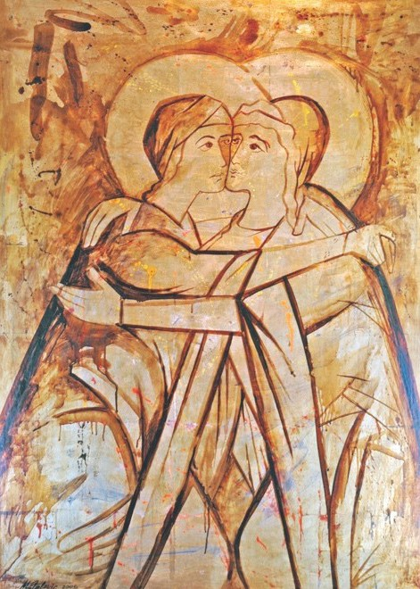
Question to ponder in silence:
For ourselves, and for the young people in our care:
Are there places of sanctuary in our lives, where we can encounter God through welcome, joy, and embrace of another?

Prayer2:
My thoughts race ahead over the beating of my heart
when I remember your goodness to me.
You have visited me!
You have overwhelmed me!
Take from my song the strident notes of pride
and arrogance,

strengthen my steps to leave the shadows
and find the movement of spirit that keeps us one.
I am with those who find joy in you and walk your way.
Mary,
I am remembered. Your song is mine.

The Visitation by Michael Galovic

Mary Our Good Mother, pray for us.
St Marcellin Champagnat, pray for us.
St Mary of the Cross MacKillop, pray for us.
And let us always remember to pray for one another
In the name of the Father, and of the Son, (+) and of the Holy Spirit. Amen.

- Adapted from Jan Richardson – The Sanctuary they make in meeting https://adventdoor.com/2009/12/13/advent-4-the-sanctuary-they-make-in-meeting/
- Rev. Shane O’Connor ocd, in ‘Mary’s Journey’, 1990.

FEAST OF SAINT MARCELLIN CHAMPAGNAT

STAFF PRAYER REFLECTION

IN THE WAY OF MARY, THE LIGHT BEARER

In the name of the Father, and of the Son, (+) and of
the Holy Spirit. Amen.
The beginning of John’s Gospel contains a powerful description of the light of Christ in creation and all human beings.
In the beginning was the Word, and the Word was with God, and the Word was God. He was in the beginning with God. All things came into being through him, and without him not one thing came into being. What has come into being in him was life, and the life was the light of all people (Jn 1:1-4).
Human society and creation are infused with the life and light of Christ.
As a community who live in the way of Mary, we are called to recognise the light of Christ in those we encounter each and every day.
The icon of Mary: Love Forever Being Born written by Kelly Latimore was inspired by this poem by Sr. Ilia Delio.
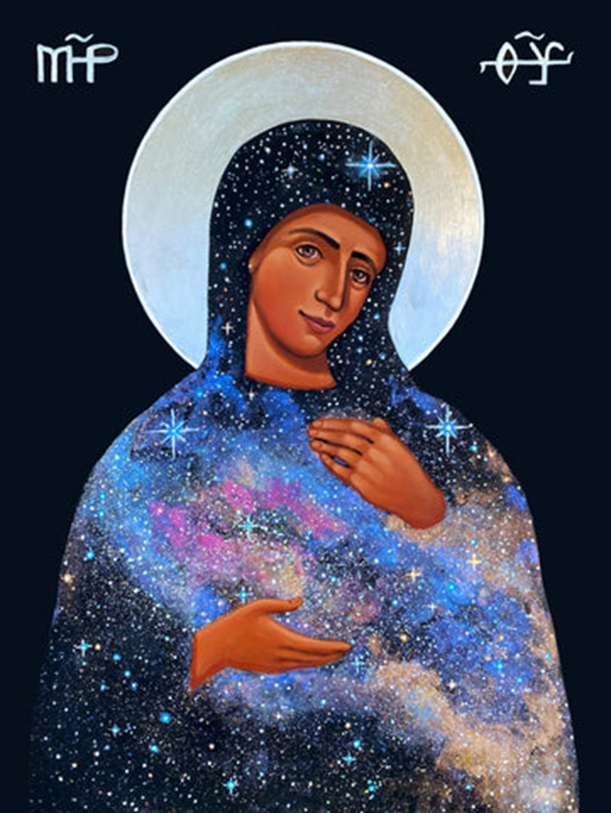
Mary: Love Forever Being Born by Kelly Latimore
“What do the stars say?
The light that meets our eyes after millions of years
summons us to look beyond.
The dark that hovers over us is filled with light.
That underneath the appearance of the stable heavens is the bubbling energy of the universe.
We are forming, forming, forming and nothing can stop us.
There is a palpable power of attraction, pulling us
toward we-know-not-where.
Love alone is the guide of the universe and the whole universe is in the human heart.
Tend to the heart and the power of love will name itself as God.”
Like Mary, we are called to be bearers of light of Christ to the world. At the same time, we should always be open to learn from our sisters and brothers more of what it is to live in the light.
Let us conclude with these words of wisdom, a reminder that light is always generous, never demanding.
The Sun Never Says1
Even after all this time
The sun never says to the earth, “You owe Me.”
Look what happens with A love like that,
It lights the Whole Sky.
Mary Our Good Mother, pray for us.
St Marcellin Champagnat, pray for us.
St Mary of the Cross MacKillop, pray for us.
And let us always remember to pray for one another
In the name of the Father, and of the Son (+), and of
the Holy Spirit. Amen.

1 The Sun Never Says in The Gift: Poems by Hafiz the Great Sufi Master, Daniel Ladinsky

FEAST OF SAINT MARCELLIN CHAMPAGNAT

STUDENT PRAYER

LIVING IN THE LIGHT OF GOD
In the name of the Father, and of the Son, (+) and of the Holy Spirit. Amen.
Reader 1: Saint Marcellin Champagnat was guided by his love for God and compassion for people to create schools for children. This education provided the light of learning for many young people, especially those most in need, and continues through the work of Marist schools in over 80 countries around the world today.
Reader 2: Saint Marcellin saw the potential in all young people and what they could be for the world, especially when the live in the light of God. “When God is on your side, and you rely only on him, nothing is impossible!”
Reader 1: We pray that our school community, inspired by the life of Saint Marcellin Champagnat, will be a place where:
Reader 2: The light of kindness is lived in our words and how we treat each other. Reader 1: The light of compassion ensures everyone is known and feels welcome. Reader 2: The light of joy fills our day and classrooms with smiles and laughter.
Reader 1: The light of hope opens our minds to abundant possibilities.
Reader 2: The light of faith opens space in our hearts for God.
Teacher: Let us pray.
Eternal and ever-loving God,
You inspired St Marcellin Champagnat in his mission to educate
children so that they may come to know and love Jesus, the light of the world. Open our hearts and minds so that we may be a community founded on love, that encourages each of us to discover the fullness of potential that you desire for our lives.
We as this through Christ our Lord.
All: Amen.
Mary Our Good Mother, pray for us.
St Marcellin Champagnat, pray for us.
St Mary of the Cross MacKillop, pray for us.
And let us always remember to pray for one another
In the name of the Father, and of the Son, (+) and of the Holy Spirit. Amen.

17

FEAST OF SAINT MARCELLIN CHAMPAGNAT

STUDENT PRAYER

OUR MARIST WAY
Our loving God,
We give thanks for the example of St Marcellin Champagnat,
a man who lived God’s love in word and action.
Inspired by the stories of St Marcellin,
help us to learn how to show love and care for others.
Help us live as people of SIMPLICITY by striving to be honest, sincere, and grateful.
Help us to live as people of PRESENCE by the ways we show respect and listen with an open heart. Help us show our LOVE OF WORK by being enthusiastic and motivated, always striving to do our best.
Help us to live FAMILY SPIRIT by the ways we treat others with welcome and care.
We pray IN THE WAY OF MARY, that we respond by showing care for all, especially those who most need
our care.
May we have hearts that are open to the blessing of God’s love in our lives.
We ask St Marcellin and Mary our Good Mother to be with us every day as we learn and work together
each day. Amen
Mary Our Good Mother, pray for us.
St Marcellin Champagnat, pray for us.
St Mary of the Cross MacKillop, pray for us.
And let us always remember to pray for one another
In the name of the Father, and of the Son, (+) and of the Holy Spirit. Amen.
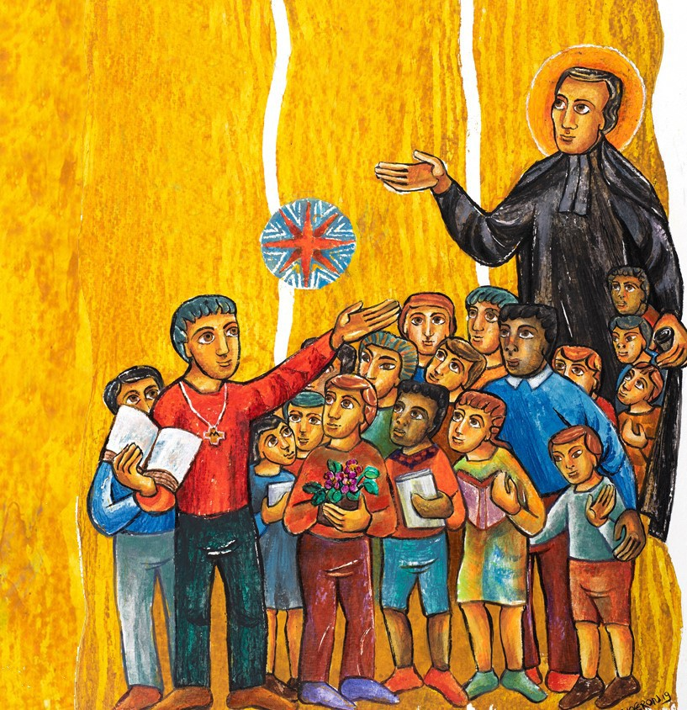

FEAST OF SAINT MARCELLIN CHAMPAGNAT

STUDENT PRAYER

GOD’S LIGHT IN OUR LIVES
In the name of the Father, and of the Son, (+) and of the Holy Spirit. Amen.
Reader 1: Light, a powerful symbol that represents the presence, guidance, and protection of God in our lives. Our founder, Saint Marcellin Champagnat, was a man who lived in the presence of God and was guided by God’s light.
Reader 2: As someone guided by God’s light, St Marcellin saw God’s Spirit in all aspects of life, especially through his dedication to the education of young people. The same light and Spirit that guided him, also guides us each day here in our Marist school.
Reader 3: As we join together in prayer today, let us close our eyes and bring to mind someone in our lives who needs God’s light.
(Pause)
Reader 4: Let us pray:
God of light and love,
As we begin this new day, we thank you for the gift of our Marist education and the spirit of St. Marcellin that guides us. Bless our teachers, classmates, and all who support us in our journey of learning and growth.
Reader 5: May the light of wisdom shine bright within us, and may the light of faith burn strong in our hearts as we walk in the footsteps of Jesus, sharing his love with each other by our words and actions. Amen.
Mary Our Good Mother, pray for us.
St Marcellin Champagnat, pray for us.
St Mary of the Cross MacKillop, pray for us.
And let us always remember to pray for one another
In the name of the Father, and of the Son, (+) and of the Holy Spirit. Amen.

19

FEAST OF SAINT MARCELLIN CHAMPAGNAT

STUDENT PRAYER

IN THE FOOTSTEPS OF SAINT MARCELLIN
In the name of the Father, and of the Son, (+) and of the Holy Spirit. Amen.
Leader: Loving God,
As we celebrate this special Feast Day, we lift our hearts in gratitude to you for the life and example of Saint Marcellin Champagnat. In his devotion to education and care for the young, he showed us the transformative power of love and dedication.
Marcellin walked among students with a gentle spirit and unwavering commitment. He saw each young person as a unique reflection of God’s love, guiding them with patience and understanding.
In the footsteps of Saint Marcellin, we come before you Jesus, seeking guidance and
inspiration. Help us, Lord, to emulate Marcellin’s character in our daily lives.
Reader 1: We pray for a spirit of generosity. Like Marcellin Champagnat, who gave of himself wholeheartedly for the sake of others, may we learn to give freely and generously to those in need. Help us to recognise the opportunities to serve our peers, our families, and our communities with love and compassion.
All: We pray for a spirit of generosity.
Reader 2: We ask for the gift of courage. Saint Marcellin faced numerous challenges and uncertainties in his mission, yet he remained steadfast in his trust in God. Grant us the courage to persevere in our studies, to speak out against injustice, and to be agents of positive change in our world, even when it is difficult.
All: We ask for the gift of courage.
Reader 3: We seek the virtue of humility. Despite his many accomplishments, Marcellin Champagnat remained humble, always giving glory to God for the work being done through him. Help us Lord, to cultivate humility in our hearts, recognising our strengths as gifts from you and using them for the greater good of our community.
All: We seek the virtue of humility.
Leader: May the light of Saint Marcellin Champagnat continue to inspire us to live lives of faith and service, with hearts of generosity, courage and humility. Guide us, O Lord, as we strive to follow Marcellin’s example and grow closer to you each day.
We ask this in the name of your Son, Jesus Christ, our Lord.
All: Amen.
Mary Our Good Mother, pray for us.
St Marcellin Champagnat, pray for us.
St Mary of the Cross MacKillop, pray for us.
And let us always remember to pray for one another
In the name of the Father, and of the Son, (+) and of the Holy Spirit. Amen.

FEAST OF SAINT MARCELLIN CHAMPAGNAT

STUDENT PRAYER

PRAYER TO THE HOLY SPIRIT
In the name of the Father, and of the Son, (+) and of the Holy Spirit. Amen.
Thank you God, for this new day.
Every good gift comes from you, and today is a fresh start.
As the sun rises over the land and over our school, help us to receive your love and shine as lights for you.
We ask that your Holy Spirit fills us afresh this morning, so that we may share with others throughout this day the love and joy that comes from knowing Jesus Christ.
Help us, Lord, to be students who bring peace and show patience to each other, to our teachers, to our parents,
and especially to those in special need of your care.
We are glad and give thanks for the examples shown to us through people like Saint Marcellin Champagnat,
who walk in your light and help guide us along our way.
We thank you for the first disciple, Mary, the Mother of Jesus.
May she be our Mother too, teaching us to love Jesus and always do God’s will.
Amen.
Mary Our Good Mother, pray for us.
St Marcellin Champagnat, pray for us.
St Mary of the Cross MacKillop, pray for us.
And let us always remember to pray for one another
In the name of the Father, and of the Son, (+) and of the Holy Spirit. Amen.
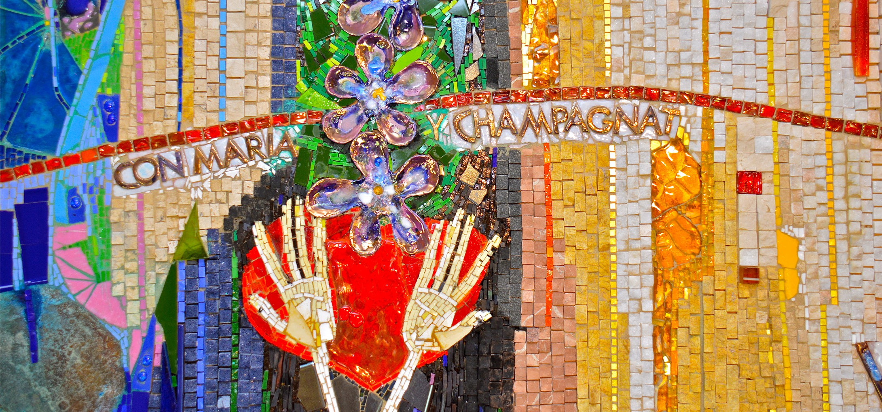

FEAST OF SAINT MARCELLIN CHAMPAGNAT

Activity - Draw your own La Valla Table.
Who are the important people in your life who are sitting with you at the table? – they can include members of your family, friends, teachers etc.
Make sure you include yourself at the table – you might like to include Marcellin Champagnat too! Draw some plates on the table. Write a word or phrase on each plate that represents the values that people at the table teach you about being in a family.

STUDENT REFLECTION ACTIVITY

GATHERED AROUND MARCELLIN’S TABLE
Imagine what it must have been like to sit with St Marcellin and share a meal at the table at La Valla all
those years ago.
How would they have prayed together?
What do you think they would have spoken about?
What sort of meal would they have shared?
The table at La Valla is an important symbol for Marists. It was this table that Marcellin built with the first brothers who started his mission in the small country hamlet. It was the table they gathered around each day. Gathering around a table reminds us of the gift of family that is an important part of the Marist story.
Marists continue to use this table as a symbol of family spirit and as a reminder of the importance of developing strong relationships with others. As part of a Marist community, we are like a family where everyone is valued, included and loved.
There is a place for everyone at Marcellin’s table. When we gather around the table we speak, laugh and share time together. Everyone is invited to sit side by side, taking time to be truly present to each other.
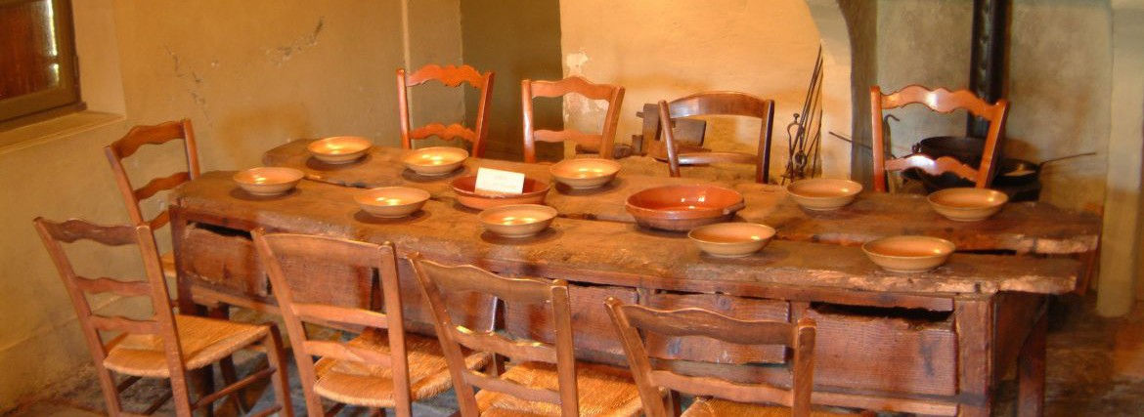
La Valla: The table built by Saint Marcellin – Champagnat – Marists of Champagnat

My La Valla Table

FEAST OF SAINT MARCELLIN CHAMPAGNAT

STUDENT REFLECTION ACTIVITY

VISIO DIVINA FOR CHILDREN
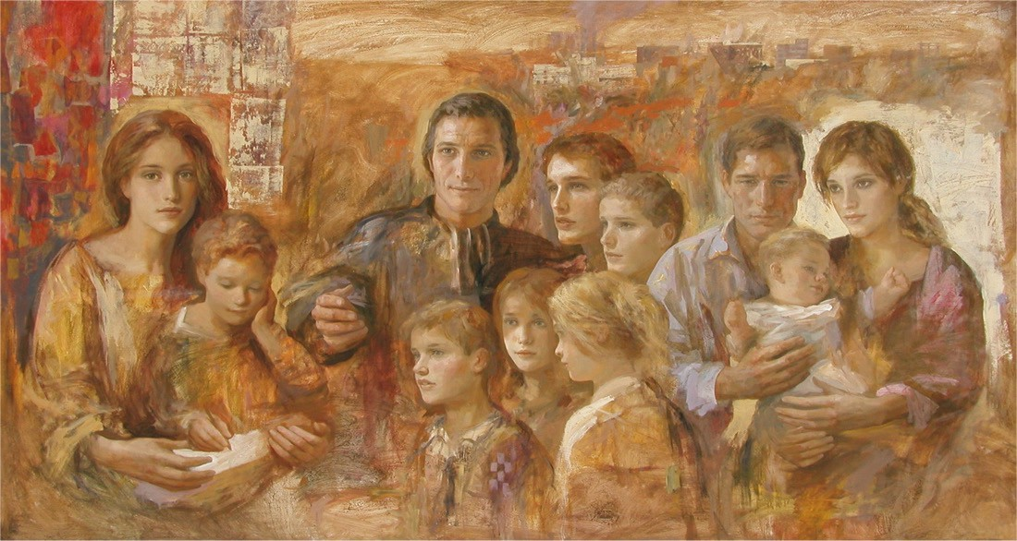
The steps of this Visio Divina are modelled on the Lectio Divina. It has four simple steps to provide an opportunity for children to reflect on and respond to open-ended questions about an image or piece of art. As a time of reflection and prayer this process invites children take time to look at a piece of art, to look for the details and identify what they see. Through questioning they identify what story the image is telling them and what they think it is about. When meditating on the image the children can make a connection to the story happening in the art.
A simple Visio Divina process for children:
Before beginning - have children seated where they can clearly see the image in an environment that is calm, prayerful and free from distraction. Quiet music can be played as part of this process to help students stay focussed.
- Visio – Invite them to look closely at the image – look for details and notice what stands out. Ask each child to identify for themselves what they believe the image tells them about what is happening in the story.
- Meditatio – Invite the children to take time to meditate on the image – to make a connection to the story happening in the art. Encourage them to imagine what it would be like to be present as part of this event. What would they see or hear? What do the colours, expressions or symbols used by the artist mean as their way of telling a story?
- Oratio – Invite the children to pray with the image. What is this story telling me about God’s love in the world? What is the message God wants me to hear? Take a few moments to speak with God about what you would like to give thanks for from this image.
- Contemplation – Invite the children to contemplate the image again quietly. We can open ourselves to God’s love by quietly examining the image again in silence. When we sit in silence, we can listen for the message God teaches us about this image during our time of prayer.

FEAST OF SAINT MARCELLIN CHAMPAGNAT

STUDENT REFLECTION ACTIVITY

GUIDED BY THE LIGHT
For Christians, light is a powerful symbol often representing the presence, guidance, and protection of God in our lives. This idea of light is seen in the story of Saint Marcellin Champagnat and Brother Stan (Stanislaus), where their journey through an unexpected snowstorm presented an enormous challenge to overcome. The appearance of a farmer’s lantern, as they prayed for help, is a reminder of God’s providence*, protecting them and guiding them to safety. This story beautifully illustrates how, just as the light led Marcellin and Brother Stan through a challenging moment of darkness, God’s light also shines on our path, offering comfort and hope in times of difficulty.

The Memorare in the Snow
Lost in the Snow by Pamela Griffith. St Gregory’s College Campbelltown

In February 1823, Marcellin learned that one of the Brothers had come down with a serious illness. Concerned about his health, he set out on a long journey across rough countryside to visit him. Brother Stan was at his side.
On their return trip, walking through a forest of trees, Marcellin and Stan got caught in a raging snowstorm. While they were both young and energetic, many hours of wandering lost in the snow eventually led to exhaustion. Br Stan had reached his limits and could not go on. As night set in, the possibility of death in the snow increased. Their only hope was to turn to Mary for help and so they prayed the Memorare, a special prayer to Mary.
Within a short while, they saw lamplight, not too far away in the distance. A local farmer had left his house to enter a nearby stable to feed his animals. For some unknown reason, this particular evening, he walked outside. Normally, he would have entered the stable through a door in the house. For reasons that can be explained only by faith, this particular night he braved wind and snow and went outside with his lantern.
For the rest of his life, Marcellin saw this moment as an act of providence, as they were protected by God. Marists today refer to this story as the Memorare in the Snow.
From: A Heart That Knew No Bounds
Brother Sean Sammon
*providence: The protective care of God.

Discussion Questions
1.
2.
3.
4.
5.
6.
What challenges did Marcellin and Brother Stan face during their journey? Why do you think they turned to Mary for help?
What role did light play in guiding Marcellin and Brother Stan to safety? How do you think they felt when they saw the light in the darkness?
What do you think the term “act of Providence” means?
In what ways is light a symbol of God’s presence and protection?

Further Activity - Guided by God’s Light Lanterns
- Provide each student with paper lantern stencil.
- Ask the students to decorate their lanterns with symbols or words representing God’s light, guidance, providence and protection. Encourage them to be colourful.
- Once the lanterns are decorated, have the students cut them out carefully and assemble.
- Option: Place battery-operated tea lights or small LED lights inside the lanterns to make them glow.
- Conclude with praying the Memorare.

Reflection and Sharing
- Invite each student to hold up their “Guided by God’s Light Lantern” and share what their artwork
represents in terms of God’s presence and guidance.
- Encourage the students to reflect on times when they have felt God’s presence or guidance in
their own lives.
- Conclude by emphasising that just as the light guided Marcellin and Brother Stanislaus through
the storm, God’s light is always there to guide and protect them.

Optional Extras
- Encourage students to write a short prayer or reflection about how they can be a source of God’s
light to others in their daily lives.
- Display the “Guided by God’s Light Lanterns” in the classroom as a visual reminder of God’s
presence and guidance.

Memorare - Traditional
Remember, O most loving Virgin Mary, that never was it known at any age,
that anyone who fled to your protection, implored your help,
or sought your intercession was left abandoned. Inspired with this confidence, therefore, I fly to you, O Virgin of virgins, my Mother.
To you do I come, before you I stand, sinful and sorrowful. Do not, O mother of the Jesus, despise my prayers,
but graciously hear and grant them. Amen.

Memorare - For today
Remember, O Mary, our loving Mother,
that no one has ever come to you for help and been left unheard. Moved by such memories, we come to you, our Good Mother, and ask your assistance in our deep need today.
We stand before you mindful of our own weaknesses and failures, but do not, O Mother of Jesus, turn your back on us,
but listen favourably to us and grant us what we need to live well in our world today. Amen.

FEAST OF SAINT MARCELLIN CHAMPAGNAT

STUDENT REFLECTION ACTIVITY

GOD SAID “LET THERE BE LIGHT”

Marcellin Champagnat was born in France at a time of darkness and trouble. The country was in upheaval. Crops failed. Poor people went hungry. As for the King of France and his Queen, Marie Antoinette, the hourglass of their lives was running out of sand. Soon, the royal couple, who were just 15 and 14 years old respectively when they were married, would lose not only their grandiose and opulent palace of Versailles, but their heads at the guillotine as crowds wildly cheered their demise.
Students educated in the great university cities like Paris had longed for light and the knowledge that could make people happy and free. But the “Age of Enlightenment” was ending. Revolutionary fervour now swept the land. A simple loaf of bread cost more than a labourer’s daily wage. People longed for justice. Many were angry. Some French citizens were prepared to kill. Indeed, Marcellin’s birth in 1789 coincided with the year of the French Revolution. But Champagnat was a man of peace and of love.
Young Marcellin grew up when violence seemed the order of the day, and a long shadow hung over France. Even in classrooms, a student could be beaten by his own teacher. Yet, the Champagnat family had hopes for a brighter future, for their family, for France, and for the world. Marcellin and his brothers and sisters were blessed with loving parents. When the parish priest paid the Champagnat family a visit, the teenaged Marcellin put his hand up as a candidate to be a future Catholic priest.
Out of the darkest of times in his country, light and love and laughter would prevail in the classrooms where Marcellin and his fellow teachers taught their young students. For, not only did Marcellin Champagnat become a priest, but he also became a schoolteacher, and the leader of a group of teachers, the Marist Brothers. It was if a wonderful explosion of light shone from the hills of the French villages as the classrooms of the Marist Brothers filled with eager learners, many from families anything but rich.
One hundred and five years after Marcellin was born, a baby boy in Belgium first saw the light of day. Georges Lemaître grew up next to the France of Champagnat. He was interested in science and in theology (the study of God and religion). In George’s day, most people believed in God, and many were religious. No one, however, had ever heard of the Big Bang Theory. Georges Lemaître became both a cosmologist (a scientist who studies the universe), and a Catholic priest. His theory is famous today.
Before George developed his theory, he saw the horrors of war. World War I had interrupted his studies. Lemaître became an artillery officer in WWI. He was a witness to the first poison gas attack in history. According to the theory he later developed, the Big Bang, the universe is expanding. The scientific belief in an expanding universe, and that the observable universe began with the explosion of a single particle at a definite point in time, was a totally unorthodox view amongst scientists in the early 1930’s.

Questions for Personal Reflection/Group Discussion
Marcellin’s dream of educating students to be good Christians and good citizens is still alive in Marist schools around the world, where the flame of knowledge burns brightly. The idea that the entire observable universe of galaxies began with a bang once seemed totally preposterous but is now universally acknowledged. Both Champagnat and Lemaître lived as “lights of the world”. So can we!
1.

2.
3.
4.
Do you know a person whose light shines brightly like Marcellin or George? Who is this and what are they known for?
What “crazy” or unorthodox ideas have become a reality since you were born?
What can you think of, not yet invented, that could be of benefit to the human family?
Marcellin responded to the need of educating children and young people in the country areas of
France. What are some of the “needs of our time?” How can a young person respond?

FEAST OF SAINT MARCELLIN CHAMPAGNAT

STUDENT REFLECTION ACTIVITY

A GREATER EXPECTATION

Resources (with links)
Aim:

Objective:
To challenge young people’s perception of their limiting beliefs, thus, expectation on the Divine Mystery.
To use ‘Unbelievable facts’ to remind us that we do not know everything. To see
Humility is required for wisdom the gaining of wisdom.
“If knowledge is power, knowing what we don’t know is wisdom.” Adam Grant.
To respect the concept of MYSTERY, that is, with Faith, we are called to be open to what is beyond our expectation & comprehension.
To know of Marcellin’s own trust - (A greater expectation) in Providence - the belief
that God will provide beyond any possible proof.
Activity & Presentation Guide Presentation Keynote
Presentation PowerPoint
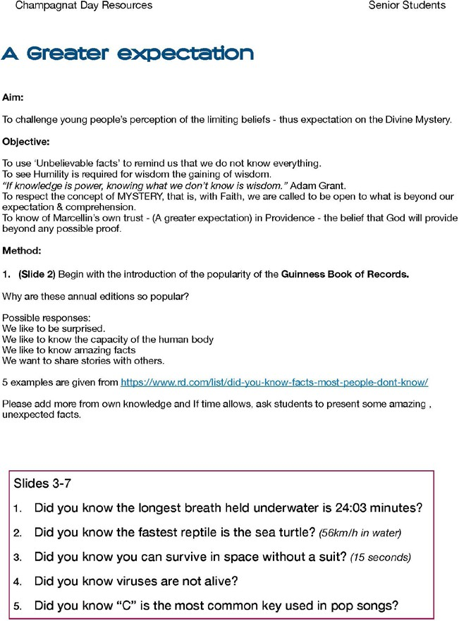
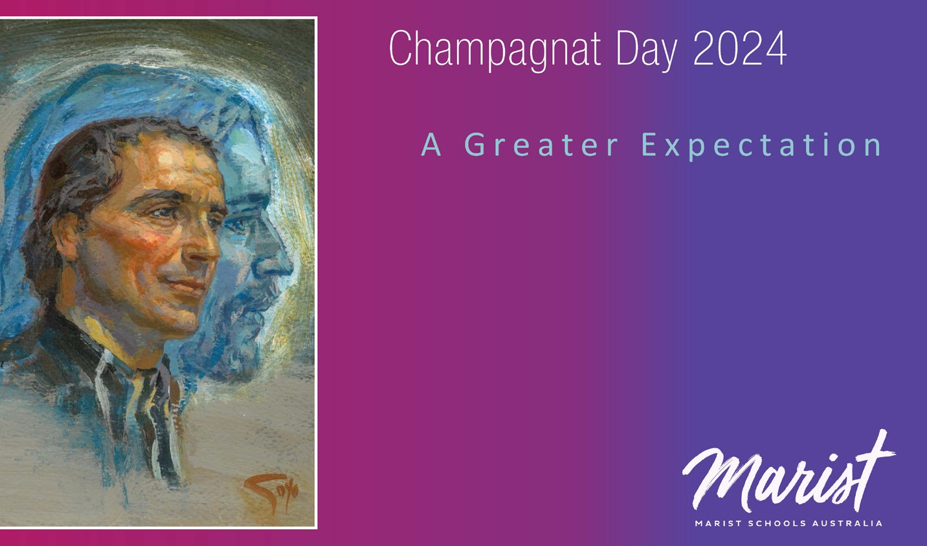

FEAST OF SAINT MARCELLIN CHAMPAGNAT

PRAYERS FROM THE
MARIST STAR OF THE SEA PROVINCE 2024 PRAYER BOOK

Morning Prayers
Lord, we come before you
to make a simple offering of our lives to you.
In the events of this day,
may we be attuned to receive your word, and respond generously as Mary did.
May the gifts that you continue to give us
be a source of new life and hope to all we meet. Amen.

Spirit of love,
alive in the universe, stir our hearts into flame by the fire and breath of your wisdom and love.
It is by the power of God’s love
that we move and live and have our being.
United with Jesus, who shows us the depth of that
love, we offer you our day with all its experiences.
Purify and transform us
so that Christ may be revealed in us
and in the hearts of all those we encounter today. Amen.

We thank you, God, for all your gifts.
Give us faith and conviction to meet the challenges of our world,
inner peace in the face of misunderstanding and
difficulty,
and courage to accept all that is painful in our lives, so that we might bring love and compassion
to those with whom we live, study and work.
Mary, mother and model, from the beginning
we were given your name and taught to live your spirit.
Ordinary Resource and Good Mother, you inspire our ways of being and acting. Be for us as you were for Champagnat – guiding, caring, ever-present mother.
We pray in thanksgiving for all who continue
to follow Saint Marcellin
in his commitment to education and the poor.
We ask this in the name of Jesus
who came to give us
the fullness of life. Amen.

The Memorare
Remember, O most loving Virgin Mary, that never was it known in any age, that anyone who fled to your protection,
implored your help, or sought your intercession was abandoned.
Inspired with confidence, therefore, I fly to you,
O Virgin of virgins, my Mother.
To you do I come, before you I stand, sinful and sorrowful. Do not, O Mother of Jesus, despise my prayers,
but graciously hear and grant them. Amen.

Salve Regina
Hail, holy Queen, Mother of Mercy.
Hail, our life, our sweetness, and our hope.
To you do we cry, poor banished children of Eve.
To you do we send up our sighs,
Mourning and weeping in this valley of tears. Turn then, most gracious advocate,
Your eyes of mercy towards us. And after this, our exile,
Show us the blessed fruit of your womb, Jesus. O clement, O loving, O sweet Virgin Mary.

Mary’s Guidance
Mother of the human family,
we confidently entrust to your care
the whole of humanity with its hopes and fears.
Do not let us lack the light of true wisdom.
Guide our steps in the ways of peace.
Enable all to meet Christ, the Way, Truth and Life.
That we may faithfully follow the way of Jesus, tell courageously the truth of Jesus,
And live joyfully the life of Jesus. Amen.

Praying with St Marcellin1
Oh Lord, everything in heaven and on earth is yours.
I want to be yours too, by a free gift of myself so that I may do your holy will entirely
and may work faithfully in the mission entrusted to me.
Mary, Good Mother, I earnestly ask you to take me under your protection and to intercede for me with your adorable Son.
Ask him to grant me the graces I need: (pause) I put all my confidence in you.
I offer you; I give you; I consecrate to you,
my person, my labours and all the actions of my life. In Jesus’ name. Amen.

1 (adapted from the prayers of St. Marcellin as found in his biography) https://champagnat.org/wp-content/uploads/2024/04/Canonizacion_Preghiera_A4_EN.pdf

