Feast of Saint Marcellin Champagnat School Resources 2022

Contents

Message from Br Peter Carroll Page 2

Prayer for the Sesquicentenary of Marist Education Page 3

Staff Prayers Pages 4 - 10

Staff Reflections Pages 11 - 14

Student Prayers – Secondary Pages 15 - 19

Student Prayers - Primary Pages 20 - 30

Student Reflection Pages 31 - 32

Feast of St Marcellin Mass Pages 33 - 40
Message from Br Peter Carroll

Dear Marist Friends

In 2022 we celebrate the one hundred and fiftieth anniversary of Marist education in Australia.
An international group of four Brothers (a Scot, two Irishmen, led by a Frenchman, Br Ludovic) arrived in Sydney in March 1872 to establish a school in the Parish conducted by the Marist Fathers at The Rocks. You can imagine the challenges they faced! How welcome was a Principal who was a Frenchman? What rumours and gossip may have spread? How did the poor Irish immigrants take to this group, when they would have preferred Brothers from their own native country? Records inform us that these were some of the problems they confronted. Then, of course, there were the children. They had enjoyed only rudimentary schooling up to this point. They preferred to roam the streets, fish in the harbour and play with their mates. Sitting attentively in a quiet classroom wasn’t one of their priorities. The Brothers’ first weeks at St Patrick’s with 139 students has been described as “chaotic”. They struggled to bring order to the undisciplined children and to advance their learning. However, they succeeded. In Australian Marist folklore this is described as the May Miracle. This month was a traditional time of devotion to Mary, and the Brothers encouraged the students to design and build special May altars and decorate them daily with flowers. This engagement of the boys and devotion to Mary seemed to bring about the desired transformation – even if it cost some locals their gardens’ flowers. From this point the students were settled and the school enjoyed a growing reputation.

This sesquicentenary is a time to look back in admiration and gratitude, and to look forward in hope and expectation.

Over the last 150 years, Marist schools have provided young people in every State and Territory (save Tasmania, where the Marist Fathers conducted a school) with the solid foundations of a Catholic education. While we’re well aware of past errors, we know that the majority have benefitted from their Marist education.

The Marist Theme for 2022 is ‘Known and Loved – Dignity for All’, and what a marvellous theme it is for this special year. St Marcellin’s ‘Golden Rule’ should be embedded in the DNA of all Marist educators: ‘love them all and love them equally’. There could be no better motto. Irrespective of background, appearance or ability, all young people are to be loved; there should be no favourites. I’m sure your own experience confirms the wisdom of these directives; when they aren’t practiced problems occur. Christian anthropology tells us that every human and all creation is to be valued, respected and treated with dignity, because all is a reflection of the Creator, all is made in God’s image and likeness. All has the divine spark within.

For 150 years, Marist schools in Australia have sought to nurture, educate and evangelise young people. If we have failed to know and love them; then we have failed. When we have done as St Marcellin instructed, then I’m confident we’ve succeeded in our mission. As we face the future, let’s all commit to advancing the dignity of all our students and, in fact, all people. Let’s start with our own though, by knowing and loving them – all of them – equally.

Br Peter Carroll FMS
Provincial and Leader of the Marist Association of St Marcellin Champagnat
Prayer for the Sesquicentenary of Marist Education

Celebrating 150 years
of Marist education in Australia

God of love
Your Spirit ignited the heart of
Saint Marcellin Champagnat
with a burning passion for God
and deep compassion for all people.

You called him and the early Marists
to bring this message of God’s tender
and all-embracing love to the young
and especially those most in need.

Generations have been inspired
by his example of humility, simplicity
and audacious courage to form
good Christians and citizens through
the Catholic education of young people.

We pray with Mary
our guide and Good Mother
that you continue to bless us
and all committed to Marist education
with Saint Marcellin’s spirit and heart that knew no bounds.

May it renew the whole Church in its mission
to make Jesus Christ known and loved, in Mary’s way,
through spreading Your compassion and love to the ends of the earth.

Amen.

Staff Prayers

Staff Prayer 1

Building the house

Reader
One of Marcellin’s favourite prayers was Psalm 127- Unless the LORD builds the house, its builders labour in vain…

At age 27, Marcellin founded the Little Brothers of Mary, established a home for the first Brothers at LaValla and within just a few years purchased an ordinary block of land on the River Gier, and built the Hermitage, dedicating it to Our Lady. Marcellin was a great builder, both of homes and of people. What underpinned his life and actions was a profound faith, and a deep love and trust in God.

Psalm 127 always reminded Marcellin of the overarching theme of trusting in God's love and care. He knew no matter what we do or where we are, the Lord is the One who makes all things come to pass in this life. It is not about our work, rather God’s plan for us.

Our journey is not unlike that of Marcellin or of the first disciples Peter and John rushing to the tomb of Christ on Easter Sunday in Eugene Burnand’s painting The Disciples. They’ve just been told by Mary Magdalene that she and the other women found it empty, that Christ has risen. Her words are ringing in their ears. But their faces and their bodies reveal they aren’t sure they can believe her.

We learn, like Peter and John, and St Marcellin, to place our trust in God for all things and to continue building God’s house through our ministry to the young in our care.

Reflection: Take a moment of silence now to gaze at this painting and reflect upon God’s hand in the work that you do.

Prayer:
Moved by the same spirit that inspired St Marcellin,
May we always call upon the strength of faith,
to have complete trust in God that guides our
work with the young people in our care.

Mary, our Good Mother …. Pray for us.
St Marcellin Champagnat …. Pray for us.
St Mary of the Cross Mackillop …. Pray for us.
And let us always remember … to pray for one another.

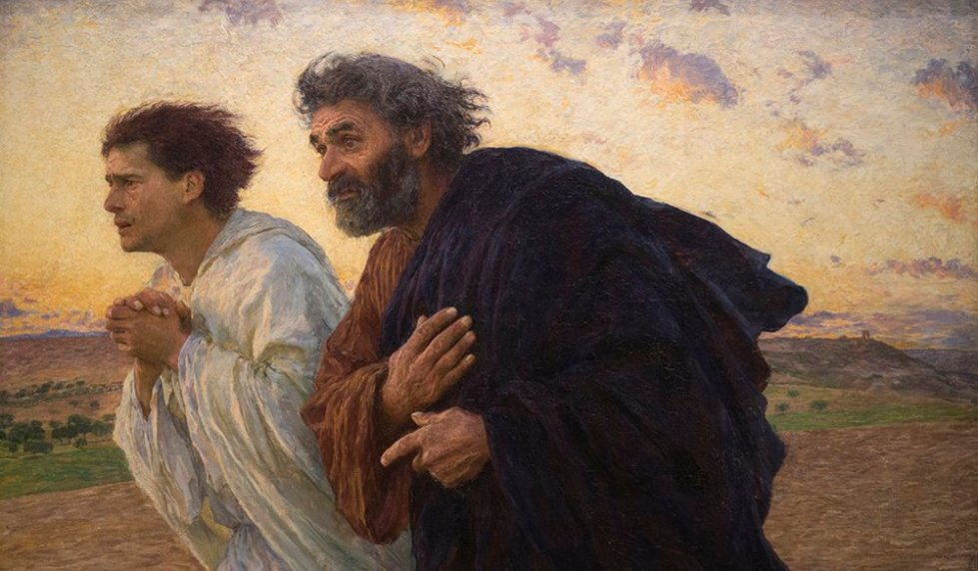
Painting The Disciples by Eugene Burnand of Peter and John rushing towards the tomb of Jesus.
Staff Prayer 2

Our Call, Our Mission

Reader: Our mission in Catholic education is to ensure that new generations of students discover the face of God and have life in abundance. Following in the footsteps of Saint Marcellin, we strive to respond to the cry of the young people who surround us. Saint Marcellin’s teaching to the Brothers, which flows through to us today, is that we must love the young people in our care, love them all equally and keep telling them how much God loves them.

Pause for a moment’s silence…

Together we pray…

Loving God,
We dedicate ourselves in helping young people
to discover meaning in their lives, through the light of faith.
Help each of us to be prophets for the young people in our care,
announcing to them that life is wonderful,
that it is worth the struggle to build a better world.
We encourage our young to be critical of the society that surrounds them
while inviting them to commit themselves to make their dream for a better world a reality.
Amen.

(adapted from Gathered Around the Same Table #42)

Mary, our Good Mother …. Pray for us.
St Marcellin Champagnat …. Pray for us.
St Mary of the Cross Mackillop …. Pray for us.
And let us always remember … to pray for one another.

Staff Prayer 3

Family Spirit

Reader: The essence of our Marist story and spirituality is family. St Marcellin Champagnat passed on to the first Brothers a form of relationship based on the example of Mary and Joseph and his own family. They lived in an atmosphere of family and of home life. The spirit of family went with them wherever they went and formed part of the educational style of their schools. How do we live this spirit of family for each other in our Marist place today, especially to those most in need?

Pause for a moment’s silence…

Together we pray…

Gracious God,
Your wish for us, your people, is to unite and come together
as one family around your Son, Jesus.
Family spirit is a value that helps us as people and can transform our world.
The spirit of family supports, sustains, and helps each other to grow.

Help us to trust in others, to accept our own limits, to feel appreciated
and to share the best of what God has given to us;
where there is no need to pretend, but just to enjoy being with others,
living in peace and harmony.
We ask this prayer through Christ Our Lord.
Amen.

Mary, our Good Mother …. Pray for us.
St Marcellin Champagnat …. Pray for us.
St Mary of the Cross Mackillop …. Pray for us.
And let us always remember … to pray for one another.

Staff Prayer 4

Relationships

Reader 1: The relationship of Marcellin to Mary was deeply marked by a loving and total trust in her, as the Good Mother, because it was her work that he undertook. He wrote once: “Without Mary we are nothing and with Mary we have everything, because Mary always has her adorable Son within her arms or in her heart.”

This belief remained constant all through his life. Jesus and Mary were the treasure on which Marcellin had learned to place his own heart. This intimate relationship helped shape the Marial dimension of our spirituality.

Reader 2: The Marist motto, All to Jesus through Mary, all to Mary for Jesus, captures this close relationship between the Son and the Mother and our Founder’s attitude of confidence in Mary, which we are invited to live constantly.

Pause for a moment’s silence…

Together we pray…

Mary,
Marcellin was chosen, as we are today,
to carry the message of Jesus to our schools, families, and community.
Help guide us to always be of service to those in need.
You give us your name as Marists,
to show us that you walk the path of life with us,
and share in our humanity.
We pray with you, our guide and Good Mother,
to help renew our mission to education
to make your son, Jesus Christ known and loved to the ends of the earth.
Amen.

(adapted from Water From the Rock: Marist Spirituality #25)

Mary, our Good Mother …. Pray for us.
St Marcellin Champagnat …. Pray for us.
St Mary of the Cross Mackillop …. Pray for us.
And let us always remember … to pray for one another.

Staff Reflection 1

A Spirit of Simplicity

Introduction: In this celebratory year of Marist Education in Australia, we take a moment to reflect upon the gifts that we, as Marist educators, can receive from St Marcellin Champagnat and how we animate this spirit in our own lives and that of the young people in our College.

Br Mark Farrelly was a loving and lovable educator who heard the calls of God and of Champagnat and was passionate about following these calls. He was only forty-seven years old when a brain tumour shortened his life. The following extract is from a publication A Simple Gift: The Uniqueness of Marcellin Champagnat’s Educational Charism in which Br Mark centres our interest in what a Champagnat school should offer to the formation of young learners in Australian Catholic education.

A Spirit of Simplicity

Brother Alexander Balko, a leading Marist historian, describes this as the single most distinctive feature of Marcellin's approach to the formation of young people, as Marcellin himself called it a virtue and named it "simplicity".

By it, he meant something quite different from the understanding that prevailed in his day. He tied it with two complementary virtues, "humility" and "modesty". Don't be fooled, he warned, into thinking that to be simple, humble, and modest means you must hate yourself or that, to achieve some state of perfection, you must punish yourself and others for every little fault you can find. These were fashionable religious ideals in Marcellin’s time in the nineteenth century, and they were applied to the education of children as well.

Marcellin believed something different: that simplicity really means accepting yourself as you are, with all your strengths and weaknesses. Be thankful for the gifts you have been given in this life. Rejoice in them. Use them for everyone's benefit. Look for the good in everyone, even the least attractive; for the God who loves us has made each of us basically good.

In other words, Marcellin wanted no dissembling. We Australians would say that he abhorred bulldust and show. Be transparent, be people of integrity, practice what you preach, let people -especially young people - see you just as you are. And, by the warmth of your presence and your good example, form others to be the same.

It was a revolutionary insight he shared with a few others among his contemporary founders. It was a seed planted by the Spirit among the Christian people in rare individuals like Marcellin Champagnat. It was not to come to fruition in the wider Church until the documents of the Second Vatican Council in the early 1960s.

Typically, Marcellin came upon a very down-to-earth symbol for this noble quality that we recognise as a unique feature of every Marist educator. In the summer fields around La Valla, tiny purple violets grew in the long grass. You couldn't easily see them, but you knew they were there because of their powerful fragrance. That's simplicity, humility and modesty, he insisted. You don't have to be seen to do good to do it! People will notice the enriching fragrance if you act selflessly, with integrity and generous concern, to meet the other’s needs.

For reflection/discussion:
1) What is attractive to you about this explanation of ‘simplicity’?
2) What are the challenges of living this way?
3) Where do you see this virtue being demonstrated in your community?

Extract from A Simple Gift: The Uniqueness of Marcellin Champagnat’s Educational Charism
By Br Mark Farrelly FMS (1952-1999)
First published in 1997. Link to full document HERE

Staff Reflection 2

Caring for the Earth

In looking at sketches of the earliest French Marist schools and Brothers community houses it is noticeable that well-tended and productive gardens often feature close to the buildings. Early images of Notre Dame de l’Hermitage, the house built by Marcellin with his early Brothers, offer examples of this.

There is a strong link between Marcellin’s goal of forming Brothers who could meet the urgent need he saw for providing education for poor rural children and ‘caring for the earth’. His vision was for teaching brothers who would enable young people to grow into being good Christians and exemplary citizens. Marcellin’s Brothers were expected to provide for themselves. He made this clear in the Rule of Life he wrote for the Brothers which stipulated that their food “should be plain, wholesome and abundant”. This meant regular and careful work keeping productive garden plots at their houses in the villages and hamlets of their schools. From the start this was an important and ongoing part of their community life.

Today, let’s reflect for a moment on the importance of getting our hands into the dirt, of cultivating the soil and working effectively each day to ensure an ongoing, year-round supply of key vegetables and fruit. Those first Marists did that as a matter of course. For many of us there may not be such a strong, even urgent, regular daily sense of connection with the soil, plants and animals of our planet.

Our survival and life still depends completely on the basics of life yet we are often at a remove from the processes and physical work involved in providing the food we eat each day. Does it seem almost magical that packaged milk in plastic bottles appears on our supermarket shelves, labelled and ready to be used before a certain day. Our daily bread, sliced, wrapped in plastic and neatly stacked awaits our selection and purchase. Fruit, vegies and meat are usually there in abundance as well. As we push our shopping trolley around the aisles there is never a cow in sight, let alone a steaming cow pat on lush green grass. The same applies to the wheat, corn, onions, apricots, apples, oranges and every other possible fresh food product that is laid out before us.

We simply purchase, carry and consume ‘the product’ and dispose of the packaging and leftovers into a weekly garbage collection where it simply ‘disappears’ into a “waste management process” Is it good enough to simply wash our hands of this and go on with life?

Probably not! Conscious of our responsibility to Care for the Earth, Our Mother and aware of what a serious issue this is, we as educators, active citizens and Christians are already concerned. As Marists we are well placed to act meaningfully in our times. Our words and actions can build on the example of Saint Marcellin and those pragmatic down to earth early Marists in their gardens, or on the roads and paths through the forests to the villages, hamlets and homes in the rural France of their time.

Let us strive to care actively and intelligently for the Earth now. Pope Francis sets the bar high for us and the young people of today with his call in Laudato Si’.

Some questions to ponder:
- What might I be planting and harvesting this year?
- In what ways am I contributing to caring for the Earth, Our Mother?

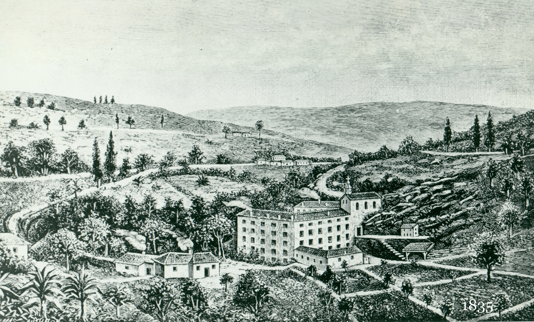
Notre Dame de l’Hermitage showing 4 garden plots (foreground right)

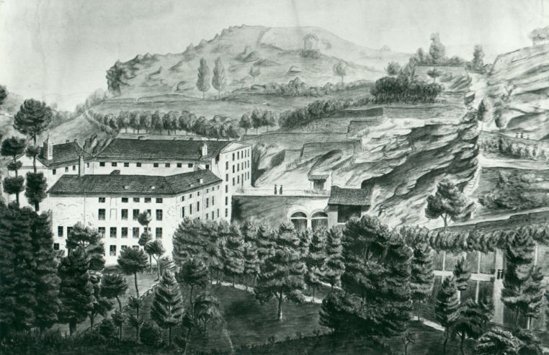

An early sketch of Notre Dame de l’Hermitage. Note two Brothers near garden area bottom right.

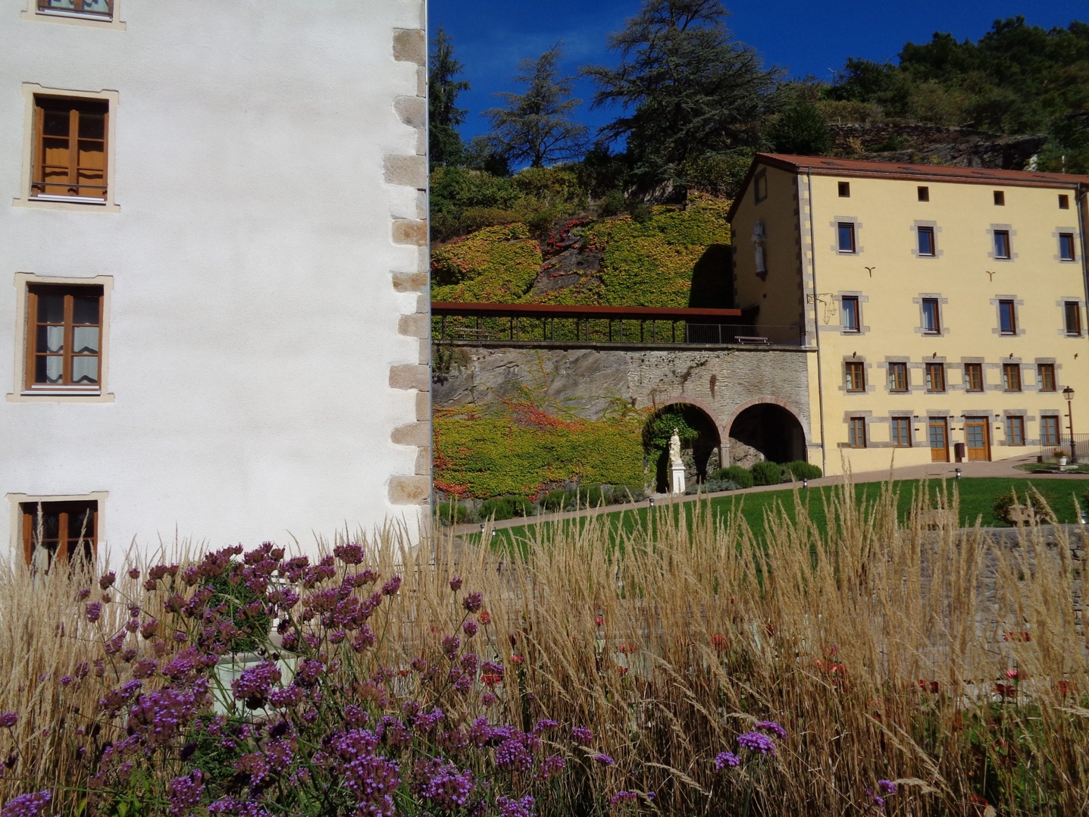

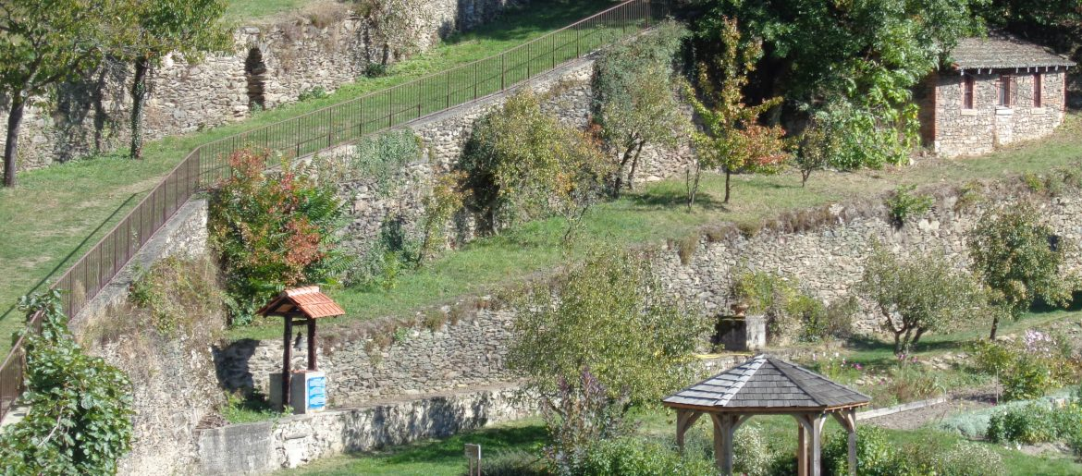
Terraces built by early Brothers for gardens and orchards at Notre Dame de l’Hermitage
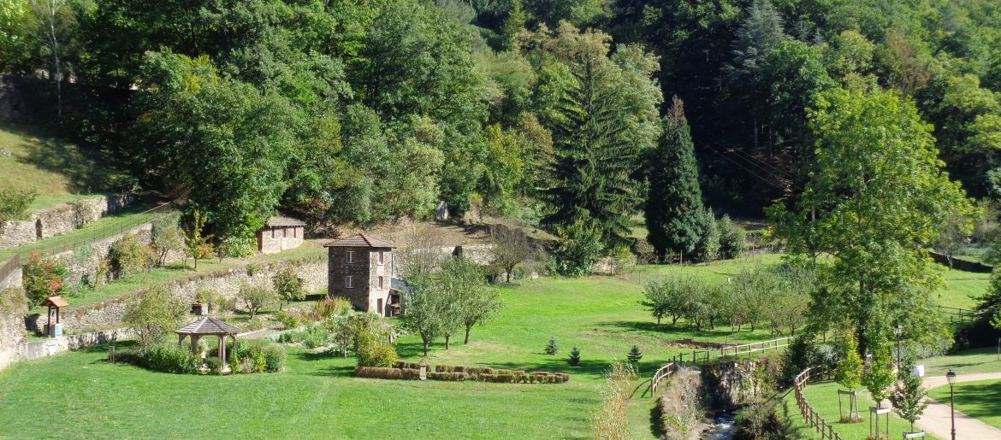
Former vegetable gardening areas beside the River Gier, Notre Dame de l’Hermitage 2015 –Small fruit orchard groves still present.

Student Prayers - Secondary

Prayer 1
Global Marist Family

Reader 1:
Sign of the Cross: In the name of the Father, the Son and the Holy Spirit. Amen.

We Listen:
When St Marcellin Champagnat started the first Marist school in France over 200 years ago, he dreamed that Marist schools would be in every diocese throughout the world.

This year we are celebrating the 150th anniversary of the first Marist school in Australia. With the arrival of four Marist Brothers from France, they quickly established a school at the Rocks in Sydney and enrolled 139 students on Monday April 8th, 1872.

Today, there are 56 Marist schools across Australia and almost 600 globally providing education to 700,000 young people across the world.

Reader 2:
We Pray:
Dear God, we give thanks to you for St Marcellin Champagnat and the dream he had of making Jesus Christ known and loved throughout the whole world.

We pray for Marists wherever they may be, especially those who are suffering due to poverty, civil unrest or other conditions that are affecting their lives.

May Mary, our Good Mother, be our protector just as she was for Jesus. Amen.

Mary, our Good Mother …. Pray for us.
St Marcellin Champagnat …. Pray for us.
St Mary of the Cross Mackillop …. Pray for us.
And let us always remember … to pray for one another.

Sign of the Cross: In the name of the Father, the Son and the Holy Spirit. Amen.

Prayer 2
Marist Mission

Reader 1:
Sign of the Cross: In the name of the Father, the Son, and the Holy Spirit. Amen.

We Listen:
At the heart of our Marist mission, is to demonstrate the love of God in our lives by reaching out in kindness and service to others. What we see in the world both amazes and shocks us. On the one hand, we celebrate the beauty and diversity of nature and its wonderous harmony. We rejoice too in the rich cultural diversity of humankind. Yet we also come face to face with violence and insecurity, poverty and despair, ecological destruction, illiteracy, and ignorance.

For those we meet each day we seek to be reflections of God. Our desire is to be a visible and permanent memory of the loving and merciful presence of God in the midst of God’s people. In some mysterious way, God works through us and in us. By being with God we learn our way of being like God: shepherd, friend, and faithful companion*.

Reader 2:
We Pray:
Loving God, you created human beings in your image. Help us to live out the Marist mission by seeing the dignity in the people we meet every day.

By having you close in our lives, may the spirit of your love shine in us and through us, so we too may be shepherds, friends and faithful companions to others.

Mary, our Good Mother …. Pray for us.
St Marcellin Champagnat …. Pray for us.
St Mary of the Cross Mackillop …. Pray for us.
And let us always remember … to pray for one another.

Sign of the Cross: In the name of the Father, the Son and the Holy Spirit. Amen.

adapted from Water from the Rock: Marist Spirituality #125,137)

Prayer 3
Mary, Our Good Mother

Reader 1:
Sign of the Cross: In the name of the Father, the Son and the Holy Spirit. Amen.

We Listen:
Key among the influences that shaped Saint Marcellin, was his personal experience of being loved intensely by Jesus and called by Mary. An incident early in 1823 was understood by Marcellin and his Brothers as highly significant. Marcellin and one of the Brothers, (Stanislaus) were lost in a snow storm. With his companion unconscious at his feet, Marcellin believed that if Mary does not come to our aid, we are lost. Placing his life in God´s hands, he prayed the Memorare (Mem-o-rar-ray). His prayer to Mary was miraculously answered. Marcellin and his first Brothers saw in this incident a deeper reality: God‘s choice of them to share in the same mission that was entrusted to Mary.

Reader 2
We Pray:
Loving God, you gifted us with Mary, the Mother of Jesus, as our Good Mother too. As Marists, we call upon Mary to be our guide and companion, together with your son Jesus.

Help us always to remember the special place that Mary has in her heart for each of us. May we be encouraged by the example that Saint Marcellin has passed onto our generation through his faith in Mary and trust in God.

Mary, our Good Mother …. Pray for us.
St Marcellin Champagnat …. Pray for us.
St Mary of the Cross Mackillop …. Pray for us.
And let us always remember … to pray for one another.

Sign of the Cross: In the name of the Father, the Son and the Holy Spirit. Amen.

(adapted from Water from the Rock: Marist Spirituality #7)

Prayer 4
Marist Spirit

Reader 1:
Sign of the Cross: In the name of the Father, the Son and the Holy Spirit. Amen.

We Listen:
The Marist spirit is born of the experience of being loved by God and of our desire to actively participate in the mission of Jesus. God is passionate about the world and its people, and Jesus expresses this love by a ministry of teaching and healing. Jesus said, I came that you may have life and have it abundantly (John Chapter 10: verse 10).

As brothers and sisters sharing in Life, we want to grow in care for our planet and all creation. With others, we foster the hope that all humankind will come to appreciate the world as our home, where nature is delicately balanced. This requires our living together in an atmosphere of reverence, mutual respect, justice and participation. *

Reader 2
We Pray:
Creator God, encouraged by the good works of St Marcellin in the township of LaValla, we pray for our community here at [NAME OF SCHOOL] that we may always be passionate about the care of creation and compassionate for all people.

Let us always remember that we are created in your image, and that in each and every person, Christ is present. We ask Mary to pray with us and for us as we say..

Hail Mary, full of grace, the Lord is with you. Blessed are you among women and blessed is the fruit of your womb, Jesus. Holy Mary, Mother of God, pray for us sinners, now and at the hour of our death Amen.

Mary, our Good Mother …. Pray for us.
St Marcellin Champagnat …. Pray for us.
St Mary of the Cross Mackillop …. Pray for us.
And let us always remember … to pray for one another.

Sign of the Cross: In the name of the Father, the Son and the Holy Spirit. Amen.

(adapted from Water from the Rock: Marist Spirituality #122,124)

Prayer 5
150 Years of Marist Education in Australia

Reader 1:
Sign of the Cross: In the name of the Father, the Son and the Holy Spirit. Amen.

150 years ago, four young men all aged in their 20s, from France, Ireland and Scotland commenced the first Marist school in Australia. Over these past 150 years, many thousands of Australian Marists, Brothers and Lay, have worked with faith and commitment to share Saint Marcellin’s vision to make Jesus known and loved through the Christian education of young people.

In this significant year, we give thanks for our Marist schools, colleges and ministries, for the women and men who dedicate their lives to this work; to the students, their families and other people who are cared for, nurtured and loved in the Way of Mary, for Jesus. May this vital work continue for many generations to come.

Reader 2
We Pray:

Merciful God, we pray in gratefulness for the wisdom, inspiration and faith of St Marcellin Champagnat and the many women and men who have followed and continue to follow in his footsteps, bringing the love of Jesus and Mary into the hearts of young people just like us.

We pray in gratitude for our own teachers and staff here in this college, for their dedication and commitment to their work and care of the students here. May you bless them and their families and give them the encouragement and satisfaction of doing your work.

Mary, our Good Mother …. Pray for us.
St Marcellin Champagnat …. Pray for us.
St Mary of the Cross Mackillop …. Pray for us.
And let us always remember … to pray for one another.

Sign of the Cross: In the name of the Father, the Son and the Holy Spirit. Amen.

Primary Student Prayer 1

Novena of St Marcellin Champagnat

What is a Novena?
The word novena is taken from “novem,” the Latin word for nine. A novena is made up of nine days of prayer and meditation usually, to ask God for special prayer requests. Novenas are often used to ask specific saints to pray for us.
Novenas are an ancient tradition that goes back to the days of the Apostles. Jesus told His disciples to pray together after His ascension into heaven, so they went to an upper room along with the Blessed Virgin Mary (Acts 1:14) and joined constantly in prayer for nine days. The main objective of the novena is to help you open up your heart to God to the many blessings that God wants to give you.
As a class, we are going to pray a novena. However, you can pray your own individual novena over nine days whenever you like, especially if you have a special prayer request.
This pattern of nine days of prayer is the basis of the novena and we are going to pray for the nine days leading to the Feast of St Marcellin on 6 June.
Let us, as a class, decide upon our prayer request, that is, with what will we ask St Marcellin Champagnat to help us.
- This could be for someone in our community who needs our support
- It might be for those in our wider community who are doing it tough e.g., street kids, homeless people
- Perhaps it is someone in another country e.g., the people suffering because of the war in Ukraine

The ritual we complete today will be repeated every time we pray our Novena prayer.

St Marcellin Champagnat had a special love for Mary, Jesus’ Mother, and so in our novena prayers we, too, will pray to Jesus through Mary and St Marcellin.

Day 1

Reader:
To begin our prayer, we still our bodies and our minds and open our hearts for our prayer.

(some soft instrumental music is played)

(someone from the class lights the novena candle)

Together we start by making the Sign of the Cross:

All: In the name of the Father, and of the Son and of the Holy Spirit, Amen.

Opening Prayer: Open us to your love Gracious God, as we begin this new day.

Dear Jesus, we thank you for giving us your Blessed Mother Mary and St Marcellin Champagnat to show us how to love you and others.

Mary and Marcellin, you are good role models for us, and we ask you to hold us close in your hearts and bring all our special prayers to Jesus.

We pray especially, in this novena, for… (say your prayer intention here)

(spend a moment in silent prayer for your request)

Closing Prayer: We thank you loving God for your presence with us today, and we thank you for listening to our prayer.

All: Our Father, who art in heaven, hallowed be your name; your kingdom come; your will be done on earth as it is in heaven. Give us this day our daily bread; and forgive us our trespasses as we forgive those who trespass against us; and lead us not into temptation but deliver us from evil. Amen.

All: In the name of the Father, and of the Son and of the Holy Spirit, Amen.

Day 2

Reader:
To begin our prayer, we still our bodies and our minds and open our hearts for our prayer.

(some soft instrumental music is played)

(someone from the class lights the novena candle)

Together we start by making the Sign of the Cross:

All: In the name of the Father, and of the Son and of the Holy Spirit, Amen.

Opening Prayer: Open our hearts Jesus to welcome everyone we encounter today.

Dear Jesus, we ask you to hear our prayers and be with us as we journey through our day.

Mary, thank you for saying ‘yes’ to the invitation of the Angel to be the Mother of Jesus. St Marcellin Champagnat, thank you for having the courage and vision to form the Marist Brothers for the world.

We pray especially, in this novena, for… (say your prayer intention here)

(spend a moment in silent prayer for your request)

Closing Prayer: Jesus, help us to be like you in all we are, say and do.

All: Hail Mary, full of grace, the Lord is with you. Blessed are you among women and blessed is the fruit of your womb, Jesus. Holy Mary, Mother of God, pray for us sinners now, and at the hour of our death. Amen.

All: In the name of the Father, and of the Son and of the Holy Spirit, Amen.

Day 3

Reader:
To begin our prayer, we still our bodies and our minds and open our hearts for our prayer.

(some soft instrumental music is played)

(someone from the class lights the novena candle)

Together we start by making the Sign of the Cross:

All: In the name of the Father, and of the Son and of the Holy Spirit, Amen.

Opening Prayer: We ask that you give us the courage to always do what is right and just.

Dear Jesus, help us to be ready to offer assistance to others whenever we see that they need it.

You call us through Mary and Marcellin to communicate your love and compassion to everyone we meet.

We pray especially, in this novena, for… (say your prayer intention here)

(spend a moment in silent prayer for your request)

Closing Prayer: Jesus, help us to be like you and always show compassion to others.

All: Our Father, who art in heaven, hallowed be your name; your kingdom come; your will be done on earth as it is in heaven. Give us this day our daily bread; and forgive us our trespasses as we forgive those who trespass against us; and lead us not into temptation but deliver us from evil. Amen.

All: In the name of the Father, and of the Son and of the Holy Spirit, Amen.

Day 4

Reader:
To begin our prayer, we still our bodies and our minds and open our hearts for our prayer.

(some soft instrumental music is played)

(someone from the class lights the novena candle)

Together we start by making the Sign of the Cross:

All: In the name of the Father, and of the Son and of the Holy Spirit, Amen.

Opening Prayer: Dear God, as we come together today, we give you thanks for the good gifts you give us.
Jesus may the dream of St Marcellin live in our communities and families today in such a way that we all experience the love you feel for all people.

Mary, may our relationships with people be shaped in your way. May we show tenderness and comfort to those we meet today. St Marcellin wanted his young Brothers to love one another. Help us to show our love to those in our community today.

We pray especially, in this novena, for… (say your prayer intention here)

(spend a moment in silent prayer for your request)

Closing Prayer: Jesus, help us to be like you in all we are, say and do.

All: Hail Mary, full of grace, the Lord is with you. Blessed are you among women and blessed is the fruit of your womb Jesus. Holy Mary, Mother of God, pray for us sinners now, and at the hour of our death. Amen.

All: In the name of the Father, and of the Son and of the Holy Spirit, Amen.

Day 5

Reader:
To begin our prayer, we still our bodies and our minds and open our hearts for our prayer.

(some soft instrumental music is played)

(someone from the class lights the novena candle)

Together we start by making the Sign of the Cross:

All: In the name of the Father, and of the Son and of the Holy Spirit, Amen

Opening Prayer: God of grace, we open our hearts, minds and souls to you.
Dear Jesus, my we follow Mary and St Marcellin in their total trust in you and we pray for your guidance as we respond to the challenges of our world.

Mary, you are with us on our journey, may your presence and example help us to follow Jesus in your way of kindness and love.

We pray especially, in this novena, for… (say your prayer intention here)

(spend a moment in silent prayer for your request)

Closing Prayer: Help us to discover a heart just like Marcellin's heart within us.

All: Hail Mary, full of grace, the Lord is with you. Blessed are you among women and blessed is the fruit of your womb Jesus. Holy Mary, Mother of God, pray for us sinners now, and at the hour of our death. Amen.

All: In the name of the Father, and of the Son and of the Holy Spirit, Amen.

Day 6

Reader:
To begin our prayer, we still our bodies and our minds and open our hearts for our prayer.

(some soft instrumental music is played)

(someone from the class lights the novena candle)

Together we start by making the Sign of the Cross:

All: In the name of the Father, and of the Son and of the Holy Spirit, Amen

Opening Prayer: Dear God, come be with us today as we learn and play together.
Spirit of God, give us a generous heart to respond to the needs of people who are suffering today. May we show your compassion through our care for them.

May you make yourself present to each of us and give us the courage to walk the way of the Gospel as did Mary our Good Mother and St Marcellin.

We pray especially, in this novena, for… (say your prayer intention here)

(spend a moment in silent prayer for your request)

Closing Prayer: Jesus and Mary, be with us!

All: Our Father, who art in heaven, hallowed be your name; your kingdom come; your will be done on earth as it is in heaven. Give us this day our daily bread; and forgive us our trespasses as we forgive those who trespass against us; and lead us not into temptation but deliver us from evil. Amen.

All: In the name of the Father, and of the Son and of the Holy Spirit, Amen.

Day 7

Reader:
To begin our prayer, we still our bodies and our minds and open our hearts for our prayer.

(some soft instrumental music is played)

(someone from the class lights the novena candle)

Together we start by making the Sign of the Cross:

All: In the name of the Father, and of the Son and of the Holy Spirit, Amen

Opening prayer: Lord, today we thank you for you walking with us every day. You are with us always.
Dear God, Marcellin saw you in all things, and believed all good things came from you. May we be open to your presence in our lives.

We pray especially, in this novena, for… (say your prayer intention here)

(spend a moment in silent prayer for your request)

Closing Prayer: Give us courage, O Lord, to stand up and be counted, to stand up for those who cannot stand up for themselves, to stand up for ourselves when we need to.

All: Hail Mary, full of grace, the Lord is with you. Blessed are you among women and blessed is the fruit of your womb Jesus. Holy Mary, Mother of God, pray for us sinners now, and at the hour of our death. Amen.

All: In the name of the Father, and of the Son and of the Holy Spirit, Amen

Day 8

Reader:
To begin our prayer, we still our bodies and our minds and open our hearts for our prayer.

(some soft instrumental music is played)

(someone from the class lights the novena candle)

Together we start by making the Sign of the Cross:

All: In the name of the Father, and of the Son and of the Holy Spirit, Amen

Opening Prayer: Dear God, may your goodness and love be present amongst us today. Come help us to work together in love and forgiveness.
We thank you creator God for the gift of your love for us, and the sense of belonging we experience in our family and school community.

Mary, we ask you to do all you can to help us grow in humility and love.

We pray especially, in this novena, for… (say your prayer intention here)

(spend a moment in silent prayer for your request)

Closing prayer: May we do all we can to follow you faithfully.

All: Our Father, who art in heaven, hallowed be your name; your kingdom come; your will be done on earth as it is in heaven. Give us this day our daily bread; and forgive us our trespasses as we forgive those who trespass against us; and lead us not into temptation but deliver us from evil. Amen.
All: In the name of the Father, and of the Son and of the Holy Spirit, Amen
Day 9

Reader:
To begin our prayer, we still our bodies and our minds and open our hearts for our prayer.

(some soft instrumental music is played)

(Someone from the class lights the novena candle)

Together we start by making the Sign of the Cross:

All: In the name of the Father, and of the Son and of the Holy Spirit, Amen

Opening Prayer: Lord God, we choose to look to you as we begin this school day. We give you our friendships, our learning, our hopes, and our dreams.
Mary made a stable into a home for Jesus and with Joseph, she provided a family home in Nazareth.

Jesus, we give you thanks for the love of our families and we thank you for the family spirit that is Marcellin's gift to us.

We pray especially, in this novena, for… (say your prayer intention here)

(spend a moment in silent prayer for your request)

Closing Prayer: May we strive each day to imitate Jesus and Mary more closely in our lives.

All: Hail Mary, full of grace, the Lord is with you. Blessed are you among women and blessed is the fruit of your womb Jesus. Holy Mary, Mother of God, pray for us sinners now, and at the hour of our death. Amen.

All: In the name of the Father, and of the Son and of the Holy Spirit, Amen

Primary Student Prayer 2

Marcellin Making People Known and Loved

Start with a small ritual such as the lighting of a candle in the classroom sacred space, a moment of silence, and the sign of the cross.

Reader 1: Saint Marcellin Champagnat had a love of God and a compassion for people. This is what Jesus taught his disciples when he said the most important of the commandments was to “love God and love your neighbour”.

Reader 2: Jesus made this very clear when he gave examples of what this looks like in the Gospel reading from St Matthew Chapter 25.

Reader 1: A reading for the Gospel of Saint Matthew*
*International Children’s Bible 25:34-40

“Then the King will say to the good people on his right, ‘Come. My Father has given you his blessing. Come and receive the kingdom God has prepared for you since the world was made. I was hungry, and you gave me food. I was thirsty, and you gave me something to drink. I was alone and away from home, and you invited me into your house. I was without clothes, and you gave me something to wear. I was sick, and you cared for me. I was in prison, and you visited me.’
Reader 2:
“Then the good people will answer, ‘Lord, when did we see you hungry and give you food? When did we see you thirsty and give you something to drink? When did we see you alone and away from home and invite you into our house? When did we see you without clothes and give you something to wear? When did we see you sick or in prison and care for you?’
Reader 1:
“Then the King will answer, ‘I tell you the truth. Anything you did for any of my people here, you also did for me.’
[pause]
This is the Word of the Lord.
ALL: THANKS BE TO GOD

Reader 3: Saint Marcellin Champagnat lived his life according to what Jesus was asking. To show compassion, kindness and love towards others. He was the parish priest in a small country town in France called La Valla. He started a primary school there for the poor children in the parish. He also did many good things for the people including giving meals to those who were hungry and visiting those who were sick. Often, people came to his house looking for assistance, Marcellin and the Brothers were always happy to help.

Here is one story that demonstrates Saint Marcellin’s example to us of how to show this Christian love by being generous to others.

Reader 4: From the Life of Saint Marcellin Champagnat, written by Br Furet in 1856

One winter’s afternoon Marcellin was summoned on a sick call and hurried to the address, where he found a poor unfortunate man covered with ulcers and lying on a little straw mat with only a few rags to cover his body. Moved to deep compassion at the sight of so much suffering and such great poverty, he first of all spoke a few sympathetic words to the sick man; then he ran home, sent for the Brother in charge of housekeeping, and told him to go at once to the sick man’s place, taking along a straw mattress, sheets and blankets.

The brother pointed out to Marcellin that there was no spare mattress. “What!” he asked, “not a single one in the house?” “Not one”, came the reply, “and you may remember Father, that I gave away the last one only a few days ago.” “Well”, Marcellin went on, “take the one from my bed and see that he gets it at once.”

It was not unusual for Marcellin to deprive himself in order to help the poor or to cater for the needs of his brother.

TEACHER INPUT:
It is suggested the teacher may wish to encourage age appropriate student reflection or discussion at this point.

Questions for reflection / discussion:
1) Why were Marcellin and the Brothers so kind and generous to others?
2) What are some simple ways that we can show the Christian love to others that Jesus is asking us to do.

To conclude:

Reader 3:
Heavenly Father,
You gave us Saint Marcellin Champagnat so that by his inspiration, we too will reach out to those in need with kindness, generosity and love.
We ask, with the guidance of Mary, Our Good Mother, to be the face and hands of Jesus in the lives of those we meet.

Reader 4: Together we pray…

Hail Mary, full of grace,
The Lord is with you.
Blessed are you among women,
and blessed is the fruit of your womb, Jesus.

Holy Mary, Mother of God,
pray for us sinners,
now and at the hour of our death.
Amen.

We now pray in silence for our own intentions ..
(pause for 10 seconds)

Mary, Our Good Mother . . . . . . pray for us
St Marcellin Champagnat. . . . . . pray for us
St Mary of the Cross. . . . . . . . . . pray for us
And let us always remember . . . to pray for one another.

In the name of the Father, the Son and the Holy Spirit.

Student Reflection

Known and Loved in the Sesquicentenary Year of Marist Education in Australia

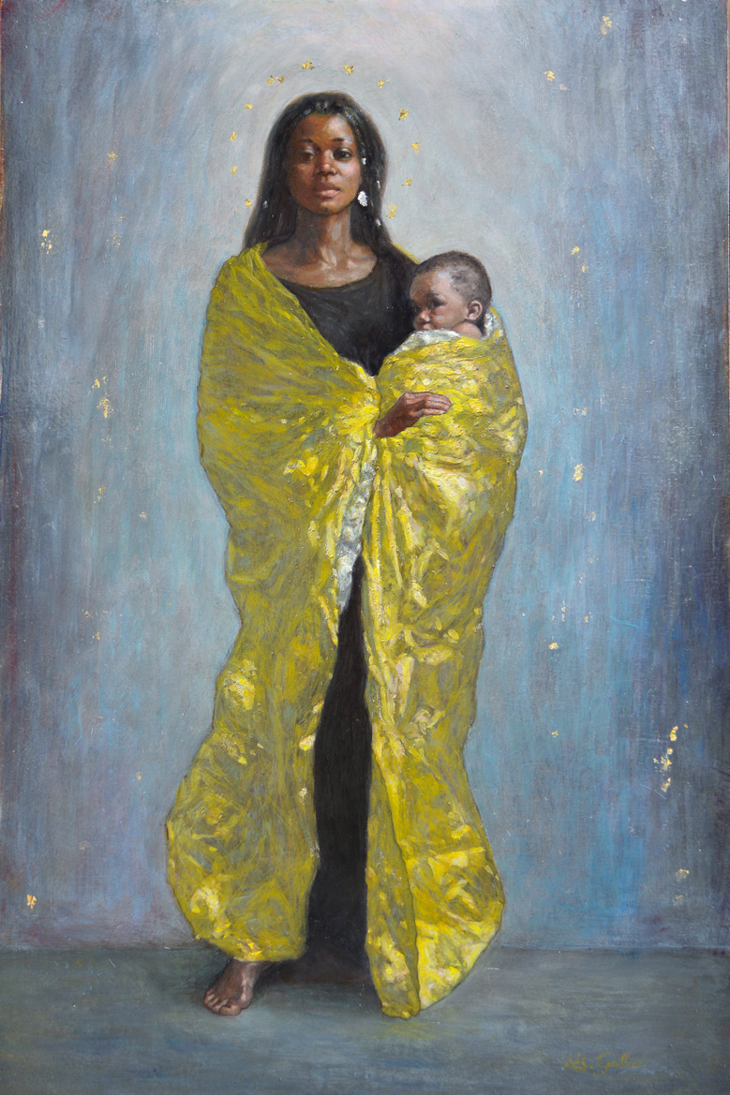

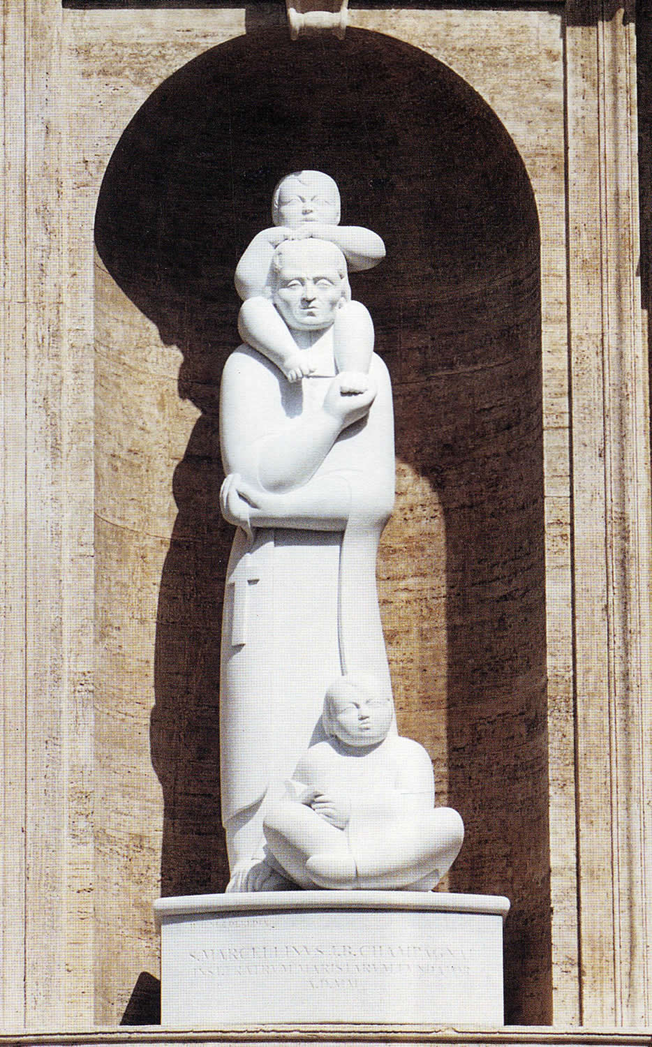

Image 1: St Marcellin Champagnat by Jimenez (1999)
Image 2: Our Lady of Loreto with the Regugees’ Cloak by Margherita Gallucci (2020)

It is often said that Mary is our model for Marist education. That she is the example we should try to follow and emulate. This comes from St Marcellin himself who coined the phrase All to Jesus through Mary – all to Mary for Jesus.

One way to look at this is through the lens of the artist. Over the years, many artists have tried to capture images of Mary and images of Marcellin which say something about the importance of each of them. Let’s have a look at 2 contemporary images – one of Mary and one of St Marcellin – with a view to understanding the connection between the two and why Marcellin had such a devotion to Mary and wanted her to be the inspiration and the model for Marist education.

Image 1: Our Lady of Loreto with the Refugees’ Cloak by Margherita Gallucci (2020)

The artist dedicated the painting to “the sacredness of human life, to the sacredness and dignity of all those who are victims of brutality, war and racism.” In this painting, Mary is protecting the vulnerable child and can be seen as the accompanier of the lost, the least and the lonely.

Let’s pause and look at the image. What do you notice?

Image 2: St Marcellin Champagnat by Jimenez Deredia (1999)

In this statue, which was done to acknowledge the canonisation of Marcellin as a saint, we see Marcellin accompanying two children, one on his shoulders and one at his feet. The child on his shoulders looks out from his position viewing the world beyond and all its possibilities. The child below leans on Marcellin expressing a personal relationship and a sense of trust.

Take a moment to look closely at the image. What do you notice?

Questions for personal reflection.

- Both images feature children. Why do you think that is?
- a) What are 3 other things you notice about Mary?
b) What are 3 other things you notice about Marcellin?

For group discussion.

- St Marcellin began Marist schools in order to “make Jesus Christ Known and Loved” and to do so “in the way of Mary.” The above painting of Mary is the image being used for our Marist theme for this year, Known and Loved – Dignity for all. How does making others known and loved help us to make Jesus known and loved?

- How might we become more aware of others in our school community, particularly those struggling? How might we respond to this?

Feast of Saint Marcellin Champagnat Mass
Solemnity

Acknowledgement of Country:
As a Marist family, we pay our respects to the traditional custodians of this sacred land, the [ ______] people, we acknowledge the elders, past and present, and the emerging leaders of Aboriginal Australia.

Introduction

The feast of Saint Marcellin Champagnat celebrates the connection we have here at [name of school], to the global Marist family. St Marcellin started primary schools in the country areas of France over 200 years ago to give an education to children who would not normally have received that opportunity. Today, there are Marist schools and other Marist ministries in over 80 countries around the world. To be Marist is to be a follower of Jesus, and we live this way in the Catholic tradition.

This year we celebrate the 150th anniversary of the opening of the first Marist Brothers school in Australia. As we begin our celebration, we pray in thanksgiving for the legacy of these first Marists to Australia and recall how they and Saint Marcellin listened to and were guided by the Holy Spirit in their hearts, giving them the strength and inspiration to care for the young people of their time. We know that this same Spirt is alive in each of us, and we pray that through our words and actions we, too, can make a difference in the lives of others today.

Let us stand as we begin our celebration.

Collect/Opening Prayer
Holy Father, you have revealed the commandment of the new law through your Only Begotten Son, and shown us how to put it into practice by the inspiring example of Saint Marcellin; grant us, we pray, the grace to persevere in loving all our brothers and sisters as he taught, and to lead our world to the knowledge of the truth of Jesus Christ, who lives and reigns with you in the unity of the Holy Spirit, God, forever and ever. Amen.

First Reading

(Sirach 24: 28-31)

A reading from the Book of Sirach.

I, wisdom, poured forth rivers.

I, like a rivulet from her stream, channelling the waters into paradise,

said to myself, “I will water my plants, my flower bed I will drench”;

and suddenly this rivulet of mine became a river,

and this stream of mine, a sea.

Thus, do I send my teachings forth shining like the dawn,

to become known afar off.

I shall penetrate the lower parts of the earth,

and I shall look upon all who sleep,

and enlighten those who hope in God.

Thus, do I pour out instruction like prophecy

and bestow it on generations to come,

and I shall continue in their descendants forever.

See, I have worked not for myself alone, but for all who seek instruction.

The Word of the Lord.

All: Thanks be to God.

Responsorial Psalm (Psalm 112: 1-9)

Response: Happy the one whom the Lord instructs.

Happy the one whom the Lord instructs,
Who greatly delights in God’s commands.
Their posterity shall be mighty upon the earth;
The upright generation shall be blessed. (R)

Wealth and riches shall be in their house.
Their generosity shall endure forever.
They dawn through the darkness, a light for the upright;
They are gracious and merciful and just. (R)

Well for the one who is gracious and lends,
Who conducts their affairs with justice;
They shall never be moved;
The just one shall be in everlasting remembrance. (R)

An evil report they shall not fear;
Their heart is firm, trusting in the Lord.
Their heart is steadfast; they shall not fear
Till they look down on his foes. (R)

Lavishly they give to the poor;
Their generosity shall endure forever;
Their horn shall be exalted in glory. (R)

Second Reading
(Acts 1:12-14; 2:44-47 NRSV)

A reading from the Acts of the Apostles.

The Apostles returned to Jerusalem from the mount called Olivet, which is near Jerusalem, a sabbath day’s journey away. When they had entered the city, they went to the room upstairs where they were staying, Peter, and John, and James, and Andrew, Philip and Thomas, Bartholomew and Matthew, James son of Alphaeus, and Simon the Zealot, and Judas son of James. All these were constantly devoting themselves to prayer, together with certain women, including Mary the mother of Jesus, as well as his brothers.

All who believed were together and had all things in common; they would sell their possessions and goods and distribute the proceeds to all, as any had need. Day by day, as they spent much time together in the temple, they broke bread at home and ate their food with glad and generous hearts, praising God and having the goodwill of all the people. And day by day the Lord added to their number those who were being saved.

The word of the Lord.

All: Thanks be to God.

Gospel Acclamation (Matthew 5:3)

Alleluia, Alleluia.
How blessed are the poor in spirit: the reign of God is theirs.
Alleluia.

Gospel
(Matthew 18:1-7,10 NRSV)

A reading from the Holy Gospel according to Matthew.

All: Glory to you, O Lord
(The congregation makes a small sign of the cross on their forehead, lips and heart)

At that time the disciples came to Jesus and asked, “Who is the greatest in the kingdom of heaven?” He called a child, whom he put among them, and said, “Truly I tell you, unless you change and become like children, you will never enter the kingdom of heaven. Whoever becomes humble like this child is the greatest in the kingdom of heaven. Whoever welcomes one such child in my name welcomes me. If any of you put a stumbling block before one of these little ones who believe in me, it would be better for you if a great millstone were fastened around your neck and you were drowned in the depth of the sea. Woe to the world because of stumbling blocks! Occasions for stumbling are bound to come, but woe to the one by whom the stumbling block comes!

“Take care that you do not despise one of these little ones; for, I tell you, in heaven their angels continually see the face of my Father in heaven.

The Gospel of the Lord.

All: Praise to you, Lord Jesus Christ.

Prayer of the Faithful

Celebrant:
Grateful to God for the many blessings received through Marist education in Australia, and aware of our dependency upon God for all that is good, let us offer up our needs to the Lord with humility and confidence.

OR

Guided by the Holy Spirit, Jesus recognised the inherent dignity of every person he encountered reaching out especially to those who felt marginalised. As a Marist community, we ask for this same inspiration as together we pray.

Reader: For the Church:
We pray for Pope Francis and all our spiritual and Church leaders, that they be blessed with courage and wisdom to face the challenges of leading the Church in this modern world.

In communion we pray.

℟. Lord, hear our prayer.

Reader: For World Leaders:
May the Holy Spirit guide and inspire our leaders to care for the most vulnerable in society and put in place policies with the intention of protecting and preserving our common home.

In communion we pray.

℟. Lord, hear our prayer.

Reader: For Marist Communities:
We pray in thanksgiving for the generations of Marist people whose dedication and generosity of spirit are the shoulders we stand upon today; may we always have the mission of making Jesus Christ known and loved, in the way of Mary, central in our daily lives.

In communion we pray.

℟. Lord, hear our prayer.

Reader: For those whose lives are troubled by sickness, mental illness or physical violence:
May their families, friends and supporters renew their trust and security in loving relationships. May all members of the Church be instruments of healing.

In communion we pray.

℟. Lord, hear our prayer.

Reader: For all those affected by the pandemic and by natural disasters:
We pray for those who are suffering, especially our Marist community in Lismore impacted by the floods. That we may we stand in solidarity and support, offering assistance where we can.

In communion we pray.

℟. Lord, hear our prayer.
Reader: For our own intentions:
(pause) We pray with Mary, Our Good Mother and Mother of the Church, that she walks with us, sharing our joys and sufferings of every day, and modelling a total trust in God.

In communion we pray.

℟. Lord, hear our prayer.

Celebrant:

Heavenly Father,
By the intercession of St Marcellin Champagnat and the Blessed Virgin Mary, we ask that you hear our prayers, which we unite with the sacrifice of your Son, who lives and reigns forever and ever.
℟. Amen.
OR: Holy God, you sent your Son, Jesus, to be our beacon of hope for all eternity; may his light and love shine brightly within our lives and through our Marist communities. We ask this, and for these prayers and the prayers in our hearts, through Christ our Lord. Amen

THE LITURGY OF THE EUCHARIST

The Preparation of the Gifts

Father, all powerful and ever living God
we do well always and everywhere to give you thanks,
and to praise you for your gifts
as we contemplate your saints in glory.
Like a loving parent,
you always watch over us, your people.
You gave us Mary as our Good Mother,
first among the believers, a just and simple woman.

You gave us Marcellin Champagnat,
a man who truly reflected your loving faithfulness
in his commitment to serving you and your people.
His life was a living witness of the ideal
that he presented to his first followers:
to become a Brother means to strive to become holy.

Through Christ, the angels of heaven offer their prayer of adoration as they rejoice in your presence forever.

Prayer after Communion

Nourished with the Body and Blood of your Son, we pray, O Lord, that we who celebrate the great work that you have accomplished in your Church through Saint Marcellin, may be strengthened by the power of this Sacrament and inspired to undertake ever greater apostolic works. Through Christ our Lord.

